1. NAME OF THE MEDICINAL PRODUCT

DARZALEX 120 MG/ML S.C. 1,800 MG

2. QUALITATIVE AND QUANTITATIVE COMPOSITION

Each 15 mL vial of solution for injection contains 1800 mg of daratumumab (120 mg daratumumab per mL).

Daratumumab is a human monoclonal IgG1κ antibody against CD38 antigen, produced in a mammalian cell line (Chinese Hamster Ovary) using recombinant DNA technology.

Excipient with known effect
Each 15 mL vial of solution for injection contains 735.1 mg of sorbitol (E420).

For the full list of excipients, see section 6.1.

3. PHARMACEUTICAL FORM

Solution for injection.
The solution is clear to opalescent, colourless to yellow, with a pH of 5.6 and osmolality of 343 to 395 mOsm/kg.

The marketing of DARZALEX 120 MG/ML S.C 1,800MG is subject to risk management plan (RMP) including “Health Care Professional (HCP) Guide” and "patient safety information card".

HCP Guide
This product is marketed with prescriber guide providing important safety information. Please ensure you are familiar with this material as it contains important safety information.

Patient safety information card
The "Patient safety information card" emphasizes important safety information that the patient should be aware of before and during treatment. Please explain to the patient the need to review the card before starting treatment.

4. CLINICAL PARTICULARS

4.1 Therapeutic indications

DARZALEX is indicated:

Multiple myeloma
- in combination with lenalidomide and dexamethasone or with bortezomib, melphalan and prednisone for the treatment of adult patients with newly diagnosed multiple myeloma who are ineligible for autologous stem cell transplant.
- in combination with bortezomib, thalidomide and dexamethasone for the treatment of adult patients with newly diagnosed multiple myeloma who are eligible for autologous stem cell transplant.
- in combination with lenalidomide and dexamethasone, or bortezomib and dexamethasone, for the treatment of adult patients with multiple myeloma who have received at least one prior therapy.
- as monotherapy for the treatment of adult patients with relapsed and refractory multiple myeloma, whose prior therapy included a proteasome inhibitor and an immunomodulatory agent and who have demonstrated disease progression on the last therapy.
- for the treatment of adult patients with multiple myeloma in combination with pomalidomide and dexamethasone in patients who have received at least one prior line of therapy including lenalidomide and a proteasome inhibitor.

- in combination with bortezomib, lenalidomide and dexamethasone for the treatment of adult patients with newly diagnosed multiple myeloma who are ineligible for autologous stem cell transplant.
- in combination with bortezomib, lenalidomide, and dexamethasone, followed by maintenance treatment in combination with lenalidomide, for the treatment of adult patients with newly diagnosed multiple myeloma who are eligible for autologous stem cell transplant.

Light chain (AL) amyloidosis
- in combination with cyclophosphamide, bortezomib and dexamethasone for the treatment of adult patients with newly diagnosed systemic AL amyloidosis.

4.2 Posology and method of administration

DARZALEX subcutaneous formulation is not intended for intravenous administration and should be given by subcutaneous injection only, using the doses specified.

DARZALEX should be administered by a healthcare professional, and the first dose should be administered in an environment where resuscitation facilities are available.

It is important to check the vial labels to ensure that the appropriate formulation (intravenous or subcutaneous formulation) and dose is being given to the patient as prescribed.

For patients currently receiving daratumamab intravenous formulation, DARZALEX solution for subcutaneous injection may be used as an alternative to the intravenous daratumumab formulation starting at the next scheduled dose.

Pre- and post-injection medicinal products should be administered to reduce the risk of infusion-related reactions (IRRs) with daratumumab. See below “Recommended concomitant medicinal products” and section 4.4.

Posology

Multiple myeloma

Dosing schedule in combination with lenalidomide and dexamethasone or pomalidomide and dexamethasone (4-week cycle regimen) and for monotherapy

The recommended dose is 1800 mg of DARZALEX solution for subcutaneous injection administered over approximately 3-5 minutes according to the following dosing schedule in table 1.

Table 1: DARZALEX dosing schedule in combination with lenalidomide and dexamethasone (Rd), pomalidomide and dexamethasone (Pd) (4-week cycle dosing regimen) and monotherapy
Weeks | Schedule
Weeks 1 to 8 | weekly (total of 8 doses)
Weeks 9 to 24ª | every two weeks (total of 8 doses)
Week 25 onwards until disease progression^{b} | every four weeks
ª First dose of the every-2-week dosing schedule is given at week 9
^{b} First dose of the every-4-week dosing schedule is given at week 25

Dexamethasone should be administered at 40 mg/week (or a reduced dose of 20 mg/week for patients >75 years).

For dose and schedule of medicinal products administered with DARZALEX solution for subcutaneous injection, see section 5.1 and the correspondingprescribing information (PI).

Dosing schedule in combination with bortezomib, melphalan and prednisone (6-week cycle regimens)

The recommended dose is 1800 mg of DARZALEX solution for subcutaneous injection administered over approximately 3-5 minutes according to the following dosing schedule in table 2.

Table 2: DARZALEX dosing schedule in combination with bortezomib, melphalan and prednisone ([VMP]; 6-week cycle dosing regimen)
Weeks | Schedule
Weeks 1 to 6 | weekly (total of 6 doses)
Weeks 7 to 54ª | every three weeks (total of 16 doses)
Week 55 onwards until disease progression^{b} | every four weeks
ª First dose of the every-3-week dosing schedule is given at week 7
^{b} First dose of the every-4-week dosing schedule is given at week 55

Bortezomib is given twice weekly at weeks 1, 2, 4 and 5 for the first 6-week cycle, followed by once weekly at weeks 1, 2, 4 and 5 for eight more 6-week cycles. For information on the VMP dose and dosing schedule when administered with DARZALEX solution for subcutaneous injection, see section 5.1.

Dosing schedule in combination with bortezomib, thalidomide and dexamethasone (4-week cycle regimens) for treatment of newly diagnosed patients eligible for autologous stem cell transplant (ASCT)

The recommended dose is 1800 mg of DARZALEX solution for subcutaneous injection administered over approximately 3-5 minutes according to the following dosing schedule in table 3.

Table 3: DARZALEX dosing schedule in combination with bortezomib, thalidomide and dexamethasone ([VTd]; 4-week cycle dosing regimen)
Treatment phase | Weeks | Schedule
Induction | Weeks 1 to 8 | weekly (total of 8 doses)
Induction | Weeks 9 to 16ª | every two weeks (total of 4 doses)
Stop for high dose chemotherapy and ASCT
Consolidation | Weeks 1 to 8^{b} | every two weeks (total of 4 doses)
ª First dose of the every-2-week dosing schedule is given at week 9
^{b} First dose of the every-2-week dosing schedule is given at week 1 upon re-initiation of treatment following ASCT

Dexamethasone should be administered at 40 mg on days 1, 2, 8, 9, 15, 16, 22 and 23 of cycles 1 and 2, and at 40 mg on days 1-2 and 20 mg on subsequent dosing days (days 8, 9, 15, 16) of cycles 3-4. Dexamethasone 20 mg should be administered on days 1, 2, 8, 9, 15, 16 in cycles 5 and 6.

For dose and schedule of medicinal products administered with DARZALEX solution for subcutaneous injection, see section 5.1 and the corresponding prescribing information (PI).

Dosing schedule in combination with bortezomib, lenalidomide and dexamethasone (4-week cycle regimens) for treatment of newly diagnosed patients eligible for autologous stem cell transplant (ASCT)

The recommended dose is 1800 mg of DARZALEX solution for subcutaneous injection administered over approximately 3-5 minutes according to the following dosing schedule in table 4.

Table 4: DARZALEX dosing schedule in combination with bortezomib, lenalidomide and dexamethasone ([VRd]; 4-week cycle dosing regimen)
Treatment phase | Weeks | Schedule
Induction in combination with bortezomib, lenalidomide and dexamethasone | Weeks 1 to 8 | weekly (total of 8 doses)
 | Weeks 9 to 16ª | every two weeks (total of 4 doses)
Stop for high dose chemotherapy and ASCT
Consolidation in combination with bortezomib, lenalidomide and dexamethasone | Weeks 17 to 24^{b} | every two weeks (total of 4 doses)
Maintenance in combination with lenalidomide | Week 25 onwards until disease progression^{c} | every four weeks
ª First dose of the every-2-week dosing schedule is given at week 9.
^{b} Week 17 corresponds to re-initiation of treatment following recovery from ASCT.
^{c} DARZALEX can be discontinued for patients who have achieved MRD negativity that is sustained for 12 months and have been treated on maintenance for at least 24 months.

Dexamethasone should be administered at 40 mg on days 1-4 and days 9-12 of each 28-day cycle during induction and consolidation (cycles 1-6).

For dose and schedule of medicinal products administered with DARZALEX solution for subcutaneous injection, see section 5.1 and the corresponding prescribing information (PI).

Dosing schedule in combination with bortezomib, lenalidomide and dexamethasone (3-week cycle regimens) for treatment of newly diagnosed patients who are ineligible for ASCT

The recommended dose is 1800 mg of DARZALEX solution for subcutaneous injection administered over approximately 3-5 minutes according to the following dosing schedule in table 5.

Table 5: DARZALEX dosing schedule in combination with bortezomib, lenalidomide and dexamethasone ([VRd]; 3-week cycle dosing regimen)
Weeks | Schedule
Weeks 1 to 6 | weekly (total of 6 doses)
Weeks 7 to 24ª | every three weeks (total of 6 doses)
Week 25 onwards until disease progression^{b} | every four weeks
ª First dose of the every-3-week dosing schedule is given at week 7.
^{b} First dose of the every-4-week dosing schedule is given at week 25.

Dexamethasone should be administered at 20 mg on days 1, 2, 4, 5, 8, 9, 11, and 12 of each 21-day cycle of cycles 1-8. For patients > 75 years or underweight (BMI < 18.5), dexamethasone may be administered at 20 mg on days 1, 4, 8, and 11.

For dose and schedule of medicinal products administered with DARZALEX solution for subcutaneous injection, see section 5.1 and the corresponding prescribing information (PI).

Dosing schedule in combination with bortezomib and dexamethasone (3-week cycle regimen)

The recommended dose is 1800 mg of DARZALEX solution for subcutaneous injection administered over approximately 3-5 minutes according to the following dosing schedule in table 6.

Table 6: DARZALEX dosing schedule in combination with bortezomib and dexamethasone (Vd) (3-week cycle dosing regimen)
Weeks | Schedule
Weeks 1 to 9 | weekly (total of 9 doses)
Weeks 10 to 24ª | every three weeks (total of 5 doses)
Week 25 onwards until disease progression^{b} | every four weeks
ª First dose of the every-3-week dosing schedule is given at week 10
^{b} First dose of the every-4-week dosing schedule is given at week 25

Dexamethasone should be administered at 20 mg on days 1, 2, 4, 5, 8, 9, 11 and 12 of the first 8 bortezomib treatment cycles or a reduced dose of 20 mg/week for patients >75 years, underweight (BMI <18.5), poorly controlled diabetes mellitus or prior intolerance to steroid therapy.

For dose and schedule of medicinal products administered with DARZALEX solution for subcutaneous injection, see section 5.1 and the corresponding prescribing information (PI).

AL amyloidosis

Dosing schedule in combination with bortezomib, cyclophosphamide and dexamethasone (4-week cycle regimens)
The recommended dose is 1800 mg of DARZALEX solution for subcutaneous injection administered over approximately 3-5 minutes according to the following dosing schedule in table 7.

Table 7: DARZALEX dosing schedule for AL amyloidosis in combination with bortezomib, cyclophosphamide and dexamethasone ([VCd];4-week cycle dosing regimen)ª
Weeks | Schedule
Weeks 1 to 8 | weekly (total of 8 doses)
Weeks 9 to 24^{b} | every two weeks (total of 8 doses)
Week 25 onwards until disease progression^{c} | every four weeks
ª In the clinical study, DARZALEX was given until disease progression or a maximum of 24 cycles (~2 years) from the first dose of study treatment.
^{b} First dose of the every-2-week dosing schedule is given at week 9
^{c} First dose of the every-4-week dosing schedule is given at week 25

For dose and schedule of medicinal products administered with DARZALEX solution for subcutaneous injection, see section 5.1 and the corresponding prescribing information (PI).

Cardiac deficiency
No clinical data are available for patients with NYHA Class IIIB and IV since they were excluded from clinical trials. Very few data on patients with Mayo cardiac stage IIIB are available. No posology can be recommended (see section 5.1).

Missed dose
If a planned dose of DARZALEX is missed, the dose should be administered as soon as possible and the dosing schedule should be adjusted accordingly, maintaining the treatment interval.

Dose modifications
No dose reductions of DARZALEX are recommended. Dose delay may be required to allow recovery of blood cell counts in the event of haematological toxicity (see section 4.4). For information concerning medicinal products given in combination with DARZALEX, see corresponding prescribing information (PI).

In clinical studies, no modification to rate or dose of DARZALEX solution for subcutaneous injection was required to manage IRRs.

Recommended concomitant medicinal products

Pre-injection medicinal product
Pre-injection medicinal products (oral or intravenous) should be administered to reduce the risk of IRRs to all patients 1-3 hours prior to every administration of DARZALEX solution for subcutaneous injection as follows:

- Corticosteroid (long-acting or intermediate-acting)
- Monotherapy:
Methylprednisolone 100 mg, or equivalent. Following the second injection, the dose of corticosteroid may be reduced to methylprednisolone 60 mg.
- Combination therapy:
Dexamethasone 20 mg (or equivalent), administered prior to every DARZALEX solution for subcutaneous injection. When dexamethasone is the background-regimen specific corticosteroid, the dexamethasone treatment dose will instead serve as pre-injection medicinal product on DARZALEX administration days (see section 5.1). Additional background regimen specific corticosteroids (e.g. prednisone) should not be taken on DARZALEX administration days when patients have received dexamethasone (or equivalent) as a pre-injection medicinal product.
- Antipyretics (paracetamol 650 to 1000 mg).
- Antihistamine (oral or intravenous diphenhydramine 25 to 50 mg or equivalent).

Post-injection medicinal product
Post-injection medicinal products should be administered to reduce the risk of delayed IRRs as follows:

- Monotherapy:
Oral corticosteroid (20 mg methylprednisolone or equivalent dose of an intermediate-acting or long-acting corticosteroid in accordance with local standards) should be administered on each of the two days following all injections (beginning the day after the injection).

- Combination therapy:
Consider administering low-dose oral methylprednisolone (≤20 mg) or equivalent the day after the DARZALEX injection. However, if a background regimen specific corticosteroid (e.g. dexamethasone, prednisone) is administered the day after the DARZALEX injection, additional post-injection medicinal products may not be needed (see section 5.1).

If the patient experiences no major IRRs after the first three injections, post-injection corticosteroids (excluding any background regimen corticosteroids) may be discontinued.

Additionally, for patients with a history of chronic obstructive pulmonary disease, the use of post-injection medicinal products including short and long acting bronchodilators, and inhaled corticosteroids should be considered. Following the first four injections, if the patient experiences no major IRRs, these inhaled post-injection medicinal products may be discontinued at the discretion of the physician.

Prophylaxis for herpes zoster virus reactivation
Anti-viral prophylaxis should be considered for the prevention of herpes zoster virus reactivation.

Special populations

Renal impairment
No formal studies of daratumumab in patients with renal impairment have been conducted. Based on population pharmacokinetic (PK) analyses no dose adjustment is necessary for patients with renal impairment (see section 5.2).

Hepatic impairment
No formal studies of daratumumab in patients with hepatic impairment have been conducted.
No dose adjustments are necessary for patients with hepatic impairment (see section 5.2).

Elderly
No dose adjustments are considered necessary (see section 5.2).

Paediatric population
DARZALEX is not indicated for children and adolescents under 18 years old.
The safety and efficacy of DARZALEX in children aged below 18 years of age have not been established.

Body weight (> 120 kg)

Limited number of patients with body weight > 120 kg have been studied using flat-dose (1800 mg) DARZALEX solution for subcutaneous injection and efficacy in these patients has not been established. No dose adjustment based on body weight can currently be recommended (see sections 4.4 and 5.2).

Method of administration

DARZALEX subcutaneous formulation is not intended for intravenous administration and should be given by subcutaneous injection only, using the doses specified. Use proper technique when withdrawing DARZALEX from the vial. To reduce the incidence of stopper coring, avoid the use of large diameter or blunt tip transfer needles or multiple stopper punctures. See section 6.6 for special precautions prior to administration.

To avoid needle clogging, attach the hypodermic injection needle or subcutaneous infusion set to the syringe immediately prior to injection.

Inject 15 mL DARZALEX solution for subcutaneous injection into the subcutaneous tissue of the abdomen approximately 7.5 cm to the right or left of the navel over approximately 3-5 minutes. Do not inject DARZALEX solution for subcutaneous injection at other sites of the body as no data are available.
Injection sites should be rotated for successive injections.

DARZALEX solution for subcutaneous injection should never be injected into areas where the skin is red, bruised, tender, hard or areas where there are scars.

Pause or slow down delivery rate if the patient experiences pain. In the event pain is not alleviated by slowing down the injection, a second injection site may be chosen on the opposite side of the abdomen to deliver the remainder of the dose.

During treatment with DARZALEX solution for subcutaneous injection, do not administer other medicinal products for subcutaneous use at the same site as DARZALEX .

4.3 Contraindications

Hypersensitivity to the active substance or to any of the excipients listed in section 6.1.

4.4 Special warnings and precautions for use

Traceability
In order to improve the traceability of biological medicinal products, the name and the batch number of the administered product should be clearly recorded.

Infusion-related reactions

DARZALEX solution for subcutaneous injection can cause severe and/or serious IRRs, including anaphylactic reactions. In clinical studies, approximately 7% (102/1380) of patients experienced an IRR. Most IRRs occurred following the first injection and were grade 1-2. IRRs occurring with subsequent injections were seen in 1% of patients (see section 4.8).

The median time to onset of IRRs following DARZALEX injection was 2.9 hours (range 0.08-83 hours). The majority of IRRs occurred on the day of treatment. Delayed IRRs have occurred in 1% of patients.

Signs and symptoms of IRRs may include respiratory symptoms, such as nasal congestion, cough, throat irritation, allergic rhinitis, wheezing as well as pyrexia, chest pain, pruritus, chills, vomiting, nausea, hypotension and blurred vision. Severe reactions have occurred, including bronchospasm, hypoxia, dyspnoea, hypertension tachycardia and ocular adverse reactions (including choroidal effusion, acute myopia and acute angle closure glaucoma) (see section 4.8).

Patients should be pre-medicated with antihistamines, antipyretics, and corticosteroids as well as monitored and counselled regarding IRRs, especially during and following the first and second injections. If an anaphylactic reaction or life-threatening (grade 4) reactions occur, appropriate emergency care should be initiated immediately. DARZALEX therapy should be discontinued immediately and permanently (see sections 4.2 and 4.3).

To reduce the risk of delayed IRRs, oral corticosteroids should be administered to all patients following DARZALEX injection (see section 4.2). Patients with a history of chronic obstructive pulmonary disease may require additional post-injection medicinal products to manage respiratory complications. The use of post-injection medicinal products (e.g. short- and long-acting bronchodilators and inhaled corticosteroids) should be considered for patients with chronic obstructive pulmonary disease. If ocular symptoms occur, interrupt DARZALEX and seek immediate ophthalmologic evaluation prior to restarting DARZALEX (see section 4.2).

Neutropenia/thrombocytopenia
DARZALEX may increase neutropenia and thrombocytopenia induced by background therapy (see section 4.8).
Complete blood cell counts should be monitored periodically during treatment according to manufacturer’s prescribing information for background therapies. Patients with neutropenia should be monitored for signs of infection. DARZALEX delay may be required to allow recovery of blood cell counts. In lower body weight patients receiving DARZALEX subcutaneous formulation, higher rates of neutropenia were observed; however, this was not associated with higher rates of serious infections. No dose reduction of DARZALEX is recommended. Consider supportive care with transfusions or growth factors.

Interference with indirect antiglobulin test (indirect Coombs test)
Daratumumab binds to CD38 found at low levels on red blood cells (RBCs) and may result in a positive indirect Coombs test. Daratumumab-mediated positive indirect Coombs test may persist for up to 6 months after the last daratumumab administration. It should be recognised that daratumumab bound to RBCs may mask detection of antibodies to minor antigens in the patient’s serum. The determination of a patient’s ABO and Rh blood type are not impacted.

Patients should be typed and screened prior to starting daratumumab treatment. Phenotyping may be considered prior to starting daratumumab treatment as per local practice. Red blood cell genotyping is not impacted by daratumumab and may be performed at any time.

In the event of a planned transfusion blood transfusion centres should be notified of this interference with indirect antiglobulin tests (see section 4.5). If an emergency transfusion is required, non-cross-matched ABO/RhD-compatible RBCs can be given per local blood bank practices.

Interference with determination of complete response
Daratumumab is a human IgG kappa monoclonal antibody that can be detected on both, the serum protein electrophoresis (SPE) and immunofixation (IFE) assays used for the clinical monitoring of endogenous M-protein (see section 4.5). This interference can impact the determination of complete response and of disease progression in some patients with IgG kappa myeloma protein.

Hepatitis B virus (HBV) reactivation
Hepatitis B virus reactivation, in some cases fatal, has been reported in patients treated with DARZALEX. HBV screening should be performed in all patients before initiation of treatment with DARZALEX.
For patients with evidence of positive HBV serology, monitor for clinical and laboratory signs of HBV reactivation during, and for at least six months following the end of DARZALEX treatment. Manage patients according to current clinical guidelines. Consider consulting a hepatitis disease expert as clinically indicated.
In patients who develop reactivation of HBV while on DARZALEX, suspend treatment with DARZALEX and institute appropriate treatment. Resumption of DARZALEX treatment in patients whose HBV reactivation is adequately controlled should be discussed with physicians with expertise in managing HBV.

Body weight (>120 kg)
There is a potential for reduced efficacy with DARZALEX solution for subcutaneous injection in patients with body weight >120 kg (see sections 4.2 and 5.2).

Excipients
This medicinal product contains sorbitol (E420). Patients with hereditary fructose intolerance (HFI) should not be given this medicinal product.

This medicinal product also contains less than 1 mmol (23 mg) sodium per dose, that is to say essentially ‘sodium-free’.

4.5 Interaction with other medicinal products and other forms of interaction

No interaction studies have been performed.

As an IgG1қ monoclonal antibody, renal excretion and hepatic enzyme-mediated metabolism of intact daratumumab are unlikely to represent major elimination routes. As such, variations in drug-metabolising enzymes are not expected to affect the elimination of daratumumab. Due to the high affinity to a unique epitope on CD38, daratumumab is not anticipated to alter drug-metabolising enzymes.

Clinical pharmacokinetic assessments with daratumumab intravenous or subcutaneous formulations and lenalidomide, pomalidomide, thalidomide, bortezomib, melphalan, prednisone, carfilzomib, cyclophosphamide and dexamethasone indicated no clinically-relevant drug-drug interaction between daratumumab and these small molecule medicinal products.

Interference with indirect antiglobulin test (indirect Coombs test)
Daratumumab binds to CD38 on RBCs and interferes with compatibility testing, including antibody screening and cross matching (see section 4.4). Daratumumab interference mitigation methods include treating reagent RBCs with dithiothreitol (DTT) to disrupt daratumumab binding or other locally validated methods. Since the Kell blood group system is also sensitive to DTT treatment, Kell-negative units should be supplied after ruling out or identifying alloantibodies using DTT-treated RBCs. Alternatively, phenotyping or genotyping may also be considered (see section 4.4).

Interference with serum protein electrophoresis and immunofixation tests
Daratumumab may be detected on serum protein electrophoresis (SPE) and immunofixation (IFE) assays used for monitoring disease monoclonal immunoglobulins (M protein). This can lead to false positive SPE and IFE assay results for patients with IgG kappa myeloma protein impacting initial assessment of complete responses by International Myeloma Working Group (IMWG) criteria. In patients with persistent very good partial response, where daratumumab interference is suspected, consider using a validated daratumumab-specific IFE assay to distinguish daratumumab from any remaining endogenous M protein in the patient’s serum, to facilitate determination of a complete response.

4.6 Fertility, pregnancy and lactation

Women of child-bearing potential/contraception
Women of child-bearing potential should use effective contraception during, and for 3 months after cessation of daratumumab treatment.

Pregnancy
There are no or limited amount of data from the use of daratumumab in pregnant women. Animal studies are insufficient with respect to reproductive toxicity (see section 5.3). DARZALEX is not recommended during pregnancy and in women of childbearing potential not using contraception.

Breast-feeding
It is unknown whether daratumumab is excreted in human milk.

A risk to newborns/infants cannot be excluded. A decision must be made whether to discontinue breast-feeding or to discontinue/abstain from DARZALEX therapy taking into account the benefit of breast-feeding for the child and the benefit of therapy for the woman.

Fertility
No data are available to determine potential effects of daratumumab on fertility in males or females (see section 5.3).

4.7 Effects on ability to drive and use machines

DARZALEX has no or negligible influence on the ability to drive and use machines. However, fatigue has been reported in patients taking daratumumab and this should be taken into account when driving or using machines.

4.8 Undesirable effects

Summary of the safety profile
The most frequent adverse reactions of any grade (≥20 % patients) with daratumumab (either intravenous or subcutaneous formulations) when administered either as monotherapy or combination treatment were IRRs, fatigue, nausea, diarrhoea, constipation, pyrexia, cough, neutropenia, thrombocytopenia, anaemia, oedema peripheral, peripheral neuropathy, upper respiratory tract infection, musculoskeletal pain and COVID-19. Serious adverse reactions were pneumonia, bronchitis, upper respiratory tract infection, sepsis, pulmonary oedema, influenza, pyrexia, dehydration, diarrhoea, atrial fibrillation and syncope.

The safety profile of the DARZALEX subcutaneous formulation was similar to that of intravenous formulation with the exception of a lower rate of IRRs. In the phase III study MMY3012, neutropenia was the only adverse reaction reported at ≥ 5% higher frequency for DARZALEX subcutaneous formulation compared to intravenous daratumumab (grade 3 or 4: 13% vs 8%, respectively).

Tabulated list of adverse reactions
Table 8 summarises the adverse reactions that occurred in patients receiving DARZALEX subcutaneous formulation or intravenous formulation of daratumumab.

The data reflects exposure to DARZALEX subcutaneous formulation (1800 mg) in 1187 patients with multiple myeloma (MM). The data includes 260 patients from a phase III active-controlled study (MMY3012) who received DARZALEX solution for subcutaneous injection as monotherapy, 149 patients from a phase III active-controlled study (MMY3013) who received DARZALEX subcutaneous formulation in combination with pomalidomide and dexamethasone (D-Pd), 351 patients from a phase III active-controlled study (MMY3014) who received DARZALEX subcutaneous formulation in combination with bortezomib, lenalidomide and dexamethasone (D-VRd), and 197 newly diagnosed multiple myeloma patients for whom transplant was not planned as initial therapy or who were ineligible for transplant from a phase III active-controlled study (MMY3019) who received DARZALEX subcutaneous formulation in combination with bortezomib, lenalidomide and dexamethasone (D-VRd). The data also reflects three open-label, clinical studies in which patients received DARZALEX solution for subcutaneous injection either as monotherapy (N=31, MMY1004 and MMY1008) and MMY2040 in which patients received DARZALEX solution for subcutaneous injection in combination with either bortezomib, melphalan and prednisone (D-VMP, n=67), lenalidomide and dexamethasone (D-Rd, n=65) or bortezomib, lenalidomide and dexamethasone (D-VRd, n=67). Additionally, data reflect exposure to 193 patients with newly diagnosed AL amyloidosis from a phase III active-controlled study (AMY3001) in which patients received DARZALEX subcutaneous formulation in combination with bortezomib, cyclophosphamide and dexamethasone (D-VCd).

The safety data also reflects exposure to intravenous daratumumab (16 mg/kg) in 2324 patients with multiple myeloma including 1910 patients who received intravenous daratumumab in combination with background regimens and 414 patients who received intravenous daratumumab as monotherapy. Post-marketing adverse reactions are also included.

Frequencies are defined as very common (≥ 1/10), common (≥ 1/100 to < 1/10), uncommon (≥ 1/1000 to < 1/100), rare (≥ 1/10000 to < 1/1000) and very rare (< 1/10000).
Table 8: Adverse reactions in multiple myeloma and AL amyloidosis patients treated with intravenous daratumumab or subcutaneous daratumumab
System organ class | Adverse reaction | Frequency | Incidence (%)
System organ class | Adverse reaction | Frequency | Any grade | Grade 3-4
Infections and infestations | Upper respiratory tract infectionª | Very common | 46 | 3
Infections and infestations | COVID-19^{a,g} | Very common | 23 | 6
Infections and infestations | Pneumoniaª | Very common | 19 | 11
Infections and infestations | Bronchitisª | Very common | 14 | 1
Infections and infestations | Urinary tract infection | Common | 7 | 1
Infections and infestations | Sepsisª | Common | 4 | 4
Infections and infestations | Cytomegalovirus infectionª | Uncommon | < 1 | < 1#
Infections and infestations | Hepatitis B Virus reactivationª | Uncommon | < 1 | < 1
Blood and lymphatic system disorders | Neutropeniaª | Very common | 42 | 36
Blood and lymphatic system disorders | Thrombocytopeniaª | Very common | 30 | 18
Blood and lymphatic system disorders | Anaemiaª | Very common | 26 | 11
Blood and lymphatic system disorders | Lymphopeniaª | Very common | 12 | 10
Blood and lymphatic system disorders | Leukopeniaª | Very common | 11 | 6
Immune system disorders | Hypogammaglobulinaemiaª | Common | 3 | < 1#
Immune system disorders | Anaphylactic reaction^{b} | Rare | - | -
Metabolism and nutrition disorders | Hypokalaemiaª | Very common | 10 | 3
Metabolism and nutrition disorders | Decreased appetite | Very common | 10 | <1
Metabolism and nutrition disorders | Hyperglycaemia | Common | 6 | 3
Metabolism and nutrition disorders | Hypocalcaemia | Common | 6 | 1
Metabolism and nutrition disorders | Dehydration | Common | 2 | 1#
Psychiatric disorders | Insomnia | Very common | 17 | 1#
Nervous system disorders | Peripheral neuropathy | Very common | 31 | 4
Nervous system disorders | Headache | Very common | 11 | < 1#
Nervous system disorders | Dizziness | Common | 9 | < 1#
Nervous system disorders | Paraesthesia | Common | 9 | < 1
Nervous system disorders | Syncope | Common | 3 | 2#
Cardiac disorders | Atrial fibrillation | Common | 4 | 1
Vascular disorders | Hypertensionª | Common | 9 | 4
Respiratory, thoracic and mediastinal disorders | Coughª | Very common | 22 | < 1#
Respiratory, thoracic and mediastinal disorders | Dyspnoeaª | Very common | 18 | 2
Respiratory, thoracic and mediastinal disorders | Pulmonary oedemaª | Common | 1 | < 1
Gastrointestinal disorders | Diarrhoea | Very common | 33 | 5
Gastrointestinal disorders | Constipation | Very common | 28 | 1
Gastrointestinal disorders | Nausea | Very common | 22 | 1#
Gastrointestinal disorders | Abdominal painª | Very common | 14 | 1
Gastrointestinal disorders | Vomiting | Very common | 13 | 1#
Gastrointestinal disorders | Pancreatitisª | Common | 1 | >1
Skin and subcutaneous tissue disorders | Rash | Very common | 12 | 1#
Skin and subcutaneous tissue disorders | Pruritus | Common | 6 | <1#
Musculoskeletal and connective tissue disorders | Musculoskeletal pain^{a,h} | Very common | 35 | 3
Musculoskeletal and connective tissue disorders | Arthralgia | Very common | 14 | 1
Musculoskeletal and connective tissue disorders | Muscle spasms | Very common | 12 | <1#
General disorders and administration site conditions | Fatigue | Very common | 24 | 4
General disorders and administration site conditions | Oedema peripheralª | Very common | 24 | 1
General disorders and administration site conditions | Pyrexia | Very common | 22 | 1
General disorders and administration site conditions | Asthenia | Very common | 19 | 2
General disorders and administration site conditions | Injection site reactions^{d,e} |  | 10 | 0
General disorders and administration site conditions | Chills | Common | 8 | <1#
Injury, poisoning and procedural complications | Infusion-related reactions^{c}
Injury, poisoning and procedural complications | Daratumumab intravenous^{f} | Very common | 39 | 5
Injury, poisoning and procedural complications | Daratumumab subcutaneous^{e} | Common | 9 | 1
# No grade 4
ª Indicates a grouping of terms.
^{b} Based on post-marketing adverse reactions.
^{c} Infusion-related reactions includes terms determined by investigators as related to infusion/injection of daratumumab.
^{d} Injection site reactions includes terms determined by investigators as related to injection of daratumumab.
^{e} Frequency based on daratumumab subcutaneous studies only (N=1573).
^{f} Frequency based on daratumumab intravenous studies only (N=2324).
^{g} Incidence is based on a subset of patients who received at least one dose of study treatment on or after 01 February 2020 (the start of the COVID-19 pandemic) from studies MMY3003, MMY3006, MMY3008 and MMY3013, and all daratumumab treated patients from studies MMY3014, MMY3019, and SMM3001 (N=1177).
^{h} Musculoskeletal pain includes back pain, flank pain, groin pain, musculoskeletal chest pain, musculoskeletal pain, musculoskeletal stiffness, myalgia, neck pain, non-cardiac chest pain, and pain in extremity.
Note: Based on 3897 multiple myeloma and AL amyloidosis patients treated with daratumumab intravenous or daratumumab subcutaneous.

Description of selected adverse reactions

Infusion-related reactions (IRRs)
In clinical studies (monotherapy and combination treatments; N=1573) with DARZALEX subcutaneous formulation, the incidence of any grade IRRs was 7.5% with the first injection of DARZALEX (1800 mg, week 1), 0.5% with the week 2 injection, and 1.3% with subsequent injections. Grades 3 and 4 IRRs were seen in 0.8% and 0.1% of patients, respectively.

Signs and symptoms of IRR may include respiratory symptoms, such as nasal congestion, cough, throat irritation, allergic rhinitis, wheezing as well as pyrexia, chest pain, pruritus, chills, vomiting, nausea, blurred vision and hypotension. Severe reactions have occurred, including bronchospasm, hypoxia, dyspnoea, hypertension tachycardia and ocular adverse reactions (including choroidal effusion, acute myopia and acute angle closure glaucoma) (see section 4.4).

Injection site reactions (ISRs)
In clinical studies (N=1573) with DARZALEX subcutaneous formulation, the incidence of any grade injection site reaction was 10.2%. There were no grade 3 or 4 ISRs. The most common (≥ 1%) ISR at the site of injection was erythema and rash.

Infections
In patients with multiple myeloma receiving daratumumab as monotherapy, the overall incidence of infections was similar between DARZALEX subcutaneous formulation (52.9%) versus intravenous daratumumab groups (50.0%). Grade 3 or 4 infections also occurred at similar frequencies between DARZALEX subcutaneous formulation (11.7%) and intravenous daratumumab (14.3%). Most infections were manageable and rarely led to treatment discontinuation. Pneumonia was the most commonly reported grade 3 or 4 infection across studies. In active-controlled studies, discontinuations from treatment due to infections occurred in 1-4% of patients. Fatal infections were primarily due to pneumonia and sepsis.

In patients with multiple myeloma receiving intravenous daratumumab combination therapy, the following were reported
Grade 3 or 4 infections:
Relapsed/refractory patient studies: DVd: 21%, Vd: 19%; DRd: 28%, Rd: 23%; DPd: 28%
Newly diagnosed patient studies: D-VMP: 23%, VMP: 15%; DRd: 32%, Rd: 23%; D-VTd: 22%, VTd: 20%.
Grade 5 (fatal) infections:
Relapsed/refractory patient studies: DVd: 1%, Vd: 2%; DRd: 2%, Rd: 1%; DPd: 2%
Newly diagnosed patient studies: D-VMP: 1%, VMP: 1%; DRd: 2%, Rd: 2%; DVTd: 0%, VTd: 0%.

In patients with multiple myeloma receiving DARZALEX subcutaneous formulation combination therapy, the following were reported:
Grade 3 or 4 infections: DPd: 28%, Pd: 23%, D-VRd (transplant eligible): 35%, VRd (transplant eligible): 27%; D-VRd (transplant ineligible):40%, VRd (transplant ineligible): 32%
Grade 5 (fatal) infections: DPd: 5%, Pd: 3%; D-VRd (transplant eligible): 2%, VRd (transplant eligible): 3%; D-VRd (transplant ineligible):8%, VRd (transplant ineligible): 6%
Key: D=daratumumab; Vd=bortezomib-dexamethasone; Rd=lenalidomide-dexamethasone; Pd=pomalidomide-dexamethasone; VMP=bortezomib-melphalan-prednisone; VTd=bortezomib-thalidomide-dexamethasone.
VRd=bortezomib-lenalidomide-dexamethasone.

In patients with AL amyloidosis receiving DARZALEX subcutaneous formulation combination therapy, the following were reported:
Grade 3 or 4 infections: D-VCd: 17%, VCd:10%
Grade 5 infections: D-VCd: 1%, VCd: 1%
Key: D=daratumumab; VCd=bortezomib-cyclophosphamide-dexamethasone

Haemolysis
There is a theoretical risk of haemolysis. Continuous monitoring for this safety signal will be performed in clinical studies and post-marketing safety data.

Cardiac disorders and AL amyloidosis-related cardiomyopathy
The majority of patients in AMY3001 had AL amyloidosis-related cardiomyopathy at baseline (D-VCd 72% vs. VCd 71%). Grade 3 or 4 cardiac disorders occurred in 11% of D-VCd patients compared to 10% of VCd patients, while serious cardiac disorders occurred in 16% vs. 13% of D-VCd and VCd patients, respectively. Serious cardiac disorders occurring in ≥2% of patients included cardiac failure (D-VCd 6.2% vs. VCd 4.3%), cardiac arrest (D-VCd 3.6% vs. VCd 1.6%) and atrial fibrillation (D-VCd 2.1% vs. VCd 1.1%). All D-VCd patients who experienced serious or fatal cardiac disorders had AL amyloidosis-related cardiomyopathy at baseline. The longer median duration of treatment in the D-VCd arm compared to the VCd arm (9.6 months vs. 5.3 months, respectively) should be taken into consideration when comparing the frequency of cardiac disorders between the two treatment groups. Exposure-adjusted incidence rates (number of patients with the event per 100 patient-months at risk) of overall grade 3 or 4 cardiac disorders (1.2 vs. 2.3), cardiac failure (0.5 vs. 0.6), cardiac arrest (0.1 vs. 0.0) and atrial fibrillation (0.2 vs. 0.1) were comparable in the D-VCd arm vs. the VCd arm, respectively.

With a median follow-up of 11.4 months, overall deaths (D-VCd 14% vs. VCd 15%) in study AMY3001 were primarily due to AL amyloidosis-related cardiomyopathy in both treatment arms.

Other special populations
In the phase III study MMY3007, which compared treatment with D-VMP to treatment with VMP in patients with newly diagnosed multiple myeloma who are ineligible for autologous stem cell transplant, safety analysis of the subgroup of patients with an ECOG performance score of 2 (D-VMP: n=89, VMP: n=84), was consistent with the overall population (see section 5.1).

Elderly patients
Of the 4553 patients who received daratumumab (n=1615 subcutaneous; n=2938 intravenous) at the recommended dose, 38% were 65 to less than 75 years of age, and 15% were 75 years of age or older. No overall differences in effectiveness were observed based on age. The incidence of serious adverse reactions was higher in older than in younger patients. Among patients with relapsed and refractory multiple myeloma (n=1976), the most common serious adverse reactions that occurred more frequently in elderly (≥65 years of age) were pneumonia and sepsis. Among patients with newly diagnosed multiple myeloma who were ineligible for autologous stem cell transplant (n=777), the most common serious adverse reaction that occurred more frequently in elderly (≥75 years of age) was pneumonia. Among patients with newly diagnosed multiple myeloma who were eligible for autologous stem cell transplant (n=351), the most common serious adverse reaction that occurred more frequently in elderly (≥ 65 years of age) was pneumonia. Among patients with newly diagnosed multiple myeloma for whom transplant was not planned as initial therapy or who were ineligible for autologous stem cell transplant (n=197), the most common serious adverse reaction that occurred more frequently in elderly (≥ 65 years of age) was pneumonia. Among patients with newly diagnosed AL amyloidosis (n=193), the most common serious adverse reaction that occurred more frequently in elderly (≥65 years of age) was pneumonia.

Reporting of suspected adverse reactions
Reporting suspected adverse reactions after authorisation of the medicinal product is important. It allows continued monitoring of the benefit/risk balance of the medicinal product.
Any suspected adverse events should be reported to the Ministry of Health according to the National Regulation by using an online form (https://sideeffects.health.gov.il/)

4.9 Overdose

Symptoms and signs
There has been no experience of overdose in clinical studies.

Treatment
There is no known specific antidote for daratumumab overdose. In the event of an overdose, the patient should be monitored for any signs or symptoms of adverse reactions and appropriate symptomatic treatment should be instituted immediately.

5. PHARMACOLOGICAL PROPERTIES

5.1 Pharmacodynamic properties

Pharmacotherapeutic group: Antineoplastic agents, monoclonal antibodies and antibody drug conjugates, ATC code: L01FC01.

DARZALEX solution for subcutaneous injection contains recombinant human hyaluronidase (rHuPH20). rHuPH20 works locally and transiently to degrade hyaluronan ((HA), a naturally occurring glycoaminoglycan found throughout the body) in the extracellular matrix of the subcutaneous space by cleaving the linkage between the two sugars (N-acetylglucosamine and glucuronic acid) which comprise HA. rHuPH20 has a half-life in skin of less than 30 minutes. Hyaluronan levels in subcutaneous tissue return to normal within 24 to 48 hours because of the rapid biosynthesis of hyaluronan.

Mechanism of action
Daratumumab is an IgG1κ human monoclonal antibody (mAb) that binds to the CD38 protein expressed on the surface of cells in a variety of haematological malignancies, including clonal plasma cells in multiple myeloma and AL amyloidosis, as well as other cell types and tissues . CD38 protein has multiple functions such as receptor mediated adhesion, signalling and enzymatic activity.

Daratumumab has been shown to potently inhibit the in vivo growth of CD38-expressing tumour cells. Based on in vitro studies, daratumumab may utilise multiple effector functions, resulting in immune mediated tumour cell death. These studies suggest that daratumumab can induce tumour cell lysis through complement-dependent cytotoxicity, antibody-dependent cell-mediated cytotoxicity, and antibody-dependent cellular phagocytosis in malignancies expressing CD38. A subset of myeloid derived suppressor cells (CD38+MDSCs), regulatory T cells (CD38+T_{regs}) and B cells (CD38+B_{regs}) are decreased by daratumumab mediated cell lysis. T cells (CD3+, CD4+, and CD8+) are also known to express CD38 depending on the stage of development and the level of activation. Significant increases in CD4+ and CD8+ T cell absolute counts, and percentages of lymphocytes, were observed with daratumumab treatment in peripheral whole blood and bone marrow. In addition, T-cell receptor DNA sequencing verified that T-cell clonality was increased with daratumumab treatment, indicating immune modulatory effects that may contribute to clinical response.

Daratumumab induced apoptosis in vitro after Fc mediated cross-linking. In addition, daratumumab modulated CD38 enzymatic activity, inhibiting the cyclase enzyme activity and stimulating the hydrolase activity. The significance of these in vitro effects in a clinical setting, and the implications on tumour growth, are not well-understood.

Pharmacodynamic effects

Natural killer (NK) cell and T-cell count
NK cells are known to express high levels of CD38 and are susceptible to daratumumab mediated cell lysis. Decreases in absolute counts and percentages of total NK cells (CD16+CD56+) and activated (CD16+CD56^{dim}) NK cells in peripheral whole blood and bone marrow were observed with daratumumab treatment. However, baseline levels of NK cells did not show an association with clinical response.

Immunogenicity
In multiple myeloma and AL amyloidosis patients treated with subcutaneous daratumumab in monotherapy and combination clinical studies, less than 1% of patients developed treatment-emergent anti-daratumumab antibodies and 7 patients tested positive for neutralising antibodies.

In multiple myeloma and AL amyloidosis patients, the incidence of treatment-emergent non-neutralising anti-rHuPH20 antibodies was 8.9% (115/1298) ) in patients who received either monotherapy DARZALEX subcutaneous formulation or combination DARZALEX subcutaneous formulation and 1 patient tested positive for neutralising antibodies. The anti-rHuPH20 antibodies did not appear to impact daratumumab exposures. The clinical relevance of the development of anti-daratumumab or anti-rHuPH20 antibodies after treatment with DARZALEX subcutaneous formulation is not known.

Clinical experience of DARZALEX solution for subcutaneous injection (subcutaneous formulation)

Monotherapy – relapsed/refractory multiple myeloma
MMY3012, an open-label, randomised, phase III non-inferiority study, compared efficacy and safety of treatment with DARZALEX solution for subcutaneous injection (1800 mg) vs. intravenous (16 mg/kg) daratumumab in patients with relapsed or refractory multiple myeloma who had received at least 3 prior lines of therapy including a proteasome inhibitor (PI) and an immunomodulatory agent (IMiD) or who were double-refractory to a PI and an IMiD. Treatment continued until unacceptable toxicity or disease progression.

A total of 522 patients were randomised: 263 to the DARZALEX subcutaneous formulation arm and 259 to the intravenous daratumumab arm. The baseline demographic and disease characteristics were similar between the two treatment groups. The median patient age was 67 years (range: 33-92 years), 55% were male and 78% were Caucasian. The median patient weight was 73 kg (range: 29 – 138 kg) Patients had received a median of 4 prior lines of therapy. A total of 51% of patients had prior autologous stem cell transplant (ASCT), 100% of patients were previously treated with both PI(s) and IMiD(s) and most patients were refractory to a prior systemic therapy, including both PI and IMiD (49%).

The study met its co-primary endpoints of overall response rate (ORR) by the IMWG response criteria (table 9) and maximum C_{trough} at pre-dose cycle 3 day 1, (see section 5.2).

Table 9: Key results from study MMY3012
 | Subcutaneous daratumumab  (N=263) | Intravenous daratumumab  (N=259)
Primary endpoint
Overall response (sCR+CR+VGPR+PR), n (%)ª | 108 (41.1%) | 96 (37.1%)
95% CI (%) | (35.1%, 47.3%) | (31.2%, 43.3%)
Ratio of response rates (95% CI)^{b} |  | 1.11 (0.89, 1.37)
CR or better, n (%) | 5 (1.9%) | 7 (2.7%)
Very good partial response (VGPR) | 45 (17.1%) | 37 (14.3%)
Partial response (PR) | 58 (22.1%) | 52 (20.1%)
Secondary endpoint
Rate of infusion-related reaction, n (%)^{c} | 33 (12.7%) | 89 (34.5%)
Progression-free survival, months
Median (95% CI) | 5.59 (4.67, 7.56) | 6.08 (4.67, 8.31)
Hazard ratio (95% CI) |  | 0.99 (0.78, 1.26)
ª Based on intent-to-treat population.
^{b} p-value <0.0001 from Farrington-Manning test for non-inferiority hypothesis.
^{c} Based on safety population. P-value<0.0001 from Cochran-Mantel-Haenszel Chi-Squared test.

After a median follow-up of 29.3 months, the median OS was 28.2 months (95% CI: 22.8, NE) in the DARZALEX subcutaneous formulation arm and was 25.6 months (95% CI: 22.1, NE) in the intravenous daratumumab arm.

Safety and tolerability results, including in lower weight patients, were consistent with the known safety profile for DARZALEX subcutaneous formulation and intravenous daratumumab.

Results from the modified-CTSQ, a patient reported outcome questionnaire that assesses patient satisfaction with their therapy, demonstrated that patients receiving DARZALEX subcutaneous formulation had greater satisfaction with their therapy compared with patients receiving intravenous daratumumab. However, open-label studies are subject to bias.

Combination therapies in multiple myeloma

Combination treatment with bortezomib, lenalidomide and dexamethasone (VRd) in patients with newly diagnosed multiple myeloma eligible for autologous stem cell transplant (ASCT)
Study MMY3014 was an open-label, randomised, active-controlled phase III study that compared induction and consolidation treatment with DARZALEX subcutaneous formulation (1800 mg) in combination with bortezomib, lenalidomide and dexamethasone (D-VRd), followed by maintenance with DARZALEX in combination with lenalidomide, to treatment with bortezomib, lenalidomide and dexamethasone (VRd), followed by maintenance with lenalidomide, in patients 70 years of age and younger with newly diagnosed multiple myeloma eligible for ASCT until documented disease progression or unacceptable toxicity. An emergency short course of corticosteroid (equivalent of dexamethasone 40 mg/day for a maximum 4 days) was permitted before treatment. Patients received DARZALEX subcutaneous formulation (1800 mg) administered subcutaneously once weekly (days 1, 8, 15, and 22) for cycles 1-2 followed by once every two weeks (days 1 and 15) for cycles 3-6. For maintenance (cycles 7+), patients received DARZALEX subcutaneous formulation (1800 mg) once every four weeks. Patients who achieved MRD negativity that was sustained for 12 months and had been treated on maintenance for at least 24 months discontinued treatment with DARZALEX subcutaneous formulation (1800 mg). Bortezomib was administered by subcutaneous (SC) injection at a dose of 1.3 mg/m² body surface area twice weekly for two weeks (days 1, 4, 8, and 11) of repeated 28-day (4-week) cycles 1-6. Lenalidomide was administered orally at 25 mg daily on days 1 to 21 during cycles 1-6. For maintenance (cycles 7+), patients received 10 mg lenalidomide daily on days 1-28 (continuously) of each cycle until documented disease progression or unacceptable toxicity. Dexamethasone (oral or intravenous) was administered at 40 mg on days 1-4 and days 9-12 of cycles 1-6. On the days of DARZALEX subcutaneous formulation (1800 mg) injection, the dexamethasone dose was administered orally or intravenously as a pre-injection medicinal product. Dose adjustments for bortezomib, lenalidomide and dexamethasone were applied according to manufacturer’s prescribing information.

A total of 709 patients were randomised: 355 to the D-VRd arm and 354 to the VRd arm. The baseline demographic and disease characteristics were similar between the two treatment groups. The median age was 60 (range: 31 to 70 years). The majority were male (59%), 64% had an ECOG performance score of 0, 31% had an ECOG performance score of 1 and 5% had an ECOG performance score of 2. Additionally, 51% had ISS stage I, 34% had ISS stage II, 15% had ISS stage III disease, 75% had a standard cytogenetic risk, 22% had a high cytogenetic risk (del17p, t[4;14], t[14;16]), and 3% had an indeterminate cytogenetic risk.

With a median follow-up of 47.5 months, the primary analysis of PFS in study MMY3014 demonstrated an improvement in PFS in the D-VRd arm as compared to the VRd arm (HR=0.42; 95% CI: 0.30, 0.59; p<0.0001). The median PFS was not reached in either arm.

Figure 1: Kaplan-Meier curve of PFS in study MMY3014
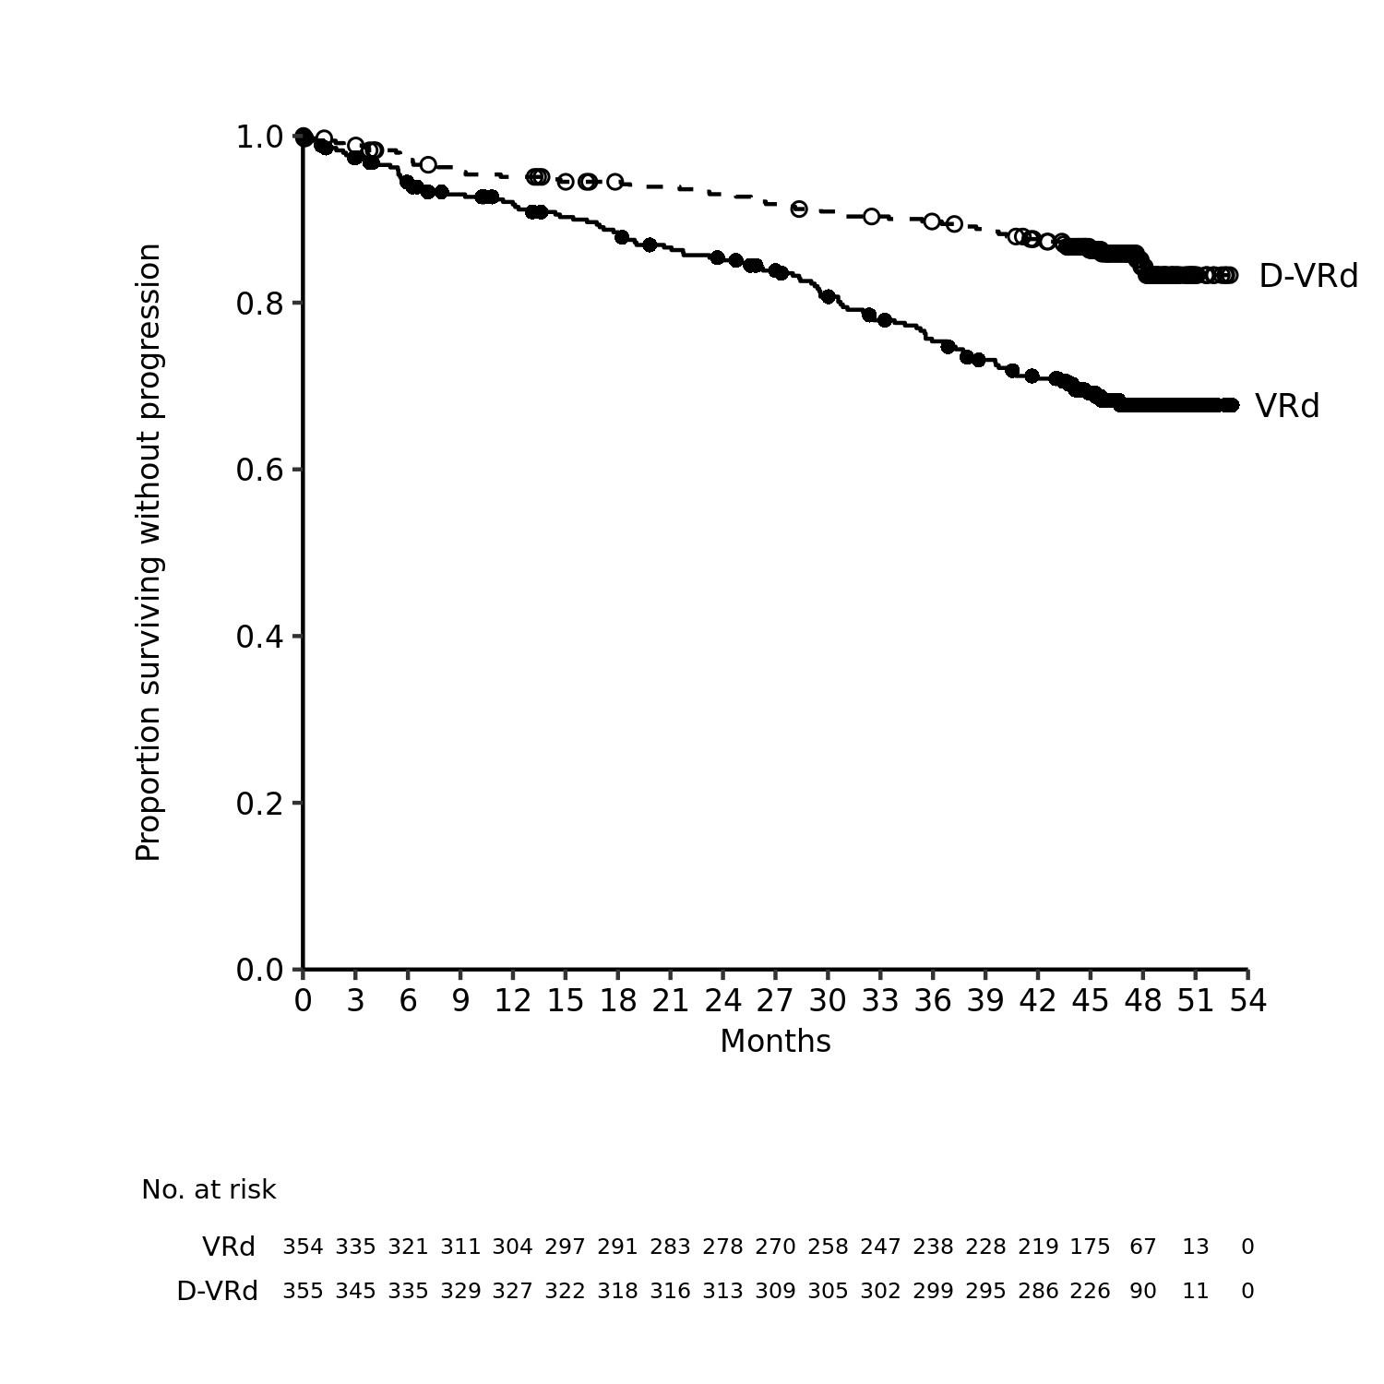
Additional efficacy results from study MMY3014 are presented in table 10 below.

Table 10: Efficacy results from study MMY3014ª
 | D-VRd (n=355) | VRd (n=354) | Odds ratio (95% CI)^{d}
Overall response (sCR+CR+VGPR+PR) n(%)ª | 343 (96.6%) | 332 (93.8%)
Stringent complete response (sCR) | 246 (69.3%) | 158 (44.6%)
Complete response (CR) | 66 (18.6%) | 90 (25.4%)
Very good partial response (VGPR) | 26 (7.3%) | 68 (19.2%)
Partial response (PR) | 5 (1.4%) | 16 (4.5%)
CR or better (sCR+CR) | 312 (87.9%) | 248 (70.1%) | 3.13 (2.11, 4.65)
95% CI (%) | (84.0%, 91.1%) | (65.0%, 74.8%)
P-value^{b} |  |  | < 0.0001
Overall MRD negativity rate^{a,c} | 267 (75.2%) | 168 (47.5%) | 3.40 (2.47, 4.69)
95% CI (%) | (70.4%, 79.6%) | (42.2%, 52.8%)
P-value^{b} |  |  | < 0.0001
D-VRd=daratumumab-bortezomib-lenalidomide-dexamethasone; VRd=bortezomib-lenalidomide-dexamethasone; MRD=minimal residual disease; CI=confidence interval
ª Based on intent-to-treat population
^{b} p-value from Cochran Mantel-Haenszel Chi-Squared test
^{c} Patients achieved both MRD negativity (threshold of 10⁻⁵) and CR or better
^{d} Mantel-Haenszel estimate of the common odds ratio for stratified tables is used

Combination treatment with bortezomib, lenalidomide and dexamethasone (VRd) in patients with newly diagnosed multiple myeloma for whom ASCT is not planned as initial therapy or who are ineligible for ASCT
Study MMY3019 was an open-label, randomised, active-controlled phase III study that compared treatment with DARZALEX subcutaneous formulation (1800 mg) in combination with bortezomib, lenalidomide and dexamethasone (D-VRd) to treatment with bortezomib, lenalidomide and dexamethasone (VRd) in patients with newly diagnosed multiple myeloma for whom ASCT was not planned as initial therapy or who were not eligible for ASCT. An emergency short course of corticosteroid (equivalent of dexamethasone 40 mg/day for a maximum 4 days) was permitted before treatment. Patients received DARZALEX subcutaneous formulation (1800 mg) administered subcutaneously once weekly (days 1, 8, and 15) for cycles 1 to 2 followed by once every three weeks for cycles 3 to 8, and once every four weeks in cycle 9 and beyond until documented disease progression or unacceptable toxicity. Bortezomib was administered by subcutaneous injection at a dose of 1.3 mg/m² body surface area twice weekly (days 1, 4, 8, and 11) of repeated 21-day (3-week) cycles 1-8. Lenalidomide was administered orally at 25 mg daily on days 1 to 14 during cycles 1-8 and on days 1-21 during cycle 9 and beyond. Dexamethasone was administered orally at 20 mg on days 1, 2, 4, 5, 8, 9, 11, and 12 of each 21-day (3-week ) cycles 1-8 and days 1, 8, 15, and 22 of each 28-day (4-week) during cycle 9 and beyond. On the days of DARZALEX subcutaneous formulation (1800 mg) injection, the dexamethasone dose was administered orally or intravenously as a pre-injection medication. Dose adjustments for bortezomib, lenalidomide and dexamethasone were applied according to manufacturer’s prescribing information.

A total of 395 patients were randomised: 197 to the D-VRd arm and 198 to the VRd arm. The baseline demographic and disease characteristics were similar between the two treatment groups. The median age was 70 (range: 31 to 80 years). Fifty percent were male, 39% had an ECOG performance score of 0, 51% had an ECOG performance score of 1 and 9% had an ECOG performance score of 2. Eighteen percent were less than 70 years of age and transplant ineligible and 27% were less than 70 years of age and were transplant deferred. Additionally, 34% had ISS stage I, 38% had ISS stage II, 28% had ISS stage III disease, 75% had a standard cytogenetic risk, 13% had a high cytogenetic risk (del17p, t[4;14], t[14;16]), and 11% had an indeterminate cytogenetic risk.

With a median follow-up of 22.3 months, the primary analysis of MRD in study MMY3019 demonstrated an improvement in overall MRD negativity rate (by NGS at or below 10⁻⁵) for patients reaching CR or better in the D-VRd arm as compared to the VRd arm. Overall MRD negativity rates were 53.3% (95% CI: 46.1, 60.4) in the D-VRd arm and 35.4% (95% CI: 28.7, 42.4) in the VRd arm (odds ratio [D-VRd versus VRd] 2.07 with 95% CI: 1.38, 3.10; p=0.0004).

At the time of primary MRD analysis, an improvement in overall CR or better rate was observed in the D-VRd arm as compared to the VRd arm. Overall CR or better rates were 76.6% (95% CI: 70.1, 82.4) in the D-VRd arm and 59.1% (95% CI: 51.9, 66.0) in the VRd arm (odds ratio [D-VRd versus VRd] 2.31; 95% CI: 1.48, 3.60; p=0.0002).

With a median follow-up of 39 months, an interim analysis of PFS in Study MMY3019 demonstrated an improvement in PFS in the D-VRd arm as compared to the VRd arm (HR=0.61; 95% CI: 0.42, 0.90; p=0.0104). The median PFS had not been reached in either arm. With more mature PFS data at the final PFS analysis, treatment effect for PFS was improved with a hazard ratio of 0.57 (95% CI: 0.41, 0.79). The median PFS had not been reached in the D-VRd arm and was 52.6 months in the VRd arm.

Figure 2: Kaplan-Meier curve of PFS at final analysis in study MMY3019

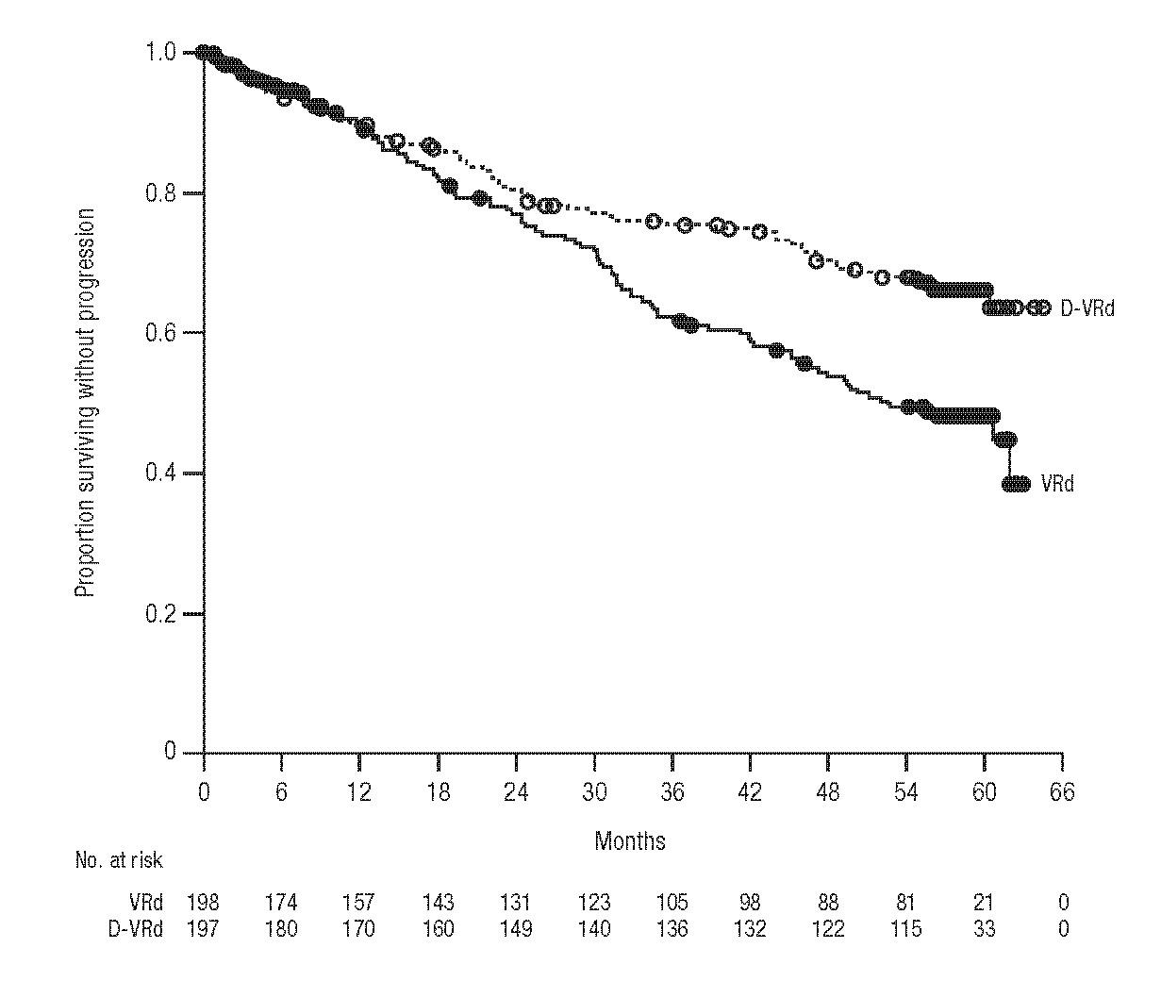

At the time of interim PFS analysis, an improvement in 1-year sustained MRD negativity rate (by NGS at or below 10⁻⁵) for patients reaching CR or better was observed in the D-VRd arm as compared to the VRd arm. Sustained MRD negativity rates were 42.6% (95% CI: 35.6, 49.9) in the D-VRd arm and 25.3% (95% CI: 19.4, 31.9) in the VRd arm (odds ratio [D-VRd versus VRd] 2.18 with 95% CI: 1.42, 3.34; p=0.0003).

Additional efficacy results from Study MMY3019 are presented in table 11 below.

Table 11: Efficacy results from the final PFS analysis of study MMY3019ª
 | D-VRd (n=197) | VRd (n=198)
Overall MRD negativity rate^{b} | 120 (60.9%) | 78 (39.4%)
Odds ratio (95% CI)^{c} | 2.37 (1.58, 3.55)
Sustained MRD negativity rate^{d} | 96 (48.7%) | 52 (26.3%)
Odds ratio (95% CI)^{c} | 2.63 (1.73, 4.00)
Overall CR or better (sCR+CR) | 160 (81.2%) | 122 (61.6%)
Odds ratio (95% CI)^{c} | 2.73 (1.71, 4.34)
Overall response (sCR+CR+VGPR+PR) n (%)ª | 191 (97.0%) | 184 (92.9%)
Stringent complete response (sCR) | 128 (65.0%) | 88 (44.4%)
Complete response (CR) | 32 (16.2%) | 34 (17.2%)
Very good partial response (VGPR) | 23 (11.7%) | 50 (25.3%)
Partial response (PR) | 8 (4.1%) | 12 (6.1%)
D-VRd=daratumumab-bortezomib-lenalidomide-dexamethasone; VRd=bortezomib-lenalidomide-dexamethasone; MRD=minimal residual disease; CI=confidence interval
ª Based on intent-to-treat population, median follow-up of 59 months
^{b} Patients achieved both MRD negativity (threshold of at or below 10⁻⁵) and CR or better
^{c} Mantel-Haenszel estimate of the common ratio for stratified tables is used. The stratification factors are: ISS staging (I, II, III), age/transplant eligibility (< 70 years ineligible, or age< 70 years and refusal to transplant, or age ≥ 70 years) as randomised. An odds ratio > 1 indicates an advantage for D-VRd.
^{d} Sustained MRD negativity is defined as MRD negative and confirmed by at least 1 year apart without MRD positive in between.

Combination therapies in multiple myeloma
MMY2040 was an open-label study evaluating the efficacy and safety of DARZALEX subcutaneous formulation 1800 mg:
- in combination with bortezomib, melphalan, and prednisone (D-VMP) in patients with newly diagnosed multiple myeloma (MM) who are ineligible for transplant. Bortezomib was administered by subcutaneous injection at a dose of 1.3 mg/m² body surface area twice weekly at weeks 1, 2, 4 and 5 for the first 6-week cycle (cycle 1; 8 doses), followed by once weekly administrations at weeks 1, 2, 4 and 5 for eight more 6-week cycles (cycles 2-9; 4 doses per cycle). Melphalan at 9 mg/m², and prednisone at 60 mg/m² were orally administered on days 1 to 4 of the nine 6-week cycles (cycles 1-9). DARZALEX subcutaneous formulation was continued until disease progression or unacceptable toxicity.
- in combination with lenalidomide and dexamethasone (D-Rd) in patients with relapsed or refractory MM. Lenalidomide (25 mg once daily orally on days 1-21 of repeated 28-day [4-week] cycles) was given with low dose dexamethasone 40 mg/week (or a reduced dose of 20 mg/week for patients > 75 years or BMI< 18.5). DARZALEX subcutaneous formulation was continued until disease progression or unacceptable toxicity.
- in combination with bortezomib, lenalidomide, and dexamethasone (D-VRd) in patients with newly diagnosed MM who are transplant eligible. Bortezomib was administered by subcutaneous injection at a dose of 1.3 mg/m² body surface area twice weekly at weeks 1 and 2. Lenalidomide was administered orally at 25 mg once daily on days 1-14; low dose dexamethasone was administered 40 mg/week in 3-week cycles. Total treatment duration was 4 cycles.

A total of 199 patients (D-VMP: 67; D-Rd: 65; D-VRd: 67) were enroled. Efficacy results were determined by computer algorithm using IMWG criteria. The study met its primary endpoint ORR for D-VMP and D-Rd and the primary endpoint VGPR or better for D-VRd (see table 12).

Table 12: Efficacy results from study MMY2040
 | D-VMP (n=67) | D-Rd (n=65) | D-VRd (n=67)
Overall response (sCR+CR+VGPR+PR), n (%)ª | 60 (89.6%) | 61 (93.8%) | 65 (97.0%)
90% CI(%) | (81.3%, 95.0%) | (86.5%, 97.9%) | (90.9%, 99.5%)
Stringent complete response (sCR) | 13 (19.4%) | 12 (18.5%) | 6 (9.0%)
Complete response (CR) | 19 (28.4%) | 13 (20.0%) | 5 (7.5%)
Very good partial response (VGPR) | 20 (29.9%) | 26 (40.0%) | 37 (55.2%)
Partial response (PR) | 8 (11.9%) | 10 (15.4%) | 17 (25.4%)
VGPR or better (sCR + CR + VGPR) | 52 (77.6%) | 51 (78.5%) | 48 (71.6%)
90% CI(%) | (67.6%, 85.7%) | (68.4%, 86.5%) | (61.2%, 80.6%)

D-VMP = Daratumumab-bortezomib-melphalan-prednisone; D-Rd = Daratumumab-lenalidomide-dexamethasone; D-VRd = Daratumumab-bortezomib-lenalidomide-dexamethasone; Daratumumab = DARZALEX subcutaneous formulation; CI=confidence interval.
ª Based on treated subjects

Combination treatment with pomalidomide and dexamethasone (Pd)
Study MMY3013 was an open-label, randomised, active-controlled phase III study that compared treatment with DARZALEX subcutaneous formulation (1800 mg) in combination with pomalidomide and low-dose dexamethasone (D-Pd) to treatment with pomalidomide and low-dose dexamethasone (Pd) in patients with multiple myeloma who had received at least one prior line of therapy with lenalidomide and a proteasome inhibitor (PI). Pomalidomide (4 mg once daily orally on days 1-21 of repeated 28-day [4-week] cycles) was given with low dose oral or intravenous dexamethasone 40 mg/week (or a reduced dose of 20 mg/week for patients >75 years). On DARZALEX subcutaneous formulation administration days, 20 mg of the dexamethasone dose was given as a pre-administration medicinal product and the remainder given the day after the administration. For patients on a reduced dexamethasone dose, the entire 20 mg dose was given as a DARZALEX subcutaneous formulation pre-administration medicinal product. Dose adjustments for pomalidomide and dexamethasone were applied according to manufacturer’s prescribing information. Treatment was continued in both arms until disease progression or unacceptable toxicity.

A total of 304 patients were randomised: 151 to the D-Pd arm and 153 to the Pd arm. Patients with documented evidence of disease progression on or after the last regimen were included in the study. Patients who had ≥ grade 3 rash during prior therapy were excluded as per the pomalidomide prescribing information (PI). The baseline demographic and disease characteristics were similar between the two treatment groups. The median patient age was 67 years (range 35 to 90 years), 18% were ≥ 75 years, 53% were male, and 89% Caucasian. Patients had received a median of 2 prior lines of therapy, 75% of patients having received 2–3 prior lines of therapy. All patients received a prior treatment with a proteasome inhibitor (PI) and lenalidomide, and 56% of patients received prior stem cell transplantation (ASCT). Ninety-six percent (96%) of patients received prior treatment with bortezomib. The majority of patients were refractory to lenalidomide (80%), a PI (48%), or both an immunomodulator and a PI (42%). Eleven percent of patients received 1 prior line of therapy; all were refractory to lenalidomide and 32.4% were refractory to both lenalidomide and a PI. Efficacy was evaluated by progression free survival (PFS) based on International Myeloma Working Group (IMWG) criteria.

With a median follow-up of 16.9 months, the primary analysis of PFS in study MMY3013 showed a statistically significant improvement in the D-Pd arm as compared to the Pd arm; the median PFS was 12.4 months in the D-Pd arm and 6.9 months in the Pd arm (HR [95% CI]: 0.63 [0.47, 0.85]; p-value = 0.0018), representing a 37% reduction in the risk of disease progression or death for patients treated with D-Pd versus Pd.

Figure 3: Kaplan-Meier curve of PFS in study MMY3013

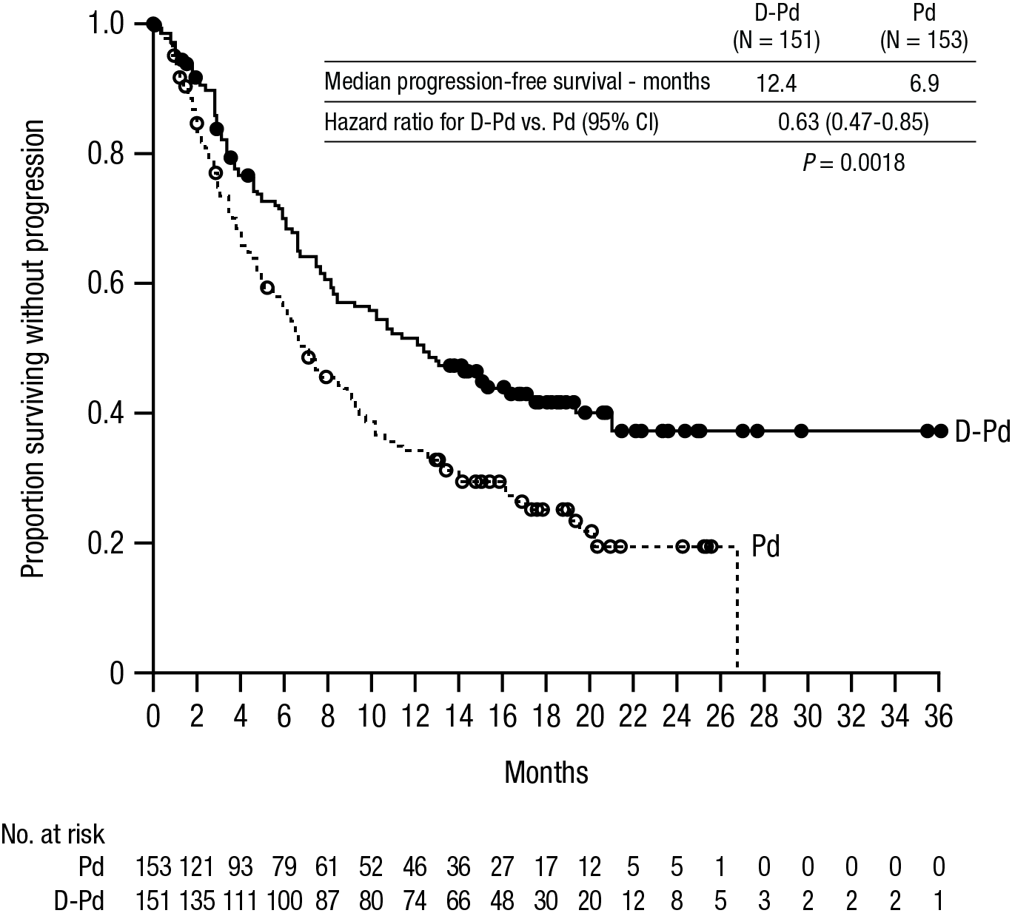

An additional planned follow-up analysis of OS after a median follow-up of 39.6 months was performed. At OS maturity of 57%, the median OS was 34.4 months in the D-Pd arm and 23.7 months in the Pd arm (HR [95% CI]: 0.82 [0.61, 1.11]).

Additional efficacy results from study MMY3013 are presented in table 13 below.

Table 13: Efficacy results from study MMY3013ª
 | D-Pd (n=151) | Pd (n=153)
Overall response (sCR+CR+VGPR+PR) n(%)ª | 104 (68.9%) | 71 (46.4%)
P-value^{b} | <0.0001
Stringent complete response (sCR) | 14 (9.3%) | 2 (1.3%)
Complete response (CR) | 23 (15.2%) | 4 (2.6%)
Very good partial response (VGPR) | 40 (26.5%) | 24 (15.7%)
Partial response (PR) | 27 (17.9%) | 41 (26.8%)
MRD negativity rate^{c} n(%) | 13 (8.7%) | 3 (2.0%)
95% CI (%) | (4.7%, 14.3%) | (0.4%, 5.6%)
P-value^{d} | 0.0102
D-Pd=daratumumab-pomalidomide-dexamethasone; Pd=pomalidomide-dexamethasone; MRD=minimal residual disease; CI=confidence interval
ª Based on intent-to-treat population
^{b} p-value from Cochran Mantel-Haenszel Chi-Squared test adjusted for stratification factors
^{c} MRD Negative rate is based on the intent-to-treat population and a threshold of 10⁻⁵
^{d} p-value from Fisher’s exact test.

In responders, the median time to response was 1 month (range: 0.9 to 9.1 months) in the D-Pd group and 1.9 months (range: 0.9 to 17.3 months) in the Pd group. The median duration of response had not been reached in the D-Pd group (range: 1 to 34.9+ months) and was 15.9 months (range: 1+ to 24.8 months) in the Pd group.

Combination treatment with bortezomib, cyclophosphamide and dexamethasone in patients with AL amyloidosis
Study AMY3001, an open-label, randomised, active-controlled phase III study, compared treatment with DARZALEX subcutaneous formulation (1800 mg) in combination with bortezomib, cyclophosphamide and dexamethasone (D-VCd) to treatment with bortezomib, cyclophosphamide and dexamethasone (VCd) alone in patients with newly diagnosed systemic AL amyloidosis. Randomisation was stratified by AL amyloidosis Cardiac Staging System, countries that typically offer autologous stem cell transplant (ASCT) for patients with AL amyloidosis, and renal function.

All patients enroled in study AMY3001 had newly diagnosed AL amyloidosis with at least one affected organ, measurable haematologic disease, cardiac stage I-IIIA (based on European Modification of Mayo 2004 cardiac stage), and NYHA class I-IIIA. Patients with NYHA class IIIB and IV were excluded.

Bortezomib (SC; 1.3 mg/m² body surface area), cyclophosphamide (oral or IV; 300 mg/m² body surface area; max dose 500 mg), and dexamethasone (oral or IV; 40 mg or a reduced dose of 20 mg for patients >70 years or body mass index [BMI] < 18.5 or those who have hypervolaemia, poorly controlled diabetes mellitus or prior intolerance to steroid therapy) were administered weekly on days 1, 8, 15, and 22 of repeated 28-day [4-week] cycles. On the days of DARZALEX dosing, 20 mg of the dexamethasone dose was given as a pre-injection medicinal product and the remainder given the day after DARZALEX administration. Bortezomib, cyclophosphamide and dexamethasone were given for six 28-day [4-week] cycles in both treatment arms, while DARZALEX treatment was continued until disease progression, start of subsequent therapy, or a maximum of 24 cycles (~2 years) from the first dose of study treatment. Dose adjustments for bortezomib, cyclophosphamide and dexamethasone were applied according to manufacturer’s prescribing information.

A total of 388 patients were randomised: 195 to the D-VCd arm and 193 to the VCd arm. The baseline demographic and disease characteristics were similar between the two treatment groups. The majority (79%) of patients had lambda free light chain disease. The median patient age was 64 years (range: 34 to 87); 47% were ≥ 65 years; 58% were male; 76% Caucasian, 17% Asian, and 3% African American; 23% had AL amyloidosis Clinical Cardiac stage I, 40% had stage II, 35% had stage IIIA, and 2% had stage IIIB. All patients had one or more affected organs and the median number of organs involved was 2 (range: 1-6) and 66% of patients had 2 or more organs involved. Vital organ involvement was: 71% cardiac, 59% renal and 8% hepatic. Patients with grade 2 sensory or grade 1 painful peripheral neuropathy were excluded. The primary efficacy endpoint was haematologic complete response (HemCR) rate as determined by the Independent Review Committee assessment based on International Concensus Criteria. Study AMY3001 demonstrated an improvement in HemCR in the D-VCd arm as compared to the VCd arm. Efficacy results are summarised in table 14.

Table 14: Efficacy results from study AMY3001ª
 | D-VCd  (n=195) | VCd  (n=193) | P value
Haematologic complete response (HemCR), n (%) | 104 (53.3%) | 35 (18.1%) | <0.0001^{b}
Very good partial response (VGPR), n (%) | 49 (25.1%) | 60 (31.1%)
Partial response (PR), n (%) | 26 (13.3%) | 53 (27.5%)
Haematologic VGPR or better (HemCR + VGPR), n (%) | 153 (78.5%) | 95 (49.2%) | <0.0001^{b}
Major organ deterioration progression-free survival (MOD-PFS), Hazard ratio with 95% CI^{c} | 0.58 (0.36, 0.93) |  | 0.0211^{d}

D-VCd=daratumumab-bortezomib-cyclophosphamide-dexamethasone; VCd=bortezomib-cyclophosphamide-dexamethasone; CI=confidence interval.

ª All results from the planned analysis after a median follow-up of 11.4 months based on intent-to-treat population

^{b} p-value from Cochran Mantel-Haenszel Chi-Squared test.

^{c} MOD-PFS defined as haematologic progression, major organ (cardiac or renal) deterioration or death

^{d} Nominal p-value from inverse probability censoring weighted log-rank test

With a median follow-up of 11.4 months, in responders, the median time to HemCR was 60 days (range: 8 to 299 days) in the D-VCd group and 85 days (range: 14 to 340 days) in the VCd group. The median time to VGPR or better was 17 days (range: 5 to 336 days) in the D-VCd group and 25 days (range: 8 to 171 days) in the VCd group. The median duration of HemCR had not been reached in either arm.

After a median follow-up of 61.4 months, the overall HemCR rates were 59.5% (95% CI: 52.2, 66.4) in the D-VCd group and 19.2% (95% CI: 13.9, 25.4) in the VCd group (odds ratio [D-VCd versus VCd] 6.03 with 95% CI: 3.80, 9.58).

Results of a MOD-PFS analysis after a median follow-up of 61.4 months showed an improvement in MOD-PFS for patients in the D-VCd group compared with the VCd group. The hazard ratio (HR) for MOD-PFS was 0.44 (95% CI: 0.31, 0.63) and the p-value was <0.0001. The median MOD-PFS was not reached in the D-VCd arm and was 30.2 months in the VCd arm. The Kaplan-Meier estimated 60-month MOD-PFS rate was 60% (95% CI: 52, 67) in the D-VCd arm and was 33% (95% CI: 23, 44) in the VCd arm.

Figure 4: Kaplan-Meier curve of MOD-PFS in study AMY3001
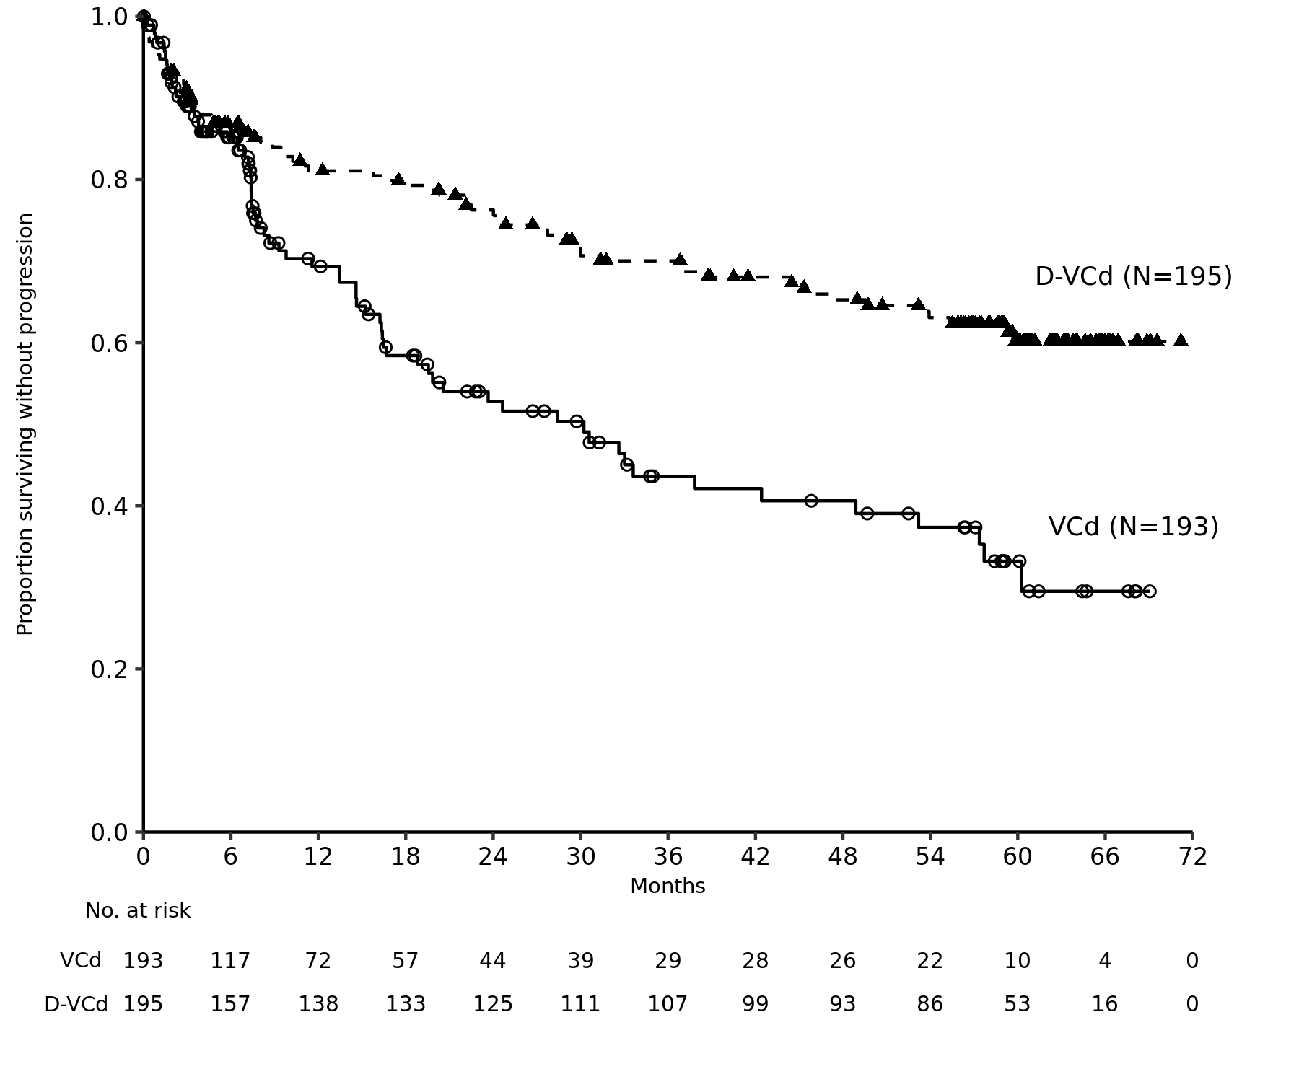

After a median follow-up of 61.4 months, a total of 112 deaths were observed [n=46 (23.6%) D-VCd vs. n=66 (34.2%) VCd group]. The median OS was not reached for either arm; however, the HR for OS was 0.62 (95% CI: 0.42, 0.90) and the p-value was 0.0121. The 60-month OS rate was 76% (95% CI: 69, 82) in the D-VCd arm and was 65% (95% CI: 57, 71) in the VCd arm.

Figure 5: Kaplan-Meier curve of OS in study AMY3001

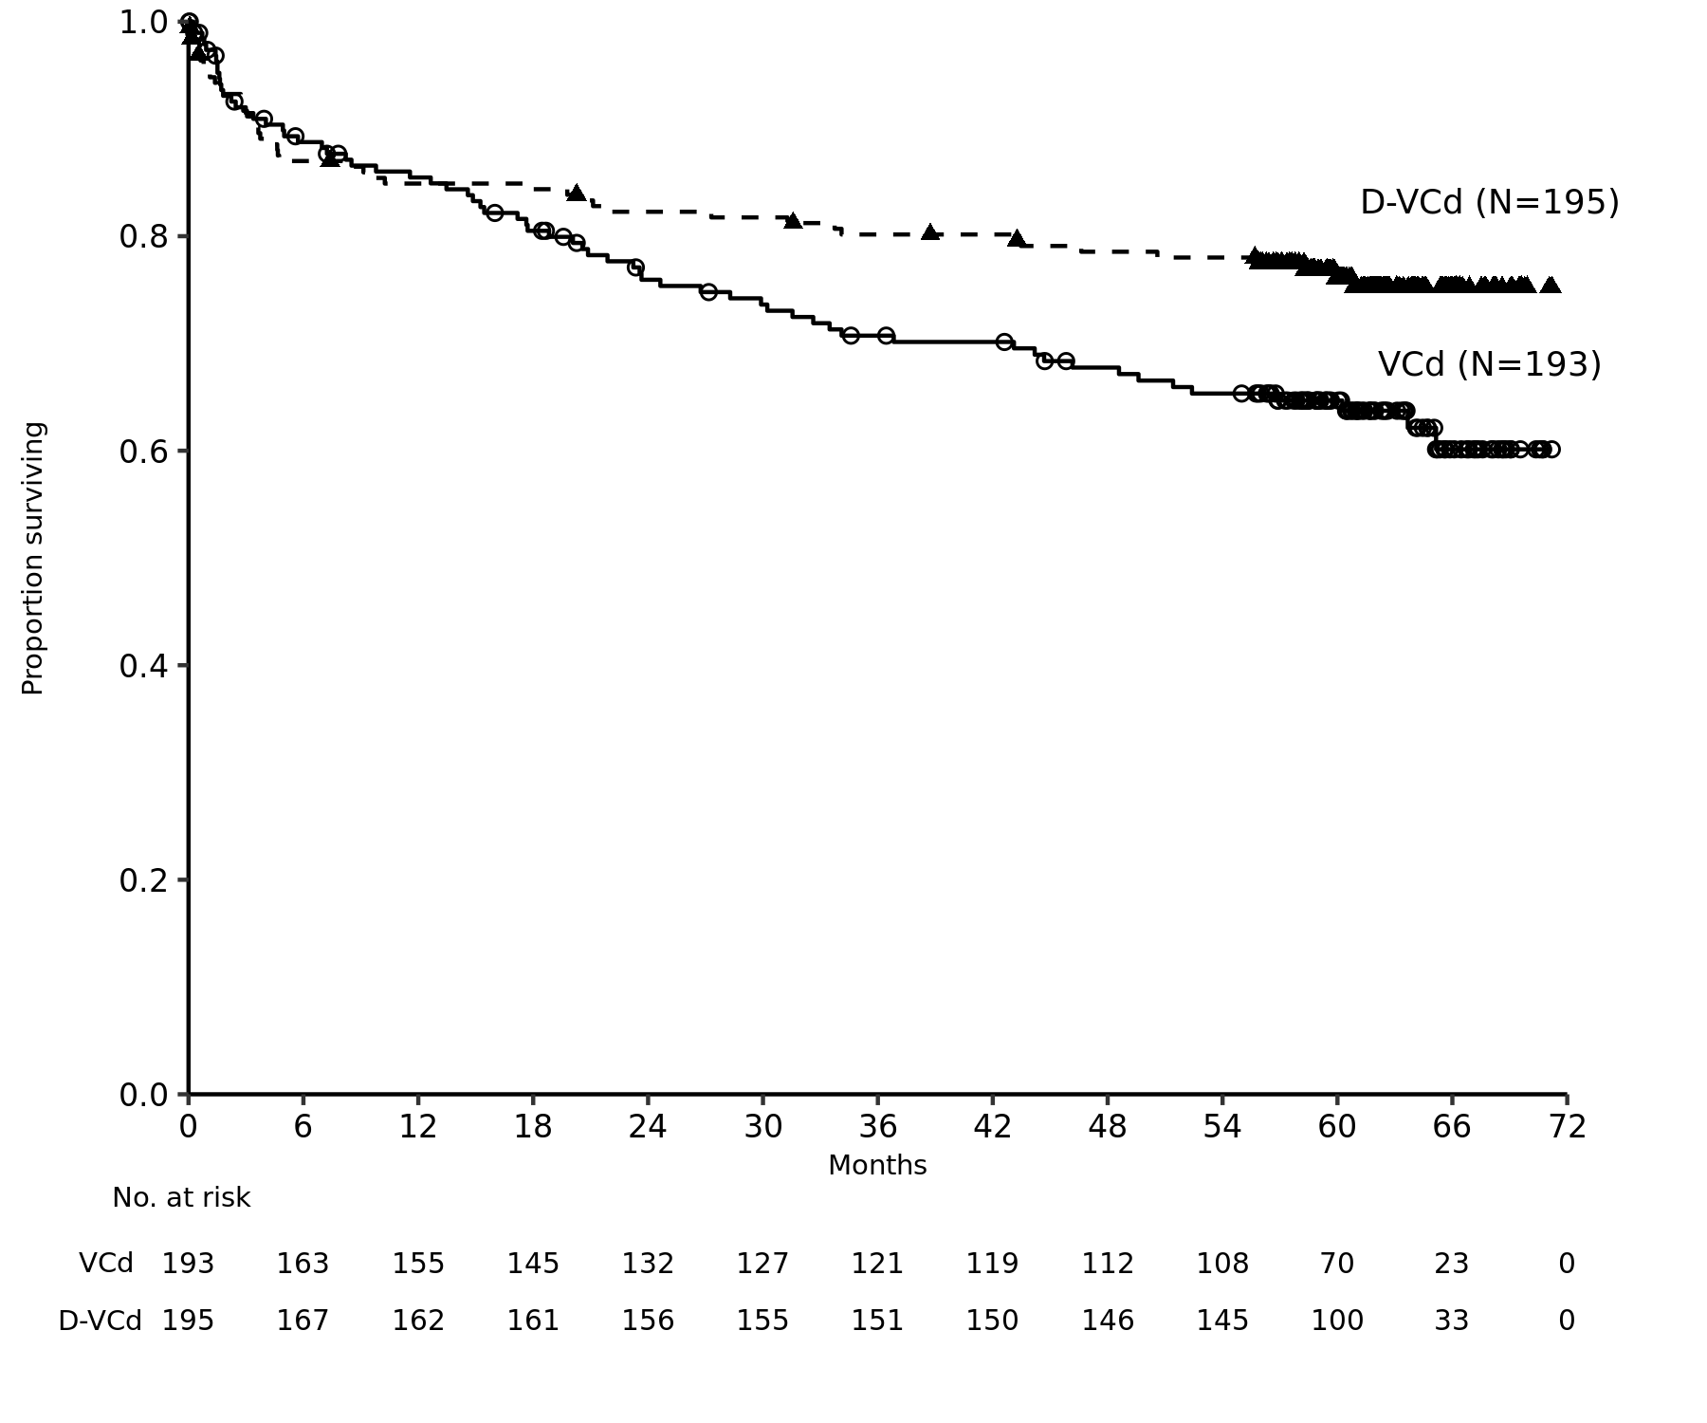

Clinical experience with daratumumab concentrate for solution for infusion (intravenous formulation)

Newly diagnosed multiple myeloma
Combination treatment with lenalidomide and dexamethasone in patients ineligible for autologous stem cell transplant:
Study MMY3008, an open-label, randomised, active-controlled phase III study, compared treatment with intravenous daratumumab 16 mg/kg in combination with lenalidomide and low-dose dexamethasone (DRd) to treatment with lenalidomide and low-dose dexamethasone (Rd) in patients with newly diagnosed multiple myeloma. Lenalidomide (25 mg once daily orally on days 1-21 of repeated 28-day [4-week] cycles) was given with low dose oral or intravenous dexamethasone 40 mg/week (or a reduced dose of 20 mg/week for patients >75 years or body mass index [BMI] <18.5). On intravenous daratumumab infusion days, the dexamethasone dose was given as a pre-infusion medicinal product. Dose adjustments for lenalidomide and dexamethasone were applied according to manufacturer’s prescribing information. Treatment was continued in both arms until disease progression or unacceptable toxicity.

A total of 737 patients were randomised: 368 to the DRd arm and 369 to the Rd arm. The baseline demographic and disease characteristics were similar between the two treatment groups. The median age was 73 (range: 45-90) years, with 44% of the patients ≥75 years of age. The majority were white (92%), male (52%), 34% had an Eastern Cooperative Oncology Group (ECOG) performance score of 0, 49.5% had an ECOG performance score of 1 and 17% had an ECOG performance score of ≥2. Twenty-seven percent had International Staging System (ISS) stage I, 43% had ISS stage II and 29% had ISS stage III disease. Efficacy was evaluated by progression free survival (PFS) based on International Myeloma Working Group (IMWG) criteria and overall survival (OS).

With a median follow-up of 28 months, the primary analysis of PFS in study MMY3008 showed an improvement in the DRd arm as compared to the Rd arm; the median PFS had not been reached in the DRd arm and was 31.9 months in the Rd arm (HR=0.56; 95% CI: 0.43, 0.73; p < 0.0001), representing 44% reduction in the risk of disease progression or death in patients treated with DRd. Results of an updated PFS analysis after a median follow-up of 64 months continued to show an improvement in PFS for patients in the DRd arm compared with the Rd arm. Median PFS was 61.9 months in the DRd arm and 34.4 months in the Rd arm (HR=0.55; 95% CI: 0.45, 0.67).

Figure 6: Kaplan-Meier curve of PFS in study MMY3008

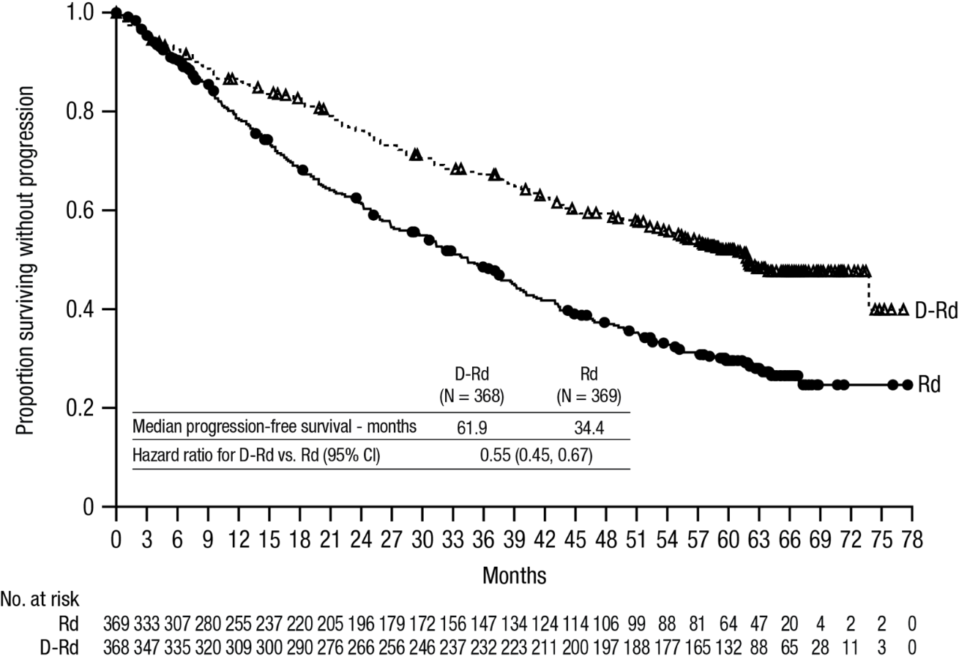

With a median follow-up of 56 months, DRd has shown an OS advantage over the Rd arm (HR=0.68; 95% CI: 0.53, 0.86; p=0.0013). Results of an updated OS analysis after a median of 89 months continued to show an improvement in OS for patients in the DRd arm compared to the Rd arm. Median OS was 90.3 months in the DRd arm and was 64.1 months in the Rd arm (HR= 0.67; 95% CI: 0.55, 0.82).

Figure 7 Kaplan-Meier curve of OS in study MMY3008

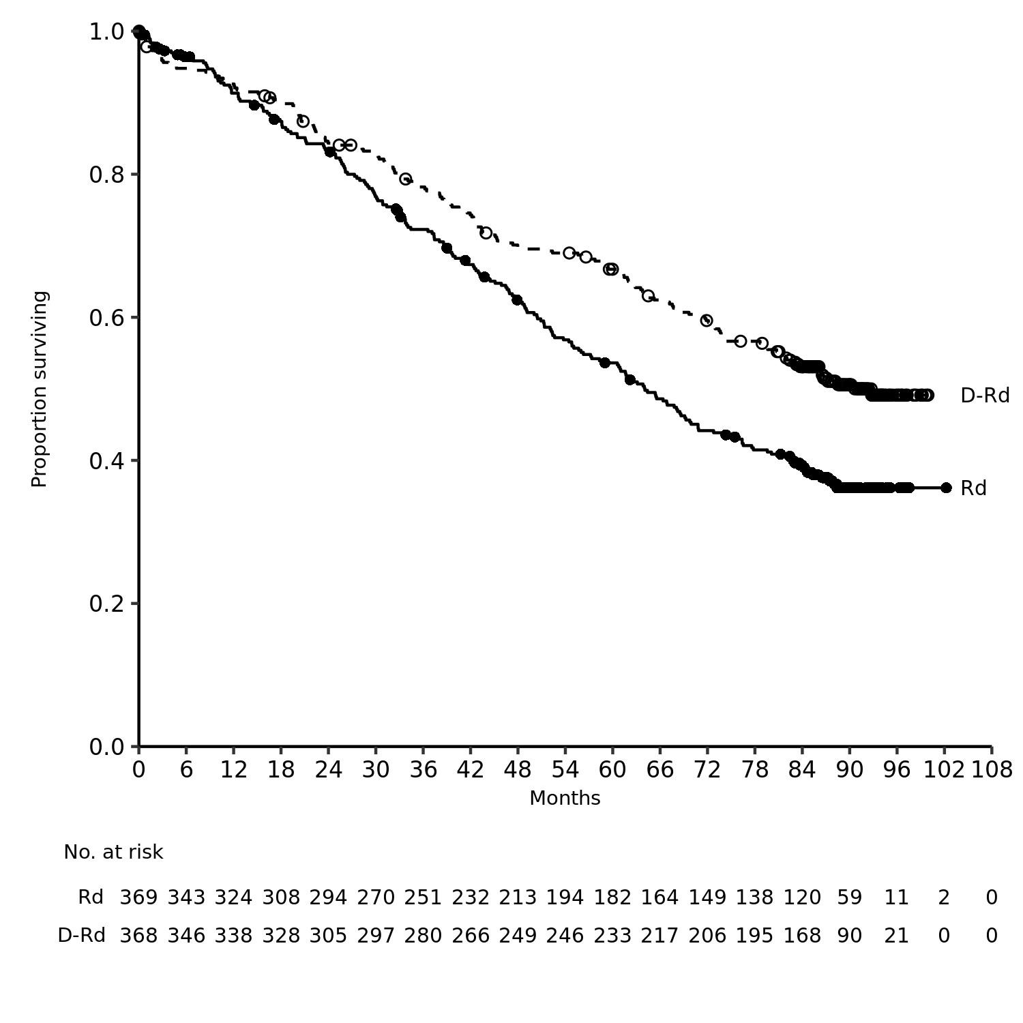

Additional efficacy results from study MMY3008 are presented in table 15 below.

Table 15: Additional efficacy results from study MMY3008ª
 | DRd (n=368) | Rd (n=369)
Overall response (sCR+CR+VGPR+PR) n(%)ª | 342 (92.9%) | 300 (81.3%)
p-value^{b} | <0.0001
Stringent complete response (sCR) | 112 (30.4%) | 46 (12.5%)
Complete response (CR) | 63 (17.1%) | 46 (12.5%)
Very good partial response (VGPR) | 117 (31.8%) | 104 (28.2%)
Partial response (PR) | 50 (13.6%) | 104 (28.2%)
CR or better (sCR + CR) | 175 (47.6%) | 92 (24.9%)
p-value^{b} | <0.0001
VGPR or better (sCR + CR + VGPR) | 292 (79.3%) | 196 (53.1%)
p-value^{b} | <0.0001
MRD negativity rate^{a,c} n(%) | 89 (24.2%) | 27 (7.3%)
95% CI (%) | (19.9%, 28.9%) | (4.9%, 10.5%)
Odds ratio with 95% CI^{d} | 4.04 (2.55, 6.39)
p-value^{e} | <0.0001

DRd=daratumumab-lenalidomide-dexamethasone; Rd=lenalidomide-dexamethasone; MRD=minimal residual disease; CI=confidence interval

ª Based on intent-to-treat population

^{b} p-value from Cochran Mantel-Haenszel Chi-Squared test.

^{c} Based on threshold of 10⁻⁵

^{d} Mantel-Haenszel estimate of the odds ratio for un-stratified tables is used. An odds ratio >1 indicates an advantage for DRd.

^{e} p-value from Fisherʼs exact test.

In responders, the median time to response was 1.05 months (range: 0.2 to 12.1 months) in the DRd group and 1.05 months (range: 0.3 to 15.3 months) in the Rd group. The median duration of response had not been reached in the DRd group and was 34.7 months (95% CI: 30.8, not estimable) in the Rd group.

Combination treatment with bortezomib, melphalan and prednisone (VMP) in patients ineligible for autologous stem cell transplant:
Study MMY3007, an open-label, randomised, active-controlled phase III study, compared treatment with intravenous daratumumab 16 mg/kg in combination with bortezomib, melphalan and prednisone (D-VMP), to treatment with VMP in patients with newly diagnosed multiple myeloma. Bortezomib was administered by subcutaneous injection at a dose of 1.3 mg/m² body surface area twice weekly at weeks 1, 2, 4 and 5 for the first 6-week cycle (cycle 1; 8 doses), followed by once weekly administrations at weeks 1, 2, 4 and 5 for eight more 6-week cycles (cycles 2-9; 4 doses per cycle). Melphalan at 9 mg/m², and prednisone at 60 mg/m² were orally administered on days 1 to 4 of the nine 6-week cycles (cycles 1-9). Intravenous daratumumab treatment was continued until disease progression or unacceptable toxicity.

A total of 706 patients were randomised: 350 to the D-VMP arm and 356 to the VMP arm. The baseline demographic and disease characteristics were similar between the two treatment groups. The median age was 71 (range: 40-93) years, with 30% of the patients ≥75 years of age. The majority were white (85%), female (54%), 25% had an ECOG performance score of 0, 50% had an ECOG performance score of 1 and 25% had an ECOG performance score of 2. Patients had IgG/IgA/Light chain myeloma in 64%/22%/10% of instances, 19% had ISS stage I, 42% had ISS stage II, 38% had ISS stage III disease and 84% had standard risk cytogenetics. Efficacy was evaluated by PFS based on IMWG criteria and overall survival (OS).

With a median follow-up of 16.5 months, the primary analysis of PFS in study MMY3007 showed an improvement in the D-VMP arm as compared to the VMP arm; the median PFS had not been reached in the D-VMP arm and was 18.1 months in the VMP arm (HR=0.5; 95% CI: 0.38, 0.65; p< 0.0001). Results of an updated PFS analysis after a median follow-up of 40 months continued to show an improvement in PFS for patients in the D-VMP arm compared with the VMP arm. Median PFS was 36.4 months in the D-VMP arm and 19.3 months in the VMP arm (HR=0.42; 95% CI:0.34, 0.51; p< 0.0001), representing a 58% reduction in the risk of disease progression or death in patients treated with D-VMP.

Figure 8: Kaplan-Meier curve of PFS in study MMY3007

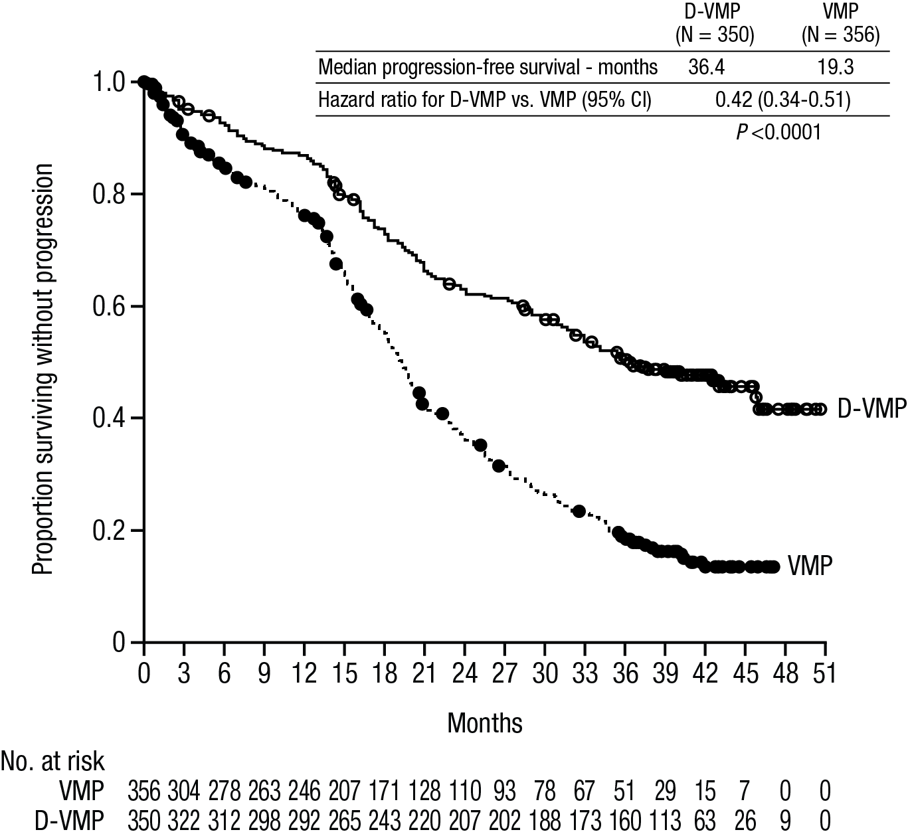

After a median follow-up of 40 months, D-VMP has shown an OS advantage over the VMP arm (HR=0.60; 95% CI: 0.46, 0.80; p=0.0003), representing a 40% reduction in the risk of death in patients treated in the D-VMP arm. After a median follow-up of 87 months, the median OS was 83 months (95% CI: 72.5, NE) in the D-VMP arm and 53.6 months (95% CI: 46.3, 60.9) in the VMP arm .
Figure 9: Kaplan-Meier curve of OS in study MMY3007
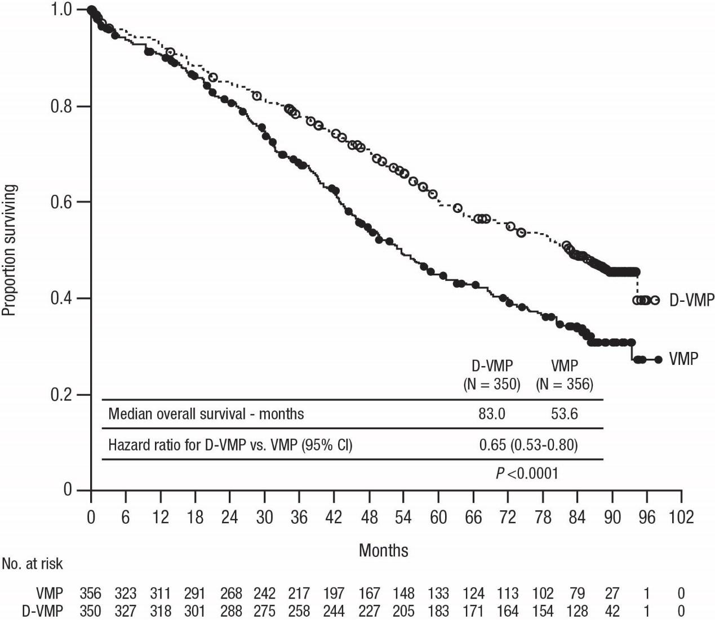

Additional efficacy results from study MMY3007 are presented in table 16 below.

Table 16: Additional efficacy results from study MMY3007ª
 | D-VMP (n=350) | VMP (n=356)
Overall response (sCR+CR+VGPR+PR) [n(%)] | 318 (90.9) | 263 (73.9)
p-value^{b} | <0.0001
Stringent complete response (sCR) [n(%)] | 63 (18.0) | 25 (7.0)
Complete response (CR) [n(%)] | 86 (24.6) | 62 (17.4)
Very good partial response (VGPR) [n(%)] | 100 (28.6) | 90 (25.3)
Partial response (PR) [n(%)] | 69 (19.7) | 86 (24.2)
MRD negativity rate (95% CI) ^{c} (%) | 22.3 (18.0, 27.0) | 6.2 (3.9, 9.2)
Odds ratio with 95% CI^{d} | 4.36 (2.64, 7.21)
p-value^{e} | <0.0001

D-VMP=daratumumab-bortezomib-melphalan-prednisone; VMP=bortezomib-melphalan-prednisone; MRD=minimal residual disease; CI=confidence interval.
ª Based on intent-to-treat population.
^{b} p-value from Cochran Mantel-Haenszel Chi-Squared test.
^{c} Based on threshold of 10⁻⁵.
^{d} A Mantel-Haenszel estimate of the common odds ratio for stratified tables is used. An odds ratio >1 indicates an advantage for D-VMP.
^{e} p-value from Fisherʼs exact test.

In responders, the median time to response was 0.79 months (range: 0.4 to 15.5 months) in the D-VMP group and 0.82 months (range: 0.7 to 12.6 months) in the VMP group. The median duration of response had not been reached in the D-VMP group and was 21.3 months (range: 18.4, not estimable) in the VMP group.

A subgroup analysis was performed on patients at least 70 years old, or those 65-69 years old with ECOG performance score of 2, or aged less than 65 years of age with significant comorbidity or ECOG performance score of 2 (D-VMP: n=273, VMP: n=270). The efficacy results in this subgroup were consistent with the overall population. In this subgroup, median PFS was not reached in the D-VMP group and was 17.9 months in the VMP group (HR=0.56; 95% CI: 0.42, 0.75; p<0.0001). The overall response rate was 90% in the D-VMP group and 74% in theVMP group (VGPR rate:29% in D-VMP group and 26% in VMP group; CR: 22% in D-VMP group and 18% in VMP group; sCR rate: 20% in D-VMP group and 7% in VMP group). The safety results of this subgroup were consistent with the overall population. Furthermore, safety analysis of the subgroup of patients with an ECOG performance score of 2 (D-VMP: n=89, VMP: n=84), was also consistent with the overall population.

Combination treatment with bortezomib, thalidomide and dexamethasone (VTd) in patients eligible for autologous stem cell transplant (ASCT)
Study MMY3006 is a 2 part, open-label, randomised, active-controlled phase III study. Part 1 compared induction and consolidation treatment with intravenous daratumumab 16 mg/kg in combination with bortezomib, thalidomide and dexamethasone (D-VTd) to treatment with bortezomib, thalidomide and dexamethasone (VTd) in patients with newly diagnosed multiple myeloma eligible for ASCT. The consolidation phase of treatment began a minimum of 30 days post-ASCT, when the patient had recovered sufficiently, and engraftment was complete. In part 2, subjects with at least a partial response (PR) by day 100 post-transplant were re-randomised in a 1:1 ratio to daratumumab maintenance or observation only. Only results from part 1 are described henceforth.

Bortezomib was administered by subcutaneous injection or intravenous injection at a dose of 1.3 mg/m² body surface area twice weekly for two weeks (days 1, 4, 8, and 11) of repeated 28 day (4-week) induction treatment cycles (cycles 1-4) and two consolidation cycles (cycles 5 and 6) following ASCT after cycle 4. Thalidomide was administered orally at 100 mg daily during the six bortezomib cycles. Dexamethasone (oral or intravenous) was administered at 40 mg on days 1, 2, 8, 9, 15, 16, 22 and 23 of cycles 1 and 2, and at 40 mg on days 1-2 and 20 mg on subsequent dosing days (days 8, 9, 15, 16) of cycles 3-4. Dexamethasone 20 mg was administered on days 1, 2, 8, 9, 15, 16 in cycles 5 and 6. On the days of intravenous daratumumab infusion, the dexamethasone dose was administered intravenously as a pre-infusion medicinal product. Dose adjustments for bortezomib, thalidomide and dexamethasone were applied according to manufacturer’s prescribing information.

A total of 1085 patients were randomised: 543 to the D-VTd arm and 542 to the VTd arm. The baseline demographic and disease characteristics were similar between the two treatment groups. The median age was 58 (range: 22 to 65) years. All patients were ≤65 years: 43% were in the age group ≥ 60-65 years, 41% were in the age group ≥ 50-60 years and 16% below age of 50 years. The majority were male (59%), 48% had an ECOG performance score of 0, 42% had an ECOG performance score of 1 and 10% had an ECOG performance score of 2. Forty percent had International Staging System (ISS) stage I, 45% had ISS stage II and 15% had ISS stage III disease.

Efficacy was evaluated by the stringent complete response (sCR) rate at day 100 post-transplant and PFS.

Table 17: Efficacy results from study MMY3006ª
 | D-VTd (n=543) | VTd (n=542) | P value^{b}

Response assessment day 100 post-transplant
Stringent complete response (sCR) | 157 (28.9%) | 110 (20.3%) | 0.0010
CR or better (sCR+CR) | 211 (38.9%) | 141 (26.0%) | <0.0001
Very good partial response or better (sCR+CR+VGPR) | 453 (83.4%) | 423 (78.0%)
MRD negativity^{c, d} n(%) | 346 (63.7%) | 236 (43.5%) | <0.0001
95% CI (%) | (59.5%, 67.8%) | (39.3%, 47.8%)
Odds ratio with 95% CIe | 2.27 (1.78, 2.90)
MRD negativity in combination with CR or better^{c} n(%) | 183 (33.7%) | 108 (19.9%) | <0.0001
95% CI (%) | (29.7%, 37.9%) | (16.6%, 23.5%)
Odds ratio with 95% CIe | 2.06 (1.56, 2.72)

D-VTd=daratumumab-bortezomib-thalidomide-dexamethasone; VTd=bortezomib-thalidomide-dexamethasone; MRD=minimal residual disease; CI=confidence interval

ª Based on intent-to-treat population

^{b} p-value from Cochran Mantel-Haenszel Chi-Squared test.

^{c} Based on threshold of 10⁻⁵

^{d} Regardless of response per IMWG

^{e} Mantel-Haenszel estimate of the common odds ratio for stratified tables is used.

With a median follow-up of 18.8 months, the primary analysis of PFS by censoring patients who were randomised to daratumumab maintenance in the second randomisation at the date of the second randomisation showed HR=0.50; 95% CI: 0.34, 0.75; p=0.0005. Results of an updated PFS analysis with a median follow-up of 44.5 months, censoring patients who were randomised to daratumumab maintenance in the second randomisation, showed HR=0.43; 95% CI: 0.33, 0.55; p< 0.0001. Median PFS was not reached in the D-VTd arm and was 37.8 months in the VTd arm.

Figure 10: Kaplan-Meier curve of PFS in study MMY3006

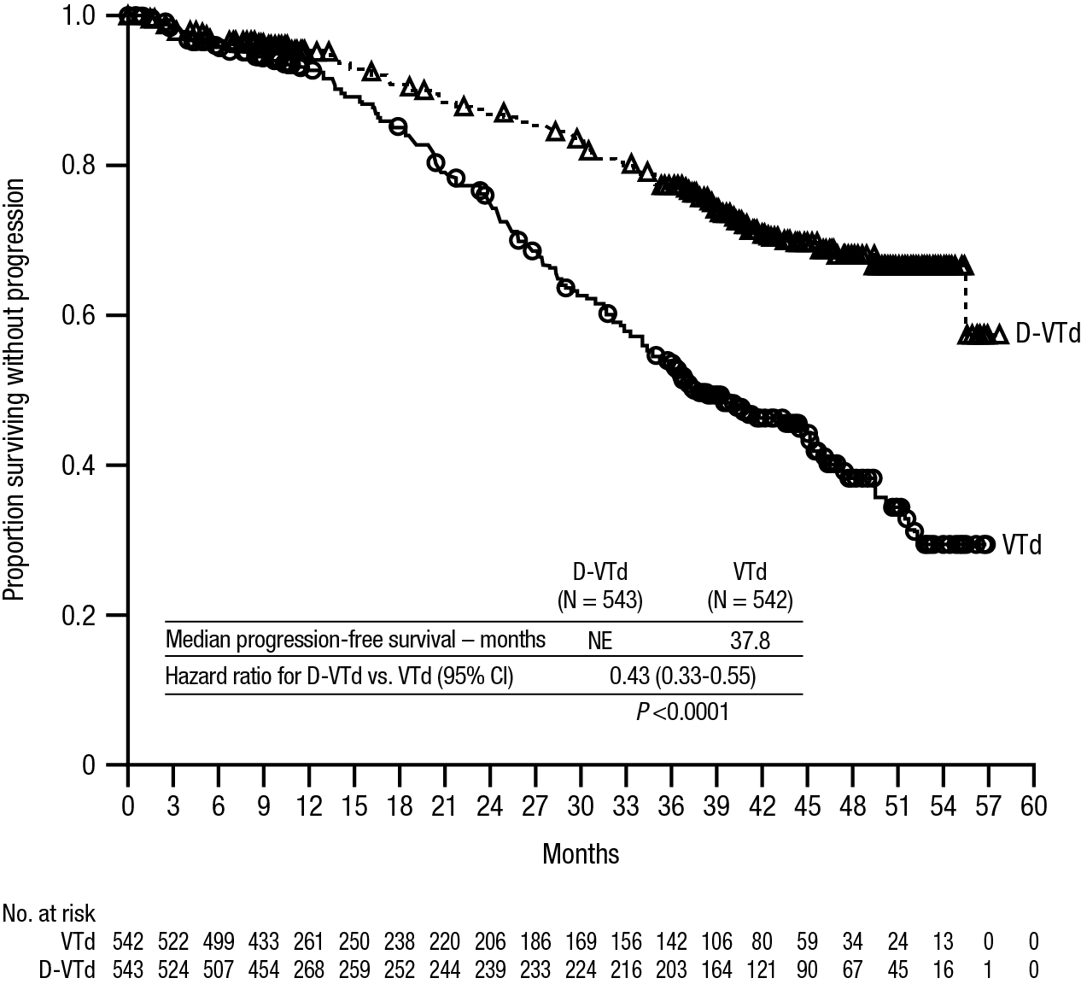

Relapsed/refractory multiple myeloma
Monotherapy:
The clinical efficacy and safety of intravenous daratumumab monotherapy for the treatment of adult patients with relapsed and refractory multiple myeloma whose prior therapy included a proteasome inhibitor and an immunomodulatory agent and who had demonstrated disease progression on the last therapy, was demonstrated in two open-label studies.

In study MMY2002, 106 patients with relapsed and refractory multiple myeloma received 16 mg/kg intravenous daratumumab until disease progression. The median patient age was 63.5 years (range, 31 to 84 years), 11% of patients were ≥ 75 years of age, 49% were male and 79% were Caucasian. Patients had received a median of 5 prior lines of therapy. Eighty percent of patients had received prior autologous stem cell transplantation (ASCT). Prior therapies included bortezomib (99%), lenalidomide (99%), pomalidomide (63%) and carfilzomib (50%). At baseline, 97% of patients were refractory to the last line of treatment, 95% were refractory to both, a proteasome inhibitor (PI) and immunomodulatory agent (IMiD), 77% were refractory to alkylating agents, 63% were refractory to pomalidomide and 48% of patients were refractory to carfilzomib.

Efficacy results of the pre-planned interim analysis based on Independent Review Committee (IRC) assessment are presented in table 18 below.

Table 18: IRC assessed efficacy results for study MMY2002
Efficacy endpoint | Intravenous daratumumab 16 mg/kg  N=106
Overall response rate¹ (ORR: sCR+CR+VGPR+PR) [n (%)] | 31 (29.2)
95% CI (%) | (20.8, 38.9)
Stringent complete response (sCR) [n (%)] | 3 (2.8)
Complete response (CR) [n] | 0
Very good partial response (VGPR) [n (%)] | 10 (9.4)
Partial response (PR) [n (%)] | 18 (17.0)
Clinical benefit rate (ORR+MR) [n (%)] | 36 (34.0)
Median duration of response [months (95% CI)] | 7.4 (5.5, NE)
Median time to response [months (range)] | 1 (0.9; 5.6)
¹ Primary efficacy endpoint (International Myeloma Working Group criteria)
CI=confidence interval; NE=not estimable; MR=minimal response

Overall response rate (ORR) in MMY2002 was similar regardless of type of prior anti-myeloma therapy.
At a survival update with a median duration of follow-up of 14.7 months, median OS was 17.5 months (95% CI:13.7, not estimable).

In study GEN501, 42 patients with relapsed and refractory multiple myeloma received 16 mg/kg intravenous daratumumab until disease progression. The median patient age was 64 years (range, 44 to 76 years), 64% were male and 76% were Caucasian. Patients in the study had received a median of 4 prior lines of therapy. Seventy-four percent of patients had received prior ASCT. Prior therapies included bortezomib (100%), lenalidomide (95%), pomalidomide (36%) and carfilzomib (19%). At baseline, 76% of patients were refractory to the last line of treatment, 64% were refractory to both a PI and IMiD, 60% were refractory to alkylating agents, 36% were refractory to pomalidomide and 17% were refractory to carfilzomib.

Pre-planned interim analysis showed that treatment with daratumumab at 16 mg/kg led to a 36% ORR with 5% CR and 5% VGPR. The median time to response was 1 (range: 0.5 to 3.2) month. The median duration of response was not reached (95% CI: 5.6 months, not estimable).

At a survival update with a median duration of follow-up of 15.2 months, median OS was not reached (95% CI: 19.9 months, not estimable), with 74% of subjects still alive.

Combination treatment with lenalidomide:
Study MMY3003, an open-label, randomised, active-controlled phase III study, compared treatment with intravenous daratumumab 16 mg/kg in combination with lenalidomide and low-dose dexamethasone (DRd) to treatment with lenalidomide and low-dose dexamethasone (Rd) in patients with relapsed or refractory multiple myeloma who had received at least one prior therapy. Lenalidomide (25 mg once daily orally on days 1-21 of repeated 28-day [4-week] cycles) was given with low dose dexamethasone at 40 mg/week (or a reduced dose of 20 mg/week for patients > 75 years or BMI < 18.5). On intravenous daratumumab infusion days, 20 mg of the dexamethasone dose was given as a pre-infusion medicinal product and the remainder given the day after the infusion. Treatment was continued in both arms until disease progression or unacceptable toxicity.

A total of 569 patients were randomised; 286 to the DRd arm and 283 to the Rd arm. The baseline demographic and disease characteristics were similar between the intravenous daratumumab and the control arm. The median patient age was 65 years (range 34 to 89 years) and 11% were ≥ 75 years. The majority of patients (86%) received a prior PI, 55% of patients had received a prior IMiD, including 18% of patients who had received prior lenalidomide; and 44% of patients had received both a prior PI and IMiD. At baseline, 27% of patients were refractory to the last line of treatment. Eighteen percent (18%) of patients were refractory to a PI only, and 21% were refractory to bortezomib. Patients refractory to lenalidomide were excluded from the study.

With a median follow-up of 13.5 months, the primary analysis of PFS in study MMY3003 demonstrated an improvement in the DRd arm as compared to the Rd arm; the median PFS had not been reached in the DRd arm and was 18.4 months in the Rd arm (HR=0.37; 95% CI: 0.27, 0.52; p< 0.0001). Results of an updated PFS analysis after a median follow-up of 55 months continued to show an improvement in PFS for patients in the DRd arm compared with the Rd arm. Median PFS was 45.0 months in the DRd arm and 17.5 months in the Rd arm (HR=0.44; 95% CI: 0.35, 0.54; p< 0.0001), representing a 56% reduction in the risk of disease progression or death in patients treated with DRd (see figure 11).

Figure 11: Kaplan-Meier curve of PFS in study MMY3003

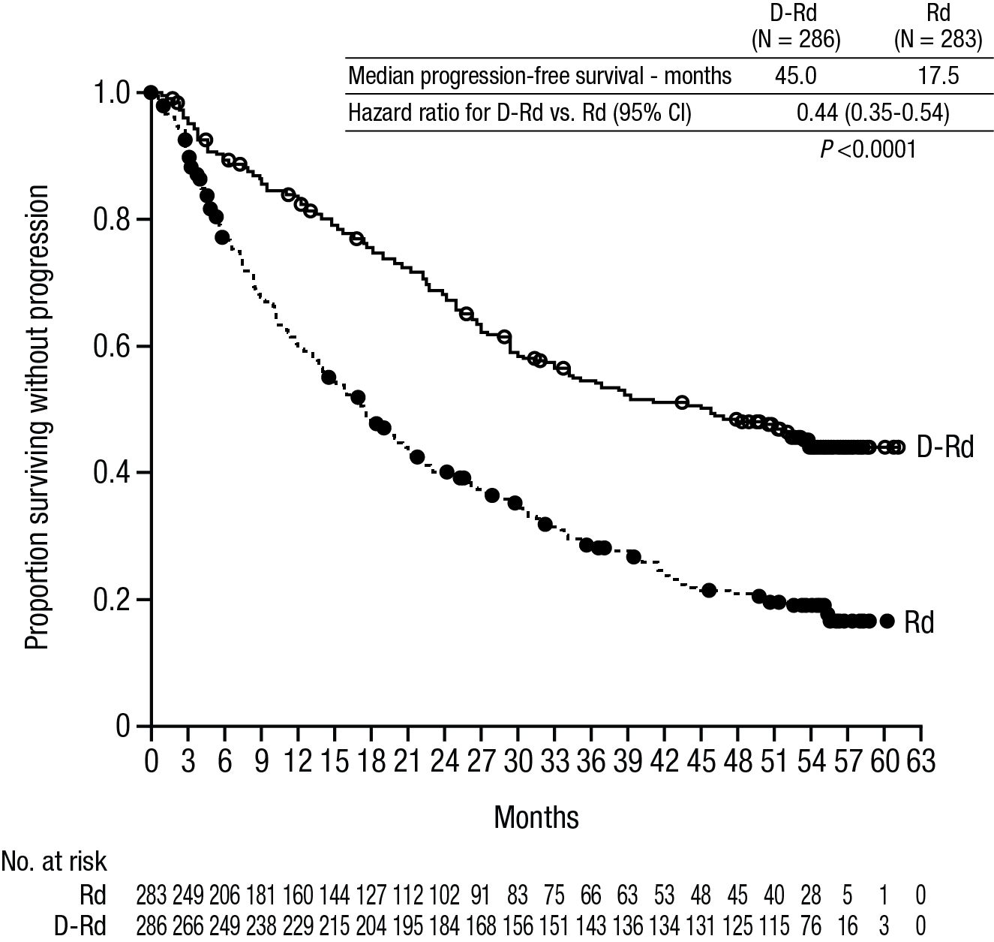

After a median follow-up of 80 months, DRd has shown an OS advantage over the Rd arm (HR=0.73; 95% CI: 0.58, 0.91; p=0.0044). The median OS was 67.6 months in the DRd arm and 51.8 months in the Rd arm.

Figure 12: Kaplan-Meier curve of OS in study MMY3003

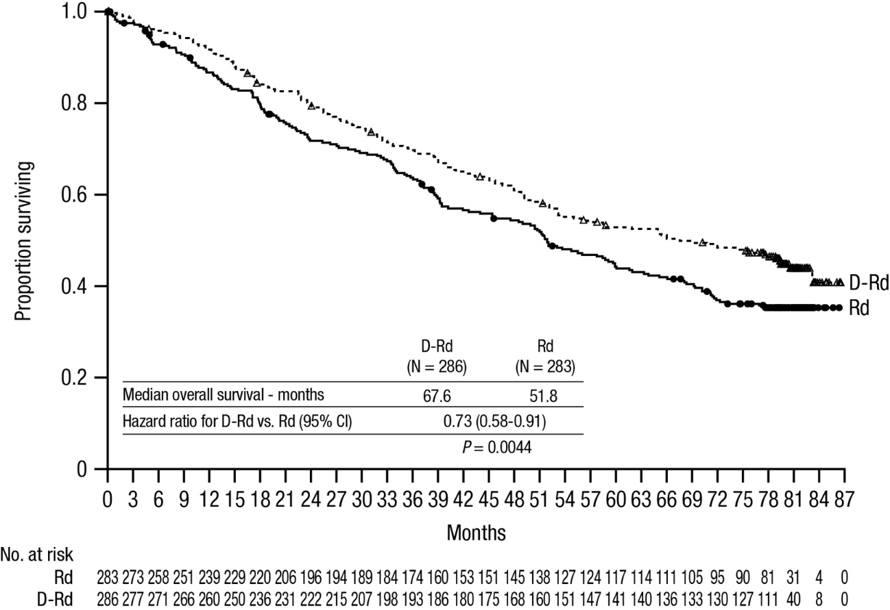

Additional efficacy results from study MMY3003 are presented in table 19 below.

Table 19: Additional efficacy results from study MMY3003
Response evaluable patient number | DRd (n=281) | Rd (n=276)
Overall response (sCR+CR+VGPR+PR) n(%) | 261 (92.9) | 211 (76.4)
p-valueª | <0.0001
Stringent complete response (sCR) | 51 (18.1) | 20 (7.2)
Complete response (CR) | 70 (24.9) | 33 (12.0)
Very good partial response (VGPR) | 92 (32.7) | 69 (25.0)
Partial response (PR) | 48 (17.1) | 89 (32.2)
Median Time to Response [months (95% CI)] | 1.0 (1.0, 1.1) | 1.3 (1.1, 1.9)
Median Duration of Response [months (95% CI)] | NE (NE, NE) | 17.4 (17.4, NE)
MRD negative rate (95% CI) ^{b} (%) | 21.0 (16.4, 26.2) | 2.8 (1.2, 5.5)
Odds ratio with 95% CI^{c} | 9.31 (4.31, 20.09)
P-value^{d} | <0.0001

DRd=daratumumab-lenalidomide-dexamethasone; Rd=lenalidomide-dexamethasone; MRD=minimal residual disease; CI=confidence interval; NE=not estimable.
ª p-value from Cochran Mantel-Haenszel Chi-Squared test.
^{b} Based on Intent-to-treat population and threshold of 10⁻⁵
^{c} Mantel-Haenszel estimate of the common odds ratio is used. An odds ratio > 1 indicates an advantage for DRd.
^{d} p-value is from a Fisher’s exact test.

Combination treatment with bortezomib:
Study MMY3004, an open-label, randomised, active-controlled phase III study, compared treatment with intravenous daratumumab 16 mg/kg in combination with bortezomib and dexamethasone (DVd), to treatment with bortezomib and dexamethasone (Vd) in patients with relapsed or refractory multiple myeloma who had received at least one prior therapy. Bortezomib was administered by subcutaneous injection or intravenous injection at a dose of 1.3 mg/m² body surface area twice weekly for two weeks (days 1, 4, 8, and 11) of repeated 21 day (3-week) treatment cycles, for a total of 8 cycles. Dexamethasone was administered orally at a dose of 20 mg on days 1, 2, 4, 5, 8, 9, 11, and 12 of each of the 8 bortezomib cycles (80 mg/week for two out of three weeks of the bortezomib cycle) or a reduced dose of 20 mg/week for patients > 75 years, BMI < 18.5, poorly controlled diabetes mellitus or prior intolerance to steroid therapy. On the days of intravenous daratumumab infusion, 20 mg of the dexamethasone dose was administered as a pre-infusion medicinal product. intravenous daratumumab treatment was continued until disease progression or unacceptable toxicity.

A total of 498 patients were randomised; 251 to the DVd arm and 247 to the Vd arm. The baseline demographic and disease characteristics were similar between the intravenous daratumumab and the control arm. The median patient age was 64 years (range 30 to 88 years) and 12% were ≥75 years. Sixty-nine percent (69%) of patients had received a prior PI (66% received bortezomib) and 76% of patients received an IMiD (42% received lenalidomide). At baseline, 32% of patients were refractory to the last line of treatment. Thirty-three percent (33%) of patients were refractory to an IMiD only, and 28% were refractory to lenalidomide. Patients refractory to bortezomib were excluded from the study.

With a median follow-up of 7.4 months, the primary analysis of PFS in study MMY3004 demonstrated an improvement in the DVd arm as compared to the Vd arm; the median PFS had not been reached in the DVd arm and was 7.2 months in the Vd arm (HR [95% CI]: 0.39 [0.28, 0.53]; p-value< 0.0001). Results of an updated PFS analysis after a median follow-up of 50 months continued to show an improvement in PFS for patients in the DVd arm compared with the Vd arm. Median PFS was 16.7 months in the DVd arm and 7.1 months in the Vd arm (HR [95% CI]: 0.31 [0.24, 0.39]; p-value< 0.0001), representing a 69% reduction in the risk of disease progression or death in patients treated with DVd versus Vd (see figure 13).

Figure 13: Kaplan-Meier curve of PFS in study MMY3004

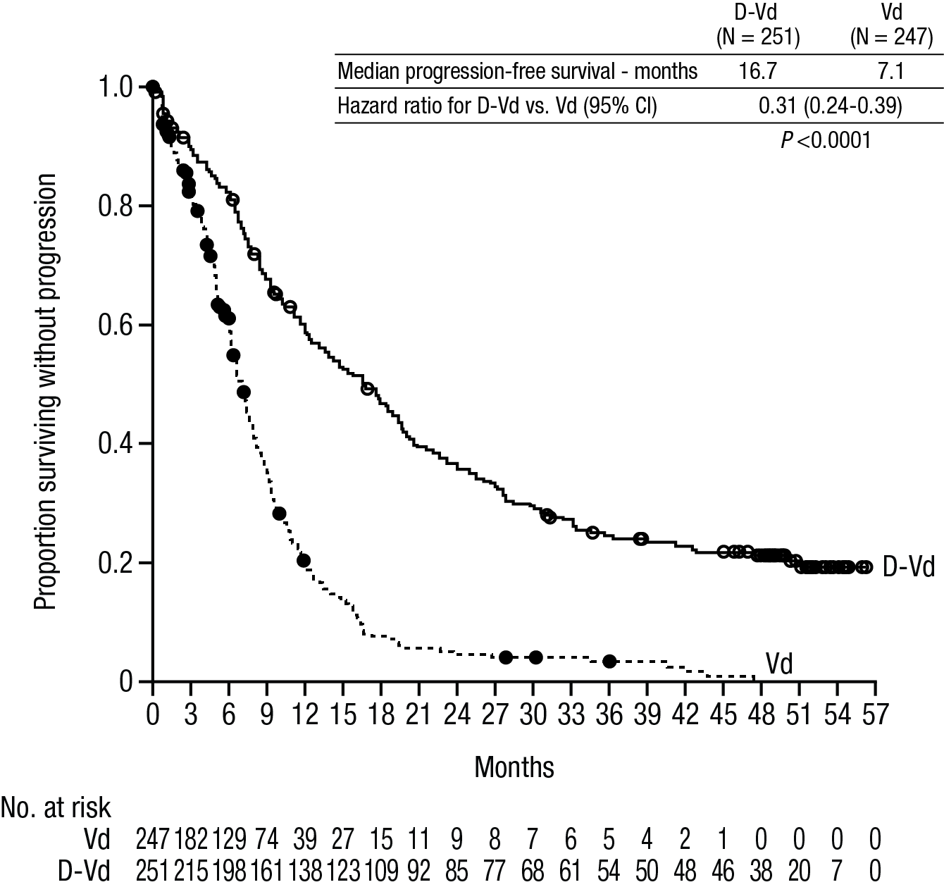
After a median follow-up of 73 months, DVd has shown an OS advantage over the Vd arm (HR=0.74; 95% CI: 0.59, 0.92; p=0.0075). The median OS was 49.6 months in the DVd arm and 38.5 months in the Vd arm.
Figure 14: Kaplan-Meier curve of OS in study MMY3004

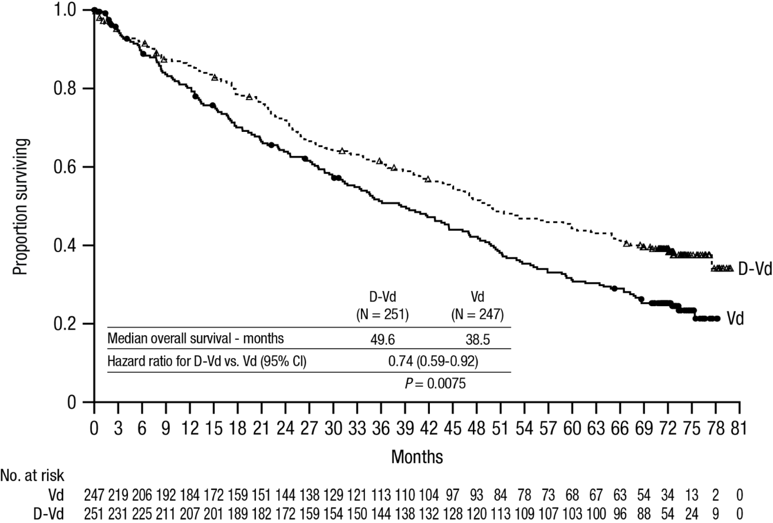

Additional efficacy results from study MMY3004 are presented in table 20 below.

Table 20: Additional efficacy results from study MMY3004
Response evaluable patient number | DVd (n=240) | Vd (n=234)
Overall response (sCR+CR+VGPR+PR) n(%) | 199 (82.9) | 148 (63.2)
P-valueª | <0.0001
Stringent complete response (sCR) | 11 (4.6) | 5 (2.1)
Complete response (CR) | 35 (14.6) | 16 (6.8)
Very good partial response (VGPR) | 96 (40.0) | 47 (20.1)
Partial response (PR) | 57 (23.8) | 80 (34.2)
Median time to response [months (range)] | 0.9 (0.8, 1.4) | 1.6 (1.5, 2.1)
Median duration of response [months (95% CI)] | NE (11.5, NE) | 7.9 (6.7, 11.3)
MRD negative rate (95% CI)^{b} | 8.8% (5.6%, 13.0%) | 1.2% (0.3%, 3.5%)
Odds ratio with 95% CI^{c} | 9.04 (2.53, 32.21)
P-value^{d} | 0.0001

DVd=daratumumab- bortezomib-dexamethasone; Vd=bortezomib-dexamethasone; MRD=minimal residual disease; CI=confidence interval; NE=not estimable.

ª p-value from Cochran Mantel-Haenszel Chi-Squared test.

^{b} Based on Intent-to-treat population and threshold of 10⁻⁵
^{c} Mantel-Haenszel estimate of the common odds ratio is used. An odds ratio >1 indicates an advantage for DVd.

^{d} p-value is from Fisher’s exact test.

Cardiac electrophysiology
Daratumumab as a large protein has a low likelihood of direct ion channel interactions. The effect of daratumumab on the QTc interval was evaluated in an open-label study for 83 patients (Study GEN501) with relapsed and refractory multiple myeloma following daratumumab infusions (4 to 24 mg/kg). Linear mixed PK-PD analyses indicated no large increase in mean QTcF interval (i.e. greater than 20 ms) at daratumumab C_{max}.

5.2 Pharmacokinetic properties

In patients with multiple myeloma, daratumumab exposure in a monotherapy study following the recommended 1800 mg administration of DARZALEX subcutaneous formulation (weekly for 8 weeks, biweekly for 16 weeks, monthly thereafter) as compared to 16 mg/kg intravenous daratumumab for the same dosing schedule, showed non-inferiority for the co-primary endpoint of maximum C_{trough} (cycle 3 day 1 pre-dose), with mean ± SD of 593 ± 306 µg/mL compared to 522 ± 226 µg/mL for intravenous daratumumab, with a geometric mean ratio of 107.93% (90% CI: 95.74-121.67).

In a combination study, AMY3001, in patients with AL amyloidosis, the maximum C_{trough} (cycle 3 day 1 pre-dose) was similar to that in multiple myeloma with mean ± SD of 597 ± 232 µg/mL following the recommended 1800 mg administration of DARZALEX subcutaneous formulation (weekly for 8 weeks, biweekly for 16 weeks, monthly thereafter).

Following the recommended dose of 1800 mg DARZALEX solution for subcutaneous injection, peak concentrations (C_{max}) increased 4.8-fold and total exposure (AUC_{0-7 days}) increased 5.4-fold from first dose to last weekly dose (8th dose). Highest trough concentrations for DARZALEX solution for subcutaneous injection are typically observed at the end of the weekly dosing regimens for both monotherapy and combination therapy.

In patients with multiple myeloma, the simulated trough concentrations following 6 weekly doses of 1800 mg DARZALEX solution for subcutaneous injection for combination therapy were similar to 1800 mg DARZALEX solution for subcutaneous injection monotherapy.

In patients with newly diagnosed multiple myeloma eligible for ASCT, daratumumab exposure in a combination study with bortezomib, lenalidomide and dexamethasone (MMY3014) was similar to that in monotherapy, with the maximum C_{trough} (cycle 3 day 1 pre-dose) mean ± SD of 526±209 µg/mL following the recommended 1800 mg administration of DARZALEX solution for subcutaneous injection weekly for 8 weeks, biweekly for 16 weeks, monthly thereafter).

In patients with newly diagnosed multiple myeloma for whom ASCT was not planned as initial therapy or who were ineligible for ASCT, daratumumab exposure in a combination study with bortezomib, lenalidomide and dexamethasone (MMY3019) was similar to that in monotherapy and other combination therapies following similar dosing schedule, with the maximum C_{trough} (cycle 3 day 1 pre-dose) mean ± SD of 407 ± 183 µg/mL following the recommended 1800 mg administration of DARZALEX solution for subcutaneous injection (weekly for 6 weeks, triweekly for 18 weeks, monthly thereafter).

In patients with multiple myeloma, daratumumab exposure in a combination study with pomalidomide and dexamethasone (study MMY3013) was similar to that in monotherapy, with the maximum C_{trough} (cycle 3 day 1 pre-dose) mean ± SD of 537 ± 277 µg/mL following the recommended 1800 mg administration of DARZALEX solution for subcutaneous injection (weekly for 8 weeks, biweekly for 16 weeks, monthly thereafter).

Absorption and distribution
At the recommended dose of 1800 mg, in multiple myeloma patients, the absolute bioavailability of DARZALEX solution for subcutaneous injection is 69%, with an absorption rate of 0.012 hour-1, with peak concentrations occurring at 70 to 72 h (Tmax). At the recommended dose of 1800 mg in AL amyloidosis patients, the absolute bioavailability was not estimated, the absorption rate constant was 0.77 day⁻¹ (8.31% CV) and peak concentrations occurred at 3 days.

The model predicted mean estimate of the volume of distribution for the central compartment was 5.25 L (36.9% CV) and peripheral compartment (V2) was 3.78 L in daratumumab monotherapy, and the modelled mean estimate of the volume of distribution for V1 was 4.36 L (28.0% CV) and V2 was 2.80 L when daratumumab was administered in combination with pomalidomide and dexamethasone in multiple myeloma patients. In AL amyloidosis patients, the model estimated apparent volume of distribution after subcutaneous administration is 10.8 L (3.1% CV). These results suggest that daratumumab is primarily localised to the vascular system with limited extravascular tissue distribution.

Metabolism and elimination
Daratumumab exhibits both concentration and time-dependent pharmacokinetics with parallel linear and nonlinear (saturable) elimination that is characteristic of target-mediated clearance. The population PK model estimated mean clearance value of daratumumab is 4.96 mL/h (58.7% CV) in daratumumab monotherapy and 4.32 mL/h (43.5% CV) when daratumumab is administered in combination with pomalidomide and dexamethasone in multiple myeloma patients. In AL amyloidosis patients, the apparent clearance after subcutaneous administration is 210 mL/day (4.1% CV). The model-based geometric mean for half-life associated with linear elimination is 20.4 days (22.4% CV) in daratumumab monotherapy and 19.7 days (15.3% CV) when daratumumab was administered in combination with pomalidomide and dexamethasone in multiple myeloma patients and 27.5 days (74.0% CV) in AL amyloidosis patients. For the monotherapy and combination regimens, the steady state is achieved at approximately 5 months into every 4 weeks dosage at the recommended dose and schedule (1800 mg; once weekly for 8 weeks, every 2 weeks for 16 weeks, and then every 4 weeks thereafter).

A population PK analysis was conducted using data from DARZALEX solution for subcutaneous injection monotherapy and combination therapy multiple myeloma studies, and the predicted PK exposures are summarised in table 21. Daratumumab exposures were similar between patients treated with DARZALEX solution for subcutaneous injection monotherapy and combination therapies.

Table 21: Daratumumab exposure following administration of DARZALEX subcutaneous formulation (1800 mg) or intravenous daratumumab (16 mg/kg) monotherapy in patients with multiple myeloma
PK parameters | Cycles | subcutaneous daratumumab  Median (5th; 95th percentile) | intravenous daratumumab  Median (5th; 95th percentile)
C_{trough} (µg/mL) | Cycle 1, 1st weekly dose | 123 (36; 220) | 112 (43; 168)
C_{trough} (µg/mL) | Cycle 2, last weekly dose (cycle 3 day 1 C_{trough}) | 563 (177; 1063) | 472 (144; 809)
C_{max} (µg/mL) | Cycle 1, 1st weekly dose | 132 (54; 228) | 256 (173; 327)
C_{max} (µg/mL) | Cycle 2, last weekly dose | 592 (234; 1114) | 688 (369; 1061)
AUC_{0-7 days} (µg/mL•day) | Cycle 1, 1st weekly dose | 720 (293; 1274) | 1187 (773; 1619)
AUC_{0-7 days} (µg/mL•day) | Cycle 2, last weekly dose | 4017 (1515; 7564) | 4019 (1740; 6370)

The predicted PK expsosures for 526 patients with transplant eligible multiple myeloma who received DARZALEX solution for subcutaneous injection in combination with VRd are summarised in table 22.

Table 22: Daratumumab exposure following administration of DARZALEX subcutaneous formulation (1800 mg) in combination with VRd in patients with transplant eligible multiple myeloma
PK parameters | Cycles | subcutaneous daratumumab  Median (5th; 95th percentile)
C_{trough} (µg/mL) | Cycle 1, 1st weekly dose | 113 (66; 171)
C_{trough} (µg/mL) | Cycle 2, last weekly dose (cycle 3 day 1 C_{trough}) | 651 (413; 915)
C_{max} (µg/mL) | Cycle 1, 1st weekly dose | 117 (67; 179)
C_{max} (µg/mL) | Cycle 2, last weekly dose | 678 (431; 958)
AUC_{0-7 days} (µg/mL•day) | Cycle 1, 1st weekly dose | 643 (322; 1027)
AUC_{0-7 days} (µg/mL•day) | Cycle 2, last weekly dose | 4637 (2941; 6522)

A population PK analysis, using data from DARZALEX solution for subcutaneous injection combination therapy in AL amyloidosis patients, was conducted with data from 211 patients. At the recommended dose of 1800 mg, predicted daratumumab concentrations were slightly higher, but generally within the same range, in comparison with multiple myeloma patients.

Table 23: Daratumumab exposure following administration of DARZALEX subcutaneous formulation (1800 mg) in patients with AL amyloidosis
PK parameters | Cycles | subcutaneous daratumumab  Median (5th; 95th percentile)
C_{trough} (µg/mL) | Cycle 1, 1st weekly dose | 138 (86; 195)
C_{trough} (µg/mL) | Cycle 2, last weekly dose (cycle 3 day 1 C_{trough}) | 662 (315; 1037)
C_{max} (µg/mL) | Cycle 1, 1st weekly dose | 151 (88; 226)
C_{max} (µg/mL) | Cycle 2, last weekly dose | 729 (390; 1105)
AUC_{0-7 days} (µg/mL•day) | Cycle 1, 1st weekly dose | 908 (482; 1365)
AUC_{0-7 days} (µg/mL•day) | Cycle 2, last weekly dose | 4855 (2562; 7522)

Special populations

Age and gender
Based on population PK analyses in patients (33-92 years) receiving monotherapy or various combination therapies, age had no statistically significant effect on the PK of daratumumab. No individualisation is necessary for patients on the basis of age.

Gender had a statistically significant effect on PK parameters in patients with multiple myeloma but not in patients with AL amyloidosis. Slightly higher exposure in females were observed than males, but the difference in exposure is not considered clinically meaningful. No individualisation is necessary for patients on the basis of gender.

Renal impairment
No formal studies of DARZALEX subcutaneous formulation in patients with renal impairment have been conducted. Population PK analyses were performed based on pre-existing renal function data in patients with multiple myeloma receiving DARZALEX subcutaneous formulation monotherapy or various combination therapies in patients with multiple myeloma or AL amyloidosis. No clinically important differences in exposure to daratumumab were observed between patients with renal impairment and those with normal renal function.

Hepatic impairment
No formal studies of DARZALEX subcutaneous formulation in patients with hepatic impairment have been conducted.
Population PK analyses were performed in patients with multiple myeloma receiving DARZALEX subcutaneous formulation monotherapy or various combination therapies in patients with multiple myeloma and in AL amyloidosis. No clinically important differences in the exposure to daratumumab were observed between patients with normal hepatic function and mild hepatic impairment. There were very few patients with moderate and severe hepatic impairment to make meaningful conclusions for these populations.

Race
Based on the population PK analyses in patients receiving either DARZALEX subcutaneous formulation monotherapy or various combination therapies, the daratumumab exposure was similar across races.

Body weight
The flat-dose administration of DARZALEX subcutaneous formulation 1800 mg as monotherapy achieved adequate exposure for all body-weight subgroups. In patients with multiple myeloma, the mean cycle 3 day 1 C_{trough} in the lower body-weight subgroup (≤65 kg) was 60% higher and in the higher body weight (> 85 kg) subgroup, 12% lower than the intravenous daratumumab subgroup. In some patients with body weight >120 kg, lower exposure was observed which may result in reduced efficacy. However, this observation is based on limited number of patients.

In patients with AL amyloidosis, no meaningful differences were observed in C_{trough} across body weight.

5.3 Preclinical safety data

Toxicology data have been derived from studies with daratumumab in chimpanzees and with a surrogate anti-CD38 antibody in cynomolgus monkeys. No chronic toxicity testing has been conducted.

No animal studies have been performed to establish the carcinogenic potential of daratumumab.

No animal studies have been performed to evaluate the potential effects of daratumumab on reproduction or development or to determine potential effects on fertility in males or females.

No carcinogenicity, genotoxicity, or fertility studies were conducted for recombinant human hyaluronidase. There were no effects on reproductive tissues and function and no systemic exposure of hyaluronidase in monkeys given 22000 U/kg/week subcutaneously (12 times higher than the human dose) for 39 weeks. As hyaluronidase is a recombinant form of the endogenous human hyaluronidase, no carcinogenity, mutagenesis, or effects on fertility are expected.

6. PHARMACEUTICAL PARTICULARS

6.1 List of excipients

Recombinant human hyaluronidase (rHuPH20)
Sorbitol
L-histidine HCl monohydrate
L-methionine
Polysorbate 20
L-histidine
Water for injections

6.2 Incompatibilities

This medicinal product must not be used with other materials except those mentioned in section 6.6.

6.3 Shelf life

The expiry date of the product is indicated on the packaging materials.

During the shelf-life, the product in unpunctured vials may be stored at room temperature (≤30°C) for a single period of up to 24 hours. Once the product has been taken out of the refrigerator, it must not be returned to the refrigerator (see section 6.6).

Prepared syringe
Chemical and physical in-use stability in syringe has been demonstrated for 24 hours at refrigerated conditions (2 °C-8 °C) protected from light, followed by no more than 12 hours at 15 °C-25 °C and ambient light. From a microbiological point of view, unless the method of opening precludes the risk of microbial contamination, the product should be used immediately. If not used immediately, in-use storage times and conditions are the responsibility of the user.

6.4 Special precautions for storage

Store in a refrigerator (2°C-8°C).
Do not freeze.
Store in the original package in order to protect from light.

For storage conditions of the opened medicinal product (see section 6.3).

6.5 Nature and contents of container

15 mL solution in a type 1 glass vial with a rubber stopper and an aluminium seal with a flip-off cap containing 1800 mg of daratumumab. Pack size of 1 vial.

6.6 Special precautions for disposal and other handling

DARZALEX solution for subcutaneous injection is for single use only and is ready to use.

DARZALEX solution for subcutaneous injection should be a clear to opalescent and colourless to yellow solution. Do not use if opaque particles, discolouration or other foreign particles are present.

DARZALEX solution for subcutaneous injection is compatible with polypropylene or polyethylene syringe material; polypropylene, polyethylene, or polyvinyl chloride (PVC) subcutaneous infusion sets; and stainless steel transfer and injection needles.

Unopened vial

Remove the DARZALEX solution for subcutaneous injection vial from refrigerated storage (2°C-8°C) and equilibrate to ambient temperature (≤30°C). The unpunctured vial may be stored at ambient temperature and ambient light for a maximum of 24 hours in the original carton to protect from light. Keep out of direct sunlight. Do not shake.

Prepared syringe

Prepare the dosing syringe in controlled and validated aseptic conditions. Withdraw 15 mL from the vial into a syringe using an 18G - 22G transfer needle with a regular bevel to minimise the risk of stopper coring. Insert the needle into the vial at a 90°angle within the ring of the stopper and minimise the number of punctures to prevent fragmentation of the stopper. Inspect the content of the syringe to ensure the absence of particulate matter, discolouration or other foreign particles.
Once transferred from the vial into the syringe, store DARZALEX solution for subcutaneous injection for up to 24 hours refrigerated followed by up to 12 hours at 15 °C-25 °C and ambient light (see section 6.3). If stored in the refrigerator, allow the solution to reach ambient temperature before administration.

Any unused medicinal product or waste material should be disposed of in accordance with local requirements.

The following information is intended for healthcare professionals only:

DARZALEX solution for subcutaneous injection should be administered by a healthcare professional.

To prevent medication errors, it is important to check the vial labels to ensure that the appropriate formulation (intravenous or subcutaneous formulation) and dose is being given to the patient as prescribed. DARZALEX solution for injection should be given by subcutaneous injection only, using the dose specified. DARZALEX subcutaneous formulation is not intended for intravenous administration.

DARZALEX solution for subcutaneous injection is for single use only and is ready to use.
- DARZALEX solution for subcutaneous injection is compatible with polypropylene or polyethylene syringe material; polypropylene, polyethylene, or polyvinyl chloride (PVC) subcutaneous infusion sets; and stainless steel transfer and injection needles.
- DARZALEX solution for subcutaneous injection should be a clear to opalescent and colourless to yellow solution. Do not use if opaque particles, discolouration or other foreign particles are present.
- Remove the DARZALEX solution for subcutaneous injection vial from refrigerated storage (2 °C – 8 °C) and equilibrate to ambient temperature (15 °C–30 °C). The unpunctured vial may be stored at ambient temperature and ambient light for a maximum of 24 hours in the original carton to protect from light. Keep out of direct sunlight. Do not shake.
- Prepare the dosing syringe in controlled and validated aseptic conditions. Withdraw 15 mL from the vial into a syringe using an 18G - 22G transfer needle with a regular bevel to minimise the risk of stopper coring. Insert the needle into the vial at a 90°angle within the ring of the stopper and minimise the number of punctures to prevent fragmentation of the stopper. Inspect the content of the syringe to ensure the absence of particulate matter, discolouration or other foreign particles.
- To avoid needle clogging, attach the hypodermic injection needle or subcutaneous infusion set to the syringe immediately prior to injection.

Storage of prepared syringe
- If the syringe containing DARZALEX is not used immediately, store the solution of DARZALEX for up to 24 hours refrigerated followed by up to 12 hours at 15 °C-25 °C and ambient light. If stored in the refrigerator, allow the solution to reach ambient temperature before administration.

Administration
- Inject 15 mL DARZALEX solution for subcutaneous injection into the subcutaneous tissue of the abdomen approximately 7.5 cm to the right or left of the navel over approximately 3-5 minutes. Do not inject DARZALEX solution for subcutaneous injection at other sites of the body as no data are available.
- Injection sites should be rotated for successive injections.
- DARZALEX solution for subcutaneous injection should never be injected into areas where the skin is red, bruised, tender, hard or areas where there are scars.
- Pause or slow down delivery rate if the patient experiences pain. In the event pain is not alleviated by slowing down the injection, a second injection site may be chosen on the opposite side of the abdomen to deliver the remainder of the dose.
- During treatment with DARZALEX solution for subcutaneous injection, do not administer other medicinal products for subcutaneous use at the same site as DARZALEX.
- Any unused medicinal product or waste material should be disposed of in accordance with local requirements.

Traceability
In order to improve the traceability of biological medicinal products, the name and the batch number of the administered product should be clearly recorded.

Revised in 01/2026.
Manufacturer: Cilag AG, Hochstrasse 201, 8200 Schaffhausen, Switzerland
Registration holder: J-C Health Care Ltd, Kibbutz Shefayim 6099000

Registration number: 167-14-36565-00

