1. NAME OF THE MEDICINAL PRODUCT

DARZALEX 20 mg/mL I.V.

2. QUALITATIVE AND QUANTITATIVE COMPOSITION

Each 5 mL vial contains 100 mg of daratumumab (20 mg daratumumab per mL).
Each 20 mL vial contains 400 mg of daratumumab (20 mg daratumumab per mL).

Daratumumab is a human monoclonal IgG1κ antibody against CD38 antigen, produced in a mammalian cell line (Chinese Hamster Ovary) using recombinant DNA technology.

Excipient with known effect
Each 5 mL vial of solution for infusion contains 273.3 mg of sorbitol.
Each 20 mL vial of solution for infusion contains 1093 mg of sorbitol.

For the full list of excipients, see section 6.1.

3. PHARMACEUTICAL FORM

Concentrate for solution for infusion.
The solution is colourless to yellow, with a pH of 5.5 and osmolality of 310 to 370 mOsm/kg.

The marketing of DARZALEX 20 MG/ML I.V is subject to risk management plan (RMP) including “Health Care Professional (HCP) Guide” and" patient safety information card".

HCP Guide
This product is marketed with prescriber guide providing important safety information. Please ensure you are familiar with this material as it contains important safety information.

Patient safety information card
The "Patient safety information card" emphasizes important safety information that the patient should be aware of before and during treatment. Please explain to the patient the need to review the card before starting treatment.

4. CLINICAL PARTICULARS

4.1 Therapeutic indications

DARZALEX is indicated:
- in combination with lenalidomide and dexamethasone or with bortezomib, melphalan and prednisone for the treatment of adult patients with newly diagnosed multiple myeloma who are ineligible for autologous stem cell transplant.
- in combination with bortezomib, thalidomide and dexamethasone for the treatment of adult patients with newly diagnosed multiple myeloma who are eligible for autologous stem cell transplant.
- in combination with lenalidomide and dexamethasone, or bortezomib and dexamethasone, for the treatment of adult patients with multiple myeloma who have received at least one prior therapy.
- as monotherapy for the treatment of adult patients with relapsed and refractory multiple myeloma, whose prior therapy included a proteasome inhibitor and an immunomodulatory agent and who have demonstrated disease progression on the last therapy.

4.2 Posology and method of administration

DARZALEX should be administered by a healthcare professional, in an environment where resuscitation facilities are available.

Pre- and post-infusion medicinal products should be administered to reduce the risk of infusion-related reactions (IRRs) with daratumumab. See below “Recommended concomitant medicinal products”, “Management of infusion-related reactions” and section 4.4.

Posology

Dosing schedule in combination with lenalidomide and dexamethasone (4-week cycle regimen) and for monotherapy
The recommended dose is DARZALEX 16 mg/kg body weight administered as an intravenous infusion according to the following dosing schedule in table 1.

Table 1: DARZALEX dosing schedule in combination with lenalidomide and dexamethasone (Rd) (4-week cycle dosing regimen) and monotherapy
Weeks | Schedule
Weeks 1 to 8 | weekly (total of 8 doses)
Weeks 9 to 24ª | every two weeks (total of 8 doses)
Week 25 onwards until disease progression^{b} | every four weeks
ª First dose of the every-2-week dosing schedule is given at week 9.
^{b} First dose of the every-4-week dosing schedule is given at week 25.

Dexamethasone should be administered at 40 mg/week (or a reduced dose of 20 mg/week for patients >75 years).

For dose and schedule of medicinal products administered with DARZALEX, see section 5.1 and the corresponding prescribing information (PI).

Dosing schedule in combination with bortezomib, melphalan and prednisone (6-week cycle regimens)
The recommended dose is DARZALEX 16 mg/kg body weight administered as an intravenous infusion according to the following dosing schedule in table 2.

Table 2: DARZALEX dosing schedule in combination with bortezomib, melphalan and prednisone ([VMP]; 6-week cycle dosing regimen)
Weeks | Schedule
Weeks 1 to 6 | weekly (total of 6 doses)
Weeks 7 to 54ª | every three weeks (total of 16 doses)
Week 55 onwards until disease progression^{b} | every four weeks
ª First dose of the every-3-week dosing schedule is given at week 7.
^{b} First dose of the every-4-week dosing schedule is given at week 55.

Bortezomib is given twice weekly at weeks 1, 2, 4 and 5 for the first 6-week cycle, followed by once weekly at weeks 1, 2, 4 and 5 for eight more 6-week cycles. For information on the VMP dose and dosing schedule when administered with DARZALEX, see section 5.1.

Dosing schedule in combination with bortezomib, thalidomide and dexamethasone (4-week cycle regimens) for treatment of newly diagnosed patients eligible for autologous stem cell transplant (ASCT)
The recommended dose is DARZALEX 16 mg/kg body weight administered as an intravenous infusion according to the following dosing schedule in table 3.

Table 3: DARZALEX dosing schedule in combination with bortezomib, thalidomide and dexamethasone ([VTd]; 4-week cycle dosing regimen)
Treatment phase | Weeks | Schedule
Induction | Weeks 1 to 8 | weekly (total of 8 doses)
Induction | Weeks 9 to 16ª | every two weeks (total of 4 doses)
Stop for high dose chemotherapy and ASCT
Consolidation | Weeks 1 to 8^{b} | every two weeks (total of 4 doses)
ª First dose of the every-2-week dosing schedule is given at week 9.
^{b} First dose of the every-2-week dosing schedule is given at week 1 upon re-initiation of treatment following ASCT.

Dexamethasone should be administered at 40 mg on days 1, 2, 8, 9, 15, 16, 22 and 23 of cycles 1 and 2, and at 40 mg on days 1-2 and 20 mg on subsequent dosing days (days 8, 9, 15, 16) of cycles 3-4. Dexamethasone 20 mg should be administered on days 1, 2, 8, 9, 15, 16 in cycles 5 and 6.

For dose and schedule of medicinal products administered with DARZALEX, see section 5.1 and the corresponding prescribing information (PI).

Dosing schedule in combination with bortezomib and dexamethasone (3-week cycle regimen):
The recommended dose is DARZALEX 16 mg/kg body weight administered as an intravenous infusion according to the following dosing schedule in table 4.

Table 4: DARZALEX dosing schedule in combination with bortezomib and dexamethasone (Vd) (3-week cycle dosing regimen)
Weeks | Schedule
Weeks 1 to 9 | weekly (total of 9 doses)
Weeks 10 to 24ª | every three weeks (total of 5 doses)
Week 25 onwards until disease progression^{b} | every four weeks
ª First dose of the every-3-week dosing schedule is given at week 10.
^{b} First dose of the every-4-week dosing schedule is given at week 25.

Dexamethasone should be administered at 20 mg on days 1, 2, 4, 5, 8, 9, 11 and 12 of the first 8 bortezomib treatment cycles or a reduced dose of 20 mg/week for patients > 75 years, underweight (BMI <18.5), poorly controlled diabetes mellitus or prior intolerance to steroid therapy.

For dose and schedule of medicinal products administered with DARZALEX, see section 5.1 and the corresponding prescribing information (PI).

Infusion rates
Following dilution the DARZALEX infusion should be intravenously administered at the initial infusion rate presented in table 5 below. Incremental escalation of the infusion rate should be considered only in the absence of infusion reactions.
To facilitate administration, the first prescribed 16 mg/kg dose at week 1 may be split over two consecutive days i.e. 8 mg/kg on day 1 and day 2 respectively, see table 5 below.

Table 5: Infusion rates for DARZALEX (16 mg/kg) administration
 |  | Dilution volume | Initial rate (first hour) | Rate incrementª | Maximum rate
Week 1 Infusion
Option 1 (Single dose infusion)
Week 1 day 1 (16 mg/kg) |  | 1000 mL | 50 mL/hour | 50 mL/hour every hour | 200 mL/hour
Option 2 (Split dose infusion)
Week 1 day 1 (8 mg/kg) | 500 mL |  | 50 mL/hour | 50 mL/hour every hour | 200 mL/hour
Week 1 day 2 (8 mg/kg) | 500 mL |  | 50 mL/hour | 50 mL/hour every hour | 200 mL/hour
Week 2 (16 mg/kg)infusion^{b} |  | 500 mL | 50 mL/hour | 50 mL/hour every hour | 200 mL/hour
Subsequent (week 3 onwards, 16 mg/kg) infusions^{c} |  | 500 mL | 100 mL/hour | 50 mL/hour every hour | 200 mL/hour
ª Incremental escalation of the infusion rate should be considered only in the absence of infusion reactions.
^{b} A dilution volume of 500 mL for the 16 mg/kg dose should be used only if there were no IRRs the previous week. Otherwise, use a dilution volume of 1000 mL.
^{c} A modified initial rate (100 mL/hour) for subsequent infusions (i.e. week 3 onwards) should only be used only if there were no IRRs during the previous infusion. Otherwise, continue to use instructions indicated in the table for the week 2 infusion rate.

Management of infusion-related reactions
Pre-infusion medicinal products should be administered to reduce the risk of infusion-related reactions (IRRs) prior to treatment with DARZALEX.

For IRRs of any grade/severity, immediately interrupt the DARZALEX infusion and manage symptoms.

Management of IRRs may further require reduction in the rate of infusion, or treatment discontinuation of DARZALEX as outlined below (see section 4.4).
- Grade 1-2 (mild to moderate): Once reaction symptoms resolve, the infusion should be resumed at no more than half the rate at which the IRR occurred. If the patient does not experience any further IRR symptoms, infusion rate escalation may be resumed at increments and intervals as clinically appropriate up to the maximum rate of 200 mL/hour (table 5).
- Grade 3 (severe): Once reaction symptoms resolve, restarting of the infusion may be considered at no more than half the rate at which the reaction occurred. If the patient does not experience additional symptoms, infusion rate escalation may be resumed at increments and intervals as appropriate (table 5). The procedure above should be repeated in the event of recurrence of grade 3 symptoms. Permanently discontinue DARZALEX upon the third occurrence of a grade 3 or greater infusion reaction.
- Grade 4 (life-threatening): Permanently discontinue DARZALEX treatment.

Missed dose
If a planned dose of DARZALEX is missed, the dose should be administered as soon as possible and the dosing schedule should be adjusted accordingly, maintaining the treatment interval.

Dose modifications
No dose reductions of DARZALEX are recommended. Dose delay may be required to allow recovery of blood cell counts in the event of haematological toxicity (see section 4.4). For information concerning medicinal products given in combination with DARZALEX, see corresponding prescribing information (PI).

Recommended concomitant medicinal products

Pre-infusion medicinal product
Pre-infusion medicinal products should be administered to reduce the risk of IRRs to all patients 1-3 hours prior to every infusion of DARZALEX as follows:

- Corticosteroid (long-acting or intermediate-acting)
- Monotherapy:
Methylprednisolone 100 mg, or equivalent, administered intravenously. Following the second infusion, the dose of corticosteroid may be reduced (oral or intravenous methylprednisolone 60 mg).
- Combination therapy:
Dexamethasone 20 mg (or equivalent), administered prior to every DARZALEX infusion. When dexamethasone is the background-regimen specific corticosteroid, the dexamethasone treatment dose will instead serve as pre-infusion medicinal product on DARZALEX infusion days (see section 5.1).
Dexamethasone is given intravenously prior to the first DARZALEX infusion and oral administration may be considered prior to subsequent infusions. Additional background regimen specific corticosteroids (e.g. prednisone) should not be taken on DARZALEX infusion days when patients have received dexamethasone as a pre-infusion medicinal product.
- Antipyretics (oral paracetamol 650 to 1000 mg)
- Antihistamine (oral or intravenous diphenhydramine 25 to 50 mg or equivalent).

Post-infusion medicinal product
Post-infusion medicinal products should be administered to reduce the risk of delayed IRRs as follows:

Monotherapy:
Oral corticosteroid (20 mg methylprednisolone or equivalent dose of an intermediate-acting or long-acting corticosteroid in accordance with local standards) should be administered on each of the two days following all infusions (beginning the day after the infusion).
Combination therapy:
Consider administering low-dose oral methylprednisolone (≤ 20 mg) or equivalent the day after the DARZALEX infusion. However, if a background regimen-specific corticosteroid (e.g. dexamethasone, prednisone) is administered the day after the DARZALEX infusion, additional post-infusion medicinal products may not be needed (see section 5.1).

Additionally, for patients with a history of chronic obstructive pulmonary disease, the use of post-infusion medicinal products including short and long acting bronchodilators, and inhaled corticosteroids should be considered. Following the first four infusions, if the patient experiences no major IRRs, these inhaled post-infusion medicinal products may be discontinued at the discretion of the physician.

Prophylaxis for herpes zoster virus reactivation
Anti-viral prophylaxis should be considered for the prevention of herpes zoster virus reactivation.

Special populations

Renal impairment
No formal studies of daratumumab in patients with renal impairment have been conducted. Based on population pharmacokinetic (PK) analyses no dose adjustment is necessary for patients with renal impairment (see section 5.2).

Hepatic impairment
No formal studies of daratumumab in patients with hepatic impairment have been conducted.
Based on population PK analyses, no dose adjustments are necessary for patients with hepatic impairment (see section 5.2).

Elderly
No dose adjustments are considered necessary (see section 5.2).

Paediatric population
DARZALEX is not indicated for children under 18 years old.
The safety and efficacy of DARZALEX in children aged below 18 years of age have not been established.
No data are available.

Method of administration
DARZALEX is for intravenous use. It is administered as an intravenous infusion following dilution with sodium chloride 9 mg/mL (0.9%) solution for injection. For instructions on dilution of the medicinal product before administration, see section 6.6.

4.3 Contraindications

Hypersensitivity to the active substance or to any of the excipients listed in section 6.1.

4.4 Special warnings and precautions for use

Traceability
In order to improve the traceability of biological medicinal products, the name and the batch number of the administered product should be clearly recorded.

Infusion-related reactions

DARZALEX can cause serious IRRs, including anaphylactic reactions (see section 4.8). These reactions can be life-threatening and fatal outcomes have been reported.

All patients should be monitored throughout the infusion for IRRs. For patients that experience any grade IRRs, continue monitoring post-infusion until symptoms resolve.

In clinical studies, IRRs were reported in approximately half of all patients treated with DARZALEX.

The majority of IRRs occurred at the first infusion and were grade 1-2 (see section 4.8). Four percent of all patients had an IRR at more than one infusion. Severe reactions have occurred, including bronchospasm, hypoxia, dyspnoea, hypertension, laryngeal oedema, pulmonary oedema and ocular adverse reactions (including choroidal effusion, acute myopia and acute angle closure glaucoma). Symptoms predominantly included nasal congestion, cough, throat irritation, chills, vomiting and nausea. Less common symptoms were wheezing, allergic rhinitis, pyrexia, chest discomfort, pruritus, hypotension and blurred vision (see section 4.8).

Patients should be pre-medicated with antihistamines, antipyretics and corticosteroids to reduce the risk of IRRs prior to treatment with DARZALEX. DARZALEX. infusion should be interrupted for IRRs of any severity and medical management/supportive treatment for IRRs should be instituted as needed. For patients with grade 1, 2, or 3 IRRs, the infusion rate should be reduced when re-starting the infusion. If an anaphylactic reaction or life-threatening (grade 4) infusion reaction occurs, appropriate emergency resuscitation should be initiated immediately. DARZALEX. therapy should be discontinued immediately and permanently (see sections 4.2 and 4.3).

To reduce the risk of delayed IRRs, oral corticosteroids should be administered to all patients following DARZALEX infusions. Additionally the use of post-infusion medicinal products (e.g. inhaled corticosteroids, short and long acting bronchodilators) should be considered for patients with a history of chronic obstructive pulmonary disease to manage respiratory complications should they occur If ocular symptoms occur, interrupt DARZALEX. infusion and seek immediate ophthalmologic evaluation prior to restarting DARZALEX. (see section 4.2).

Neutropenia/thrombocytopenia
DARZALEX may increase neutropenia and thrombocytopenia induced by background therapy (see section 4.8).
Complete blood cell counts should be monitored periodically during treatment according to prescribing information for background therapies. Patients with neutropenia should be monitored for signs of infection. DARZALEX delay may be required to allow recovery of blood cell counts. No dose reduction of DARZALEX is recommended. Consider supportive care with transfusions or growth factors.

Infections

DARZALEX can cause serious, life-threatening, or fatal infections (see section 4.8).

Patients should be closely monitored for signs and symptoms of infection prior to and during treatment with DARZALEX and treated appropriately. Prophylactic antimicrobials according to treatment guidelines should be considered prior to, during or post-treatment (see section 4.2).

Interference with indirect antiglobulin test (indirect Coombs test)
Daratumumab binds to CD38 found at low levels on red blood cells (RBCs) and may result in a positive indirect Coombs test. Daratumumab-mediated positive indirect Coombs test may persist for up to 6 months after the last daratumumab infusion. It should be recognised that daratumumab bound to RBCs may mask detection of antibodies to minor antigens in the patient’s serum. The determination of a patient’s ABO and Rh blood type are not impacted.

Patients should be typed and screened prior to starting daratumumab treatment. Phenotyping may be considered prior to starting daratumumab treatment as per local practice. Red blood cell genotyping is not impacted by daratumumab and may be performed at any time.

In the event of a planned transfusion blood transfusion centres should be notified of this interference with indirect antiglobulin tests (see section 4.5). If an emergency transfusion is required, non-cross-matched ABO/RhD-compatible RBCs can be given per local blood bank practices.

Interference with determination of complete response
Daratumumab is a human IgG kappa monoclonal antibody that can be detected on both, the serum protein electrophoresis (SPE) and immunofixation (IFE) assays used for the clinical monitoring of endogenous M-protein (see section 4.5). This interference can impact the determination of complete response and of disease progression in some patients with IgG kappa myeloma protein.

Hepatitis B virus (HBV) reactivation
Hepatitis B virus reactivation, in some cases fatal, has been reported in patients treated with DARZALEX. HBV screening should be performed in all patients before initiation of treatment with DARZALEX.
For patients with evidence of positive HBV serology, monitor for clinical and laboratory signs of HBV reactivation during, and for at least six months following the end of DARZALEX treatment. Manage patients according to current clinical guidelines. Consider consulting a hepatitis disease expert as clinically indicated.
In patients who develop reactivation of HBV while on DARZALEX, suspend treatment with DARZALEX and institute appropriate treatment. Resumption of DARZALEX treatment in patients whose HBV reactivation is adequately controlled should be discussed with physicians with expertise in managing HBV.

Excipients

This medicinal product contains sorbitol. Patients with hereditary fructose intolerance (HFI) must not be given this medicinal product unless strictly necessary.

A detailed history with regard to HFI symptoms has to be taken of each patient prior to being given this medicinal product.

4.5 Interaction with other medicinal products and other forms of interaction

No interaction studies have been performed.

As an IgG1қ monoclonal antibody, renal excretion and hepatic enzyme-mediated metabolism of intact daratumumab are unlikely to represent major elimination routes. As such, variations in drug-metabolising enzymes are not expected to affect the elimination of daratumumab. Due to the high affinity to a unique epitope on CD38, daratumumab is not anticipated to alter drug-metabolising enzymes.

Clinical pharmacokinetic assessments of daratumumab in combination with lenalidomide, pomalidomide, thalidomide, bortezomib and dexamethasone indicated no clinically-relevant drug-drug interaction between daratumumab and these small molecule medicinal products.

Interference with indirect antiglobulin test (indirect Coombs test)
Daratumumab binds to CD38 on RBCs and interferes with compatibility testing, including antibody screening and cross matching (see section 4.4). Daratumumab interference mitigation methods include treating reagent RBCs with dithiothreitol (DTT) to disrupt daratumumab binding or other locally validated methods. Since the Kell blood group system is also sensitive to DTT treatment, Kell-negative units should be supplied after ruling out or identifying alloantibodies using DTT-treated RBCs. Alternatively, phenotyping or genotyping may also be considered (see section 4.4).

Interference with serum protein electrophoresis and immunofixation tests
Daratumumab may be detected on serum protein electrophoresis (SPE) and immunofixation (IFE) assays used for monitoring disease monoclonal immunoglobulins (M protein). This can lead to false positive SPE and IFE assay results for patients with IgG kappa myeloma protein impacting initial assessment of complete responses by International Myeloma Working Group (IMWG) criteria. In patients with persistent very good partial response, where daratumumab interference is suspected, consider using a validated daratumumab-specific IFE assay to distinguish daratumumab from any remaining endogenous M protein in the patient’s serum, to facilitate determination of a complete response.

4.6 Fertility, pregnancy and lactation

Women of child-bearing potential/contraception
Women of child-bearing potential should use effective contraception during, and for 3 months after cessation of daratumumab treatment.

Pregnancy
There are no or limited amount of data from the use of daratumumab in pregnant women. Animal studies are insufficient with respect to reproductive toxicity (see section 5.3). DARZALEX is not recommended during pregnancy and in women of childbearing potential not using contraception.

Breast-feeding
It is unknown whether daratumumab is excreted in human milk.
A risk to newborns/infants cannot be excluded. A decision must be made whether to discontinue breast-feeding or to discontinue/abstain from DARZALEX therapy taking into account the benefit of breast-feeding for the child and the benefit of therapy for the woman.

Fertility
No data are available to determine potential effects of daratumumab on fertility in males or females (see section 5.3).

4.7 Effects on ability to drive and use machines

DARZALEX has no or negligible influence on the ability to drive and use machines. However, fatigue has been reported in patients taking daratumumab and this should be taken into account when driving or using machines.

4.8 Undesirable effects

Summary of the safety profile
The most frequent adverse reactions of any grade (≥ 20% patients) were IRRs, fatigue, nausea, diarrhoea, constipation, pyrexia, dyspnoea, cough, neutropenia, thrombocytopenia, anaemia, oedema peripheral, asthenia, peripheral neuropathy upper respiratory tract infection, musculoskeletal pain and COVID-19. Serious adverse reactions were sepsis, pneumonia, bronchitis, upper respiratory tract infection, pulmonary oedema, influenza, pyrexia, dehydration, diarrhoea and atrial fibrillation.

Tabulated list of adverse reactions
Table 6 summarises the adverse reactions that occurred in patients receiving DARZALEX. The data reflects exposure to DARZALEX (16 mg/kg) in 2066 patients with multiple myeloma including 1910 patients who received DARZALEX in combination with background regimens and 156 patients who received DARZALEX as monotherapy. Post-marketing adverse reactions are also included.

In study MMY3006, the number of CD34+ cell yield was numerically lower in the D-VTd arm compared with the VTd arm (Median: D-VTd: 6.3 x 10⁶/kg; VTd 8.9 x 10⁶/kg) and among those who completed mobilisation, more patients in the D-VTd group received plerixafor compared to those in the VTd arm (D-VTd: 21.7%; VTd: 7.9%). The rates of engraftment and haematopoietic reconstitution was similar among the transplanted subjects in the D-VTd and VTd arms (D-VTd: 99.8%; VTd: 99.6%; as measured by the recovery of neutrophils > 0.5 x 10⁹/L, leukocytes > 1.0 x 10⁹/L, and platelets > 50 x 10⁹/L without transfusion).
Frequencies are defined as very common (≥ 1/10), common (≥ 1/100 to < 1/10), uncommon (≥ 1/1000 to < 1/100), rare (≥ 1/10000 to < 1/1000) and very rare (< 1/10000). Within each frequency grouping, adverse reactions are presented in the order of decreasing seriousness.

Table 6: Adverse reactions in multiple myeloma patients treated with DARZALEX 16 mg/kg
System organ class | Adverse reaction | Frequency | Incidence (%)
System organ class | Adverse reaction | Frequency | Any grade | Grade 3-4
Infections and infestations | Upper respiratory tract infectionª | Very common | 46 | 4
Infections and infestations | COVID-19^{a,d} | Very common | 23 | 6
Infections and infestations | Pneumoniaa | Very common | 19 | 11
Infections and infestations | Bronchitisª | Very common | 17 | 2
Infections and infestations | Urinary tract infection | Common | 8 | 1
Infections and infestations | Sepsisª | Common | 4 | 4
Infections and infestations | Cytomegalovirus infectionª | Common | 1 | <1*
Infections and infestations | Hepatitis B Virus reactivation^{b} | Uncommon | - | -
Blood and lymphatic system disorders | Neutropeniaª | Very common | 44 | 39
Blood and lymphatic system disorders | Thrombocytopeniaª | Very common | 31 | 19
Blood and lymphatic system disorders | Anaemiaª | Very common | 27 | 12
Blood and lymphatic system disorders | Lymphopeniaª | Very common | 14 | 11
Blood and lymphatic system disorders | Leukopeniaª | Very common | 12 | 6
Immune system disorders | Hypogammaglobulinaemiaª | Common | 3 | <1*
Immune system disorders | Anaphylactic reaction^{b} | Rare | - | -
Metabolism and nutrition disorders | Decreased appetite | Very common | 12 | 1
Metabolism and nutrition disorders | Hypokalaemiaa | Very common | 10 | 3
Metabolism and nutrition disorders | Hyperglycaemia | Common | 7 | 3
Metabolism and nutrition disorders | Hypocalcaemia | Common | 6 | 1
Metabolism and nutrition disorders | Dehydration | Common | 3 | 1*
Psychiatric disorders | Insomnia | Very common | 16 | 1*
Nervous system disorders | Peripheral neuropathyª | Very common | 35 | 4
Nervous system disorders | Headache | Very common | 12 | <1*
Nervous system disorders | Paraesthesia | Very common | 11 | <1
Nervous system disorders | Dizziness | Very common | 10 | < 1*
Nervous system disorders | Syncope | Common | 2 | 2*
Cardiac disorders | Atrial fibrillation | Common | 4 | 1
Vascular disorders | Hypertensionª | Very common | 10 | 5
Respiratory, thoracic and mediastinal disorders | Coughª | Very common | 25 | <1*
Respiratory, thoracic and mediastinal disorders | Dyspnoeaª | Very common | 21 | 3
Respiratory, thoracic and mediastinal disorders | Pulmonary oedemaª | Common | 1 | <1
Gastrointestinal disorders | Constipation | Very common | 33 | 1
Gastrointestinal disorders | Diarrhoea | Very common | 32 | 4
Gastrointestinal disorders | Nausea | Very common | 26 | 2*
Gastrointestinal disorders | Vomiting | Very common | 16 | 1*
Gastrointestinal disorders | Abdominal paina | Very common | 14 | 1
Gastrointestinal disorders | Pancreatitisª | Common | 1 | 1
Skin and subcutaneous tissue disorders | Rash | Very common | 13 | 1*
Skin and subcutaneous tissue disorders | Pruritus | Common | 7 | < 1*
Musculoskeletal and connective tissue disorders | Musculoskeletal pain^{a, e} | Very common | 37 | 4
Musculoskeletal and connective tissue disorders | Arthralgia | Very common | 14 | 1
Musculoskeletal and connective tissue disorders | Muscle spasms | Very common | 14 | <1*
General disorders and administration site conditions | Oedema peripheralª | Very common | 27 | 1
General disorders and administration site conditions | Fatigue | Very common | 26 | 4
General disorders and administration site conditions | Pyrexia | Very common | 23 | 2
General disorders and administration site conditions | Asthenia | Very common | 21 | 2
General disorders and administration site conditions | Chills | Common | 9 | <1*
Injury, poisoning and procedural complications | Infusion-related reaction^{c} | Very common | 40 | 4
* No grade 4
ª Indicates grouping of terms
^{b} Post-marketing adverse reaction
^{c} Infusion-related reaction includes terms determined by investigators to be related to infusion, see below
^{d} Incidence is based on a subset of patients who received at least one dose of study treatment on or after 01 February 2020 (the start of the COVID-19 pandemic) from studies MMY3003, MMY3006, MMY3008 and MMY3013, and all daratumumab treated patients from studies MMY3014 , MMY3019, and SMM3001 (N=1177).
^{e} Musculoskeletal pain includes back pain, flank pain, groin pain, musculoskeletal chest pain, musculoskeletal pain, musculoskeletal stiffness, myalgia, neck pain, non-cardiac chest pain, and pain in extremity.

Description of selected adverse reactions

Infusion-related reactions (IRRs)
In clinical studies (monotherapy and combination treatments; N=2066) the incidence of any grade IRRs was 37% with the first (16 mg/kg, week 1) infusion of DARZALEX, 2% with the week 2 infusion, and cumulatively 6% with subsequent infusions. Less than 1% of patients had a grade 3/4 IRR with the week 2 or subsequent infusions.

The median time to onset of a reaction was 1.5 hours (range: 0 to 72.8 hours). The incidence of infusion modifications due to reactions was 36%. Median durations of 16 mg/kg infusions for the 1st week, 2nd week and subsequent infusions were approximately 7, 4 and 3 hours respectively.
Severe IRRs included bronchospasm, dyspnoea, laryngeal oedema, pulmonary oedema, ocular adverse reactions (including choroidal effusion, acute myopia and acute angle closure glaucoma), hypoxia, and hypertension. Other adverse IRRs included nasal congestion, cough, chills, throat irritation, blurred vision, vomiting and nausea (see section 4.4).

When DARZALEX dosing was interrupted in the setting of ASCT (study MMY3006) for a median of 3.75 (range: 2.4; 6.9) months, upon re-initiation of DARZALEX the incidence of IRRs was 11% at first infusion following ASCT. Infusion rate/dilution volume used upon re-initiation was that used for the last DARZALEX infusion prior to interruption due to ASCT. IRRs occurring at re-initiation of DARZALEX following ASCT were consistent in terms of symptoms and severity (grade 3/4: < 1%) with those reported in previous studies at week 2 or subsequent infusions.

In study MMY1001, patients receiving daratumumab combination treatment (n=97) were administered the first 16 mg/kg daratumumab dose at week 1 split over two days i.e. 8 mg/kg on day 1 and day 2 respectively. The incidence of any grade IRRs was 42%, with 36% of patients experiencing IRRs on day 1 of week 1, 4% on day 2 of week 1, and 8% with subsequent infusions. The median time to onset of a reaction was 1.8 hours (range: 0.1 to 5.4 hours). The incidence of infusion interruptions due to reactions was 30%. Median durations of infusions were 4.2 h for week 1-day 1, 4.2 h for week 1-day 2, and 3.4 hours for the subsequent infusions.

Infections
In patients receiving DARZALEX combination therapy, grade 3 or 4 infections were reported as follows:
Relapsed/refractory patient studies: DVd: 21%, Vd: 19%; DRd: 28%, Rd: 23%; DPd: 28%
Newly diagnosed patient studies: D-VMP: 23%, VMP: 15%; DRd: 32%, Rd: 23%; D-VTd: 22%, VTd: 20%.
Pneumonia was the most commonly reported severe (grade 3 or 4) infection across studies. In active controlled studies, discontinuations from treatment due to infections occurred in 1-4% of patients. Fatal infections were primarily due to pneumonia and sepsis.
In patients receiving DARZALEX combination therapy, fatal infections (grade 5) were reported as follows:
Relapsed/refractory patient studies: DVd: 1%, Vd: 2%; DRd: 2%, Rd: 1%; DPd: 2%
Newly diagnosed patient studies: D-VMP: 1%, VMP: 1%; DRd: 2%, Rd: 2%; DVTd: 0%, VTd: 0%.
Key: D=daratumumab; Vd=bortezomib-dexamethasone; Rd=lenalidomide-dexamethasone; Pd=pomalidomide-dexamethasone; VMP=bortezomib-melphalan-prednisone; VTd=bortezomib-thalidomide-dexamethasone.

Haemolysis
There is a theoretical risk of haemolysis. Continuous monitoring for this safety signal will be performed in clinical studies and post-marketing safety data.

Other special populations
In the phase III study MMY3007, which compared treatment with D-VMP to treatment with VMP in patients with newly diagnosed multiple myeloma who are ineligible for autologous stem cell transplant, safety analysis of the subgroup of patients with an ECOG performance score of 2 (D-VMP: n=89, VMP: n=84), was consistent with the overall population (see section 5.1).

Elderly patients
Of the 2459 patients who received DARZALEX at the recommended dose, 38% were 65 to 75 years of age, and 15% were 75 years of age or older. No overall differences in effectiveness were observed based on age. The incidence of serious adverse reactions was higher in older than in younger patients. Among patients with relapsed and refractory multiple myeloma (n=1213), the most common serious adverse reactions that occurred more frequently in elderly (≥65 years of age) were pneumonia and sepsis. Among patients with newly diagnosed multiple myeloma who are ineligible for autologous stem cell transplant (n=710), the most common serious adverse reaction that occurred more frequently in elderly (≥75 years of age) was pneumonia.

Reporting of suspected adverse reactions
Reporting suspected adverse reactions after authorisation of the medicinal product is important. It allows continued monitoring of the benefit/risk balance of the medicinal product.
Any suspected adverse events should be reported to the Ministry of Health according to the National Regulation by using an online form https://sideeffects.health.gov.il/

4.9 Overdose

Symptoms and signs
There has been no experience of overdose in clinical studies. Doses up to 24 mg/kg have been administered intravenously in a clinical study.

Treatment
There is no known specific antidote for daratumumab overdose. In the event of an overdose, the patient should be monitored for any signs or symptoms of adverse reactions and appropriate symptomatic treatment should be instituted immediately.

5. PHARMACOLOGICAL PROPERTIES

5.1 Pharmacodynamic properties

Pharmacotherapeutic group: Antineoplastic agents, monoclonal antibodies and antibody drug conjugates, ATC code: L01FC01.

Mechanism of action
Daratumumab is an IgG1κ human monoclonal antibody (mAb) that binds to the CD38 protein expressed at a high level on the surface of multiple myeloma tumour cells, as well as other cell types and tissues at various levels. CD38 protein has multiple functions such as receptor mediated adhesion, signalling and enzymatic activity.

Daratumumab has been shown to potently inhibit the in vivo growth of CD38-expressing tumour cells. Based on in vitro studies, daratumumab may utilise multiple effector functions, resulting in immune mediated tumour cell death. These studies suggest that daratumumab can induce tumour cell lysis through complement-dependent cytotoxicity, antibody-dependent cell-mediated cytotoxicity, and antibody-dependent cellular phagocytosis in malignancies expressing CD38. A subset of myeloid derived suppressor cells (CD38+MDSCs), regulatory T cells (CD38+T_{regs}) and B cells (CD38+B_{regs}) are decreased by daratumumab mediated cell lysis. T cells (CD3+, CD4+, and CD8+) are also known to express CD38 depending on the stage of development and the level of activation. Significant increases in CD4+ and CD8+ T cell absolute counts, and percentages of lymphocytes, were observed with daratumumab treatment in peripheral whole blood and bone marrow. In addition, T-cell receptor DNA sequencing verified that T-cell clonality was increased with daratumumab treatment, indicating immune modulatory effects that may contribute to clinical response.

Daratumumab induced apoptosis in vitro after Fc mediated cross-linking. In addition, daratumumab modulated CD38 enzymatic activity, inhibiting the cyclase enzyme activity and stimulating the hydrolase activity. The significance of these in vitro effects in a clinical setting, and the implications on tumour growth, are not well-understood.

Pharmacodynamic effects
Natural killer (NK) cell and T-cell count
NK cells are known to express high levels of CD38 and are susceptible to daratumumab mediated cell lysis. Decreases in absolute counts and percentages of total NK cells (CD16+CD56+) and activated (CD16+CD56^{dim}) NK cells in peripheral whole blood and bone marrow were observed with daratumumab treatment. However, baseline levels of NK cells did not show an association with clinical response.

Immunogenicity
In patients treated with intravenous daratumumab in clinical studies, less than 1% of patients developed treatment-emergent anti-daratumumab antibodies.

Clinical efficacy and safety

Newly diagnosed multiple myeloma
Combination treatment with lenalidomide and dexamethasone in patients ineligible for autologous stem cell transplant
Study MMY3008, an open-label, randomised, active-controlled phase III study, compared treatment with DARZALEX 16 mg/kg in combination with lenalidomide and low-dose dexamethasone (DRd) to treatment with lenalidomide and low-dose dexamethasone (Rd) in patients with newly diagnosed multiple myeloma. Lenalidomide (25 mg once daily orally on days 1-21 of repeated 28-day [4-week] cycles) was given with low dose oral or intravenous dexamethasone 40 mg/week (or a reduced dose of 20 mg/week for patients >75 years or body mass index [BMI] <18.5). On DARZALEX infusion days, the dexamethasone dose was given as a pre-infusion medicinal product. Dose adjustments for lenalidomide and dexamethasone were applied according to manufacturer’s prescribing information. Treatment was continued in both arms until disease progression or unacceptable toxicity.

A total of 737 patients were randomised: 368 to the DRd arm and 369 to the Rd arm. The baseline demographic and disease characteristics were similar between the two treatment groups. The median age was 73 (range: 45-90) years, with 44% of the patients ≥ 75 years of age. The majority were white (92%), male (52%), 34% had an Eastern Cooperative Oncology Group (ECOG) performance score of 0, 49.5% had an ECOG performance score of 1 and 17% had an ECOG performance score of ≥ 2. Twenty-seven percent had International Staging System (ISS) stage I, 43% had ISS stage II and 29% had ISS stage III disease. Efficacy was evaluated by progression free survival (PFS) based on International Myeloma Working Group (IMWG) criteria and overall survival (OS).

With a median follow-up of 28 months, the primary analysis of PFS in study MMY3008 showed an improvement in the DRd arm as compared to the Rd arm; the median PFS had not been reached in the DRd arm and was 31.9 months in the Rd arm (hazard ratio [HR]=0.56; 95% CI: 0.43, 0.73; p < 0.0001), representing 44% reduction in the risk of disease progression or death in patients treated with DRd. Results of an updated PFS analysis after a median follow-up of 64 months continued to show an improvement in PFS for patients in the DRd arm compared with the Rd arm. Median PFS was 61.9 months in the DRd arm and 34.4 months in the Rd arm (HR=0.55; 95% CI: 0.45, 0.67).

Figure 1: Kaplan-Meier curve of PFS in study MMY3008

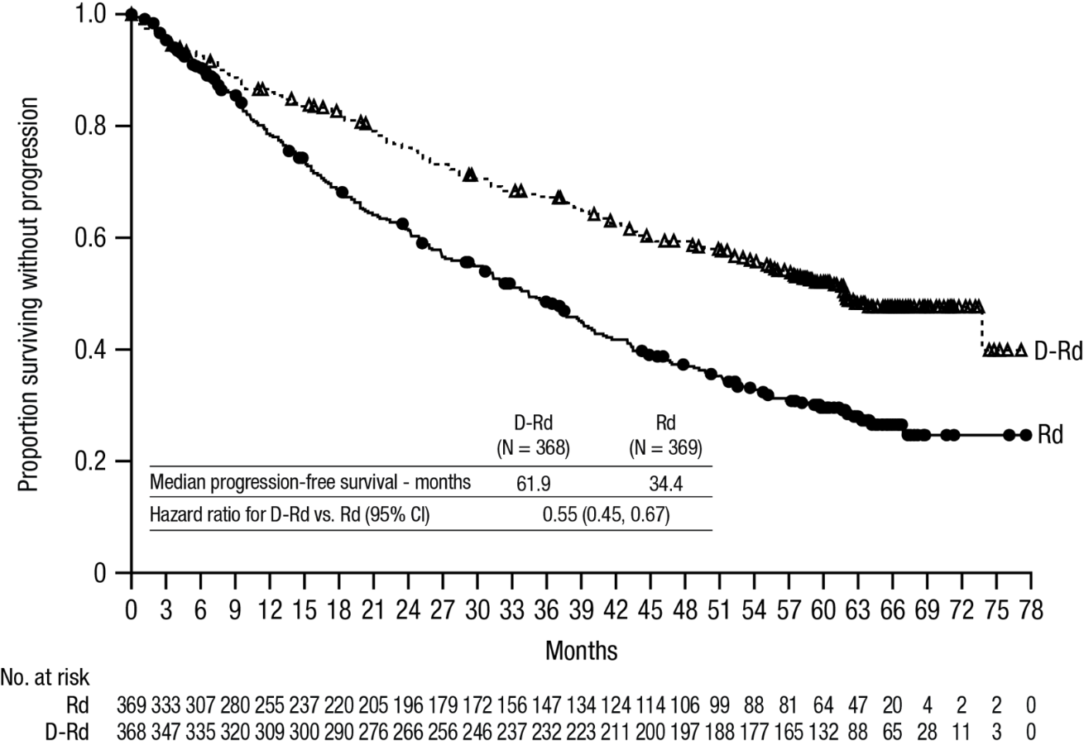

With a median follow-up of 56 months, DRd has shown an OS advantage over the Rd arm (HR=0.68; 95% CI: 0.53, 0.86; p=0.0013). Results of an updated OS analysis after a median of 89 months continued to show an improvement in OS for patients in the DRd arm compared to the Rd arm. Median OS was 90.3 months in the DRd arm and was 64.1 months in the Rd arm (HR=0.67; 95% CI: 0.55, 0.82).

Figure 2: Kaplan-Meier curve of OS in study MMY3008

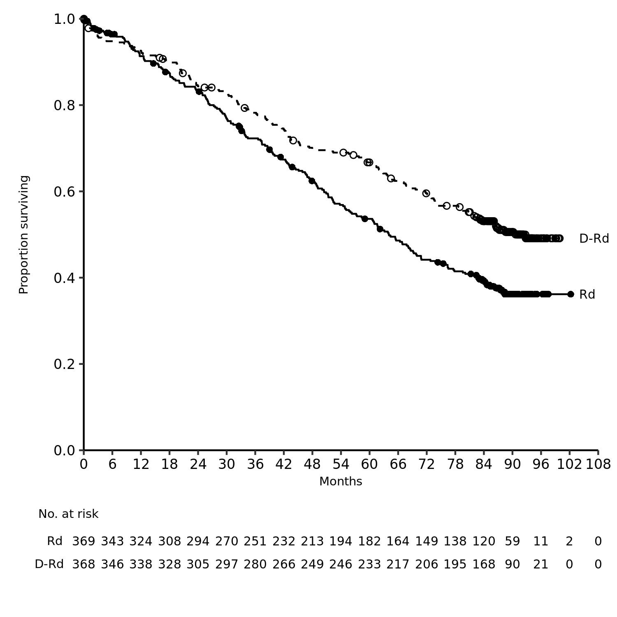

Additional efficacy results from study MMY3008 are presented in table 7 below.

Table 7: Additional efficacy results from study MMY3008ª
 | DRd (n=368) | Rd (n=369)
Overall response (sCR+CR+VGPR+PR) n(%)ª | 342 (92.9%) | 300 (81.3%)
p-value^{b} | <0.0001
Stringent complete response (sCR) | 112 (30.4%) | 46 (12.5%)
Complete response (CR) | 63 (17.1%) | 46 (12.5%)
Very good partial response (VGPR) | 117 (31.8%) | 104 (28.2%)
Partial response (PR) | 50 (13.6%) | 104 (28.2%)
CR or better (sCR + CR) | 175 (47.6%) | 92 (24.9%)
p-value^{b} | <0.0001
VGPR or better (sCR + CR + VGPR) | 292 (79.3%) | 196 (53.1%)
p-value^{b} | <0.0001
MRD negativity rate^{a,c} n(%) | 89 (24.2%) | 27 (7.3%)
95% CI (%) | (19.9%, 28.9%) | (4.9%, 10.5%)
Odds ratio with 95% CI^{d} | 4.04 (2.55, 6.39)
p-value^{e} | <0.0001

DRd=daratumumab-lenalidomide-dexamethasone; Rd=lenalidomide-dexamethasone; MRD=minimal residual disease; CI=confidence interval

ª Based on intent-to-treat population

^{b} p-value from Cochran Mantel-Haenszel Chi-Squared test.

^{c} Based on threshold of 10⁻⁵

^{d} Mantel-Haenszel estimate of the odds ratio for un-stratified tables is used. An odds ratio >1 indicates an advantage for DRd.

^{e} p-value from Fisherʼs exact test.

In responders, the median time to response was 1.05 months (range: 0.2 to 12.1 months) in the DRd group and 1.05 months (range: 0.3 to 15.3 months) in the Rd group. The median duration of response had not been reached in the DRd group and was 34.7 months (95% CI: 30.8, not estimable) in the Rd group.

Combination treatment with bortezomib, melphalan and prednisone (VMP) in patients ineligible for autologous stem cell transplant
Study MMY3007, an open-label, randomised, active-controlled phase III study, compared treatment with DARZALEX 16 mg/kg in combination with bortezomib, melphalan and prednisone (D-VMP), to treatment with VMP in patients with newly diagnosed multiple myeloma. Bortezomib was administered by subcutaneous injection at a dose of 1.3 mg/m² body surface area twice weekly at weeks 1, 2, 4 and 5 for the first 6-week cycle (cycle 1; 8 doses), followed by once weekly administrations at weeks 1, 2, 4 and 5 for eight more 6-week cycles (cycles 2-9; 4 doses per cycle). Melphalan at 9 mg/m², and prednisone at 60 mg/m² were orally administered on days 1 to 4 of the nine 6-week cycles (cycles 1-9). DARZALEX treatment was continued until disease progression or unacceptable toxicity.

A total of 706 patients were randomised: 350 to the D-VMP arm and 356 to the VMP arm. The baseline demographic and disease characteristics were similar between the two treatment groups. The median age was 71 (range: 40-93) years, with 30% of the patients ≥75 years of age. The majority were white (85%), female (54%), 25% had an ECOG performance score of 0, 50% had an ECOG performance score of 1 and 25% had an ECOG performance score of 2. Patients had IgG/IgA/Light chain myeloma in 64%/22%/10% of instances, 19% had ISS stage I, 42% had ISS stage II, 38% had ISS stage III disease and 84% had standard risk cytogenetics. Efficacy was evaluated by PFS based on IMWG criteria and overall survival (OS).

With a median follow-up of 16.5 months, the primary analysis of PFS in study MMY3007 showed an improvement in the D-VMP arm as compared to the VMP arm; the median PFS had not been reached in the D-VMP arm and was 18.1 months in the VMP arm (HR=0.5; 95% CI: 0.38, 0.65; p < 0.0001). Results of an updated PFS analysis after a median follow-up of 40 months continued to show an improvement in PFS for patients in the D-VMP arm compared with the VMP arm. Median PFS was 36.4 months in the D-VMP arm and 19.3 months in the VMP arm (HR=0.42; 95% CI: 0.34, 0.51; p < 0.0001), representing a 58% reduction in the risk of disease progression or death in patients treated with D-VMP.

Figure 3: Kaplan-Meier curve of PFS in study MMY3007

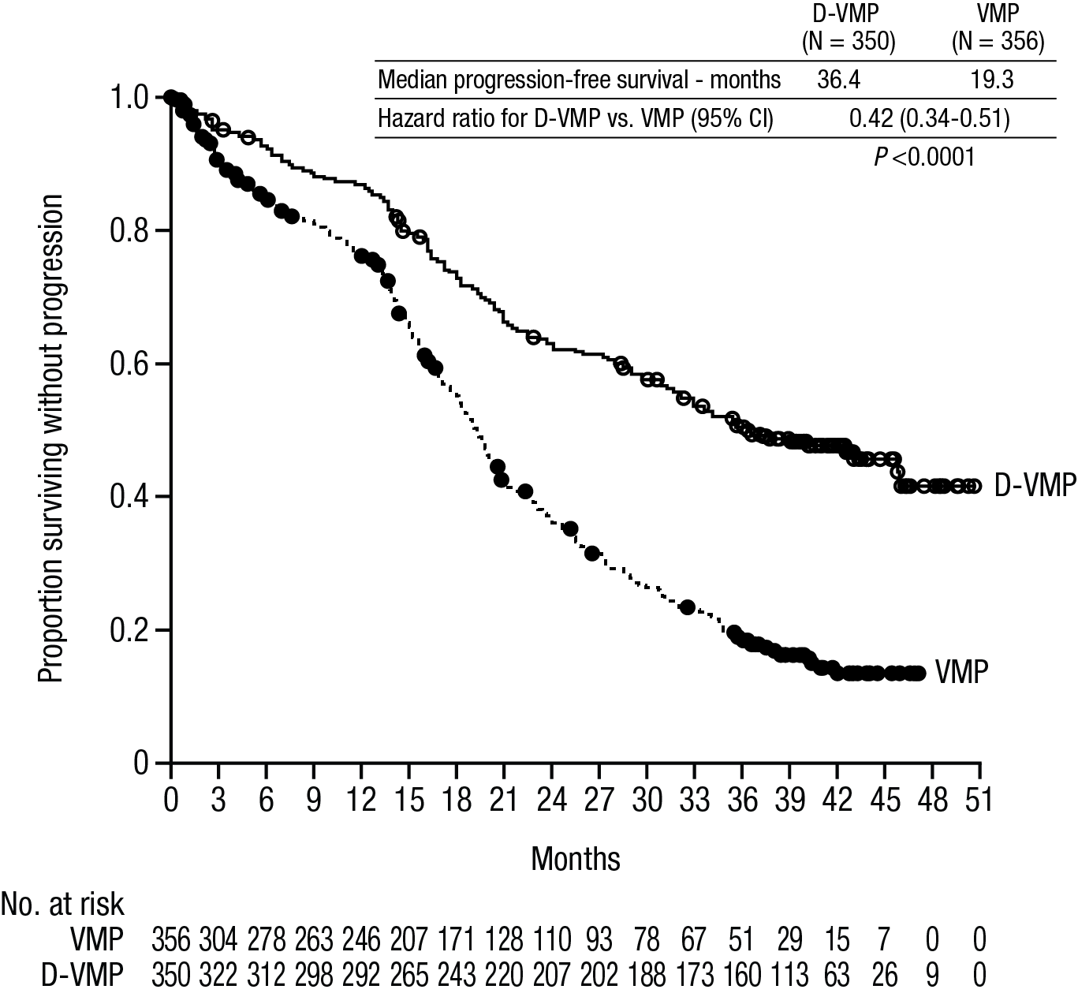

After a median follow-up of 40 months, D-VMP has shown an OS advantage over the VMP arm (HR=0.60; 95% CI: 0.46, 0.80; p=0.0003), representing a 40% reduction in the risk of death in patients treated in the D-VMP arm. After a median follow-up of 87 months, the median OS was 83 months (95% CI: 72.5, NE) in the D-VMP arm and 53.6 months (95% CI: 46.3, 60.9) in the VMP arm.
.

Figure 4: Kaplan-Meier curve of OS in study MMY3007

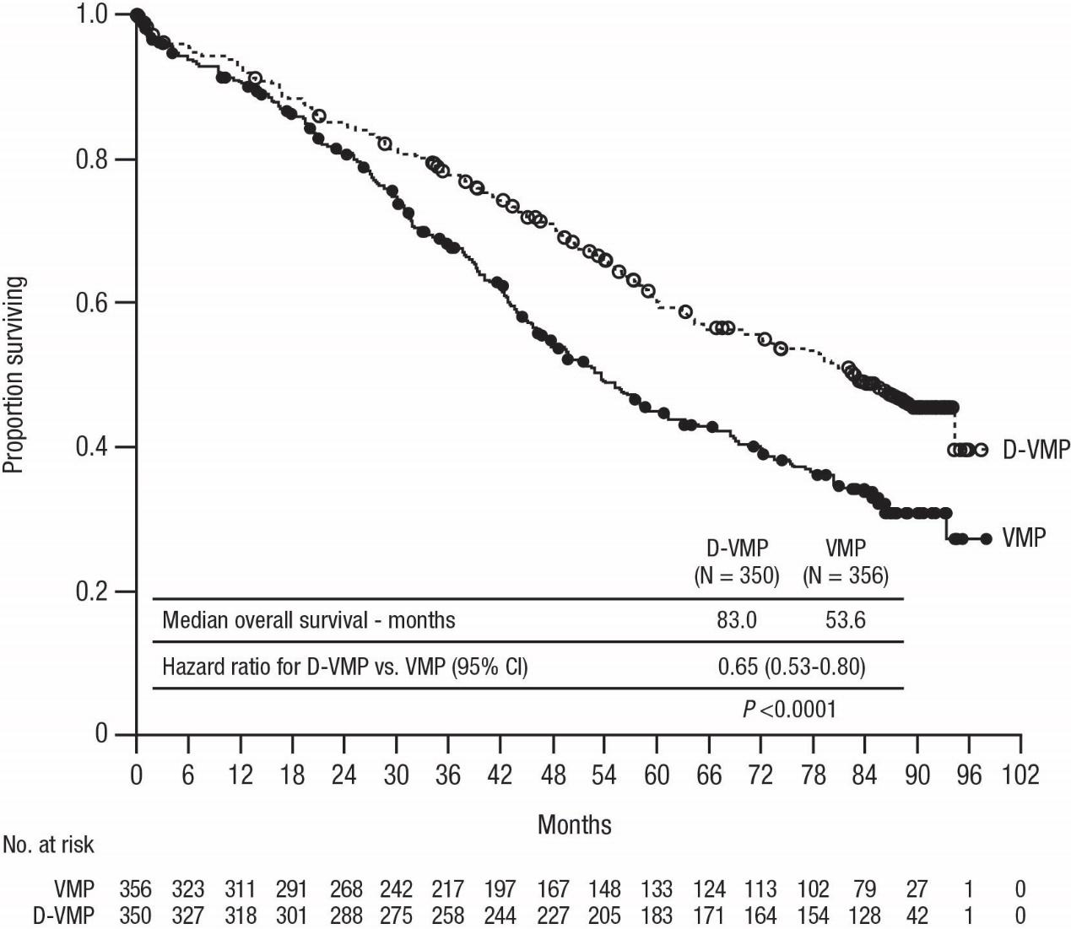

Additional efficacy results from study MMY3007 are presented in table 8 below.

Table 8: Additional efficacy results from study MMY3007ª
 | D-VMP (n=350) | VMP (n=356)
Overall response (sCR+CR+VGPR+PR) [n(%)] | 318 (90.9) | 263 (73.9)
p-value^{b} | <0.0001
Stringent complete response (sCR) [n(%)] | 63 (18.0) | 25 (7.0)
Complete response (CR) [n(%)] | 86 (24.6) | 62 (17.4)
Very good partial response (VGPR) [n(%)] | 100 (28.6) | 90 (25.3)
Partial response (PR) [n(%)] | 69 (19.7) | 86 (24.2)
MRD negativity rate (95% CI) ^{c} (%) | 22.3 (18.0, 27.0) | 6.2 (3.9, 9.2)
Odds ratio with 95% CI^{d} | 4.36 (2.64, 7.21)
p-value^{e} | <0.0001

D-VMP=daratumumab-bortezomib-melphalan-prednisone; VMP=bortezomib-melphalan-prednisone; MRD=minimal residual disease; CI=confidence interval
ª Based on intent-to-treat population
^{b} p-value from Cochran Mantel-Haenszel Chi-Squared test.
^{c} Based on threshold of 10⁻⁵
^{d} A Mantel-Haenszel estimate of the common odds ratio for stratified tables is used. An odds ratio >1 indicates an advantage for D-VMP.
^{e} p-value from Fisherʼs exact test.

In responders, the median time to response was 0.79 months (range: 0.4 to 15.5 months) in the D-VMP group and 0.82 months (range: 0.7 to 12.6 months) in the VMP group. The median duration of response had not been reached in the D-VMP group and was 21.3 months (range: 18.4, not estimable) in the VMP group.

A subgroup analysis was performed on patients at least 70 years old, or those 65-69 years old with ECOG performance score of 2, or aged less than 65 years of age with significant comorbidity or ECOG performance score of 2 (D-VMP: n=273, VMP: n=270). The efficacy results in this subgroup were consistent with the overall population. In this subgroup, median PFS was not reached in the D-VMP group and was 17.9 months in the VMP group (HR=0.56; 95% CI: 0.42, 0.75; p < 0.0001). The overall response rate was 90% in the D-VMP group and 74% in theVMP group (VGPR rate:29% in D-VMP group and 26% in VMP group; CR: 22% in D-VMP group and 18% in VMP group; sCR rate: 20% in D-VMP group and 7% in VMP group). The safety results of this subgroup were consistent with the overall population. Furthermore, safety analysis of the subgroup of patients with an ECOG performance score of 2 (D-VMP: n=89, VMP: n=84), was also consistent with the overall population.

Combination treatment with bortezomib, thalidomide and dexamethasone (VTd) in patients eligible for autologous stem cell transplant (ASCT)
Study MMY3006 is a 2 part, open-label, randomised, active-controlled phase III study. Part 1 compared induction and consolidation treatment with DARZALEX 16 mg/kg in combination with bortezomib, thalidomide and dexamethasone (D-VTd) to treatment with bortezomib, thalidomide and dexamethasone (VTd) in patients with newly diagnosed multiple myeloma eligible for ASCT. The consolidation phase of treatment began a minimum of 30 days post-ASCT, when the patient had recovered sufficiently, and engraftment was complete. In part 2, subjects with at least a partial response (PR) by day 100 post-transplant were re-randomised in a 1:1 ratio to daratumumab maintenance or observation only. Only results from part 1 are described henceforth.

Bortezomib was administered by subcutaneous injection or intravenous injection at a dose of 1.3 mg/m² body surface area twice weekly for two weeks (days 1, 4, 8, and 11) of repeated 28 day (4-week) induction treatment cycles (cycles 1-4) and two consolidation cycles (cycles 5 and 6) following ASCT after cycle 4. Thalidomide was administered orally at 100 mg daily during the six bortezomib cycles. Dexamethasone (oral or intravenous) was administered at 40 mg on days 1, 2, 8, 9, 15, 16, 22 and 23 of cycles 1 and 2, and at 40 mg on days 1-2 and 20 mg on subsequent dosing days (days 8, 9, 15, 16) of cycles 3-4. Dexamethasone 20 mg was administered on days 1, 2, 8, 9, 15, 16 in cycles 5 and 6. On the days of DARZALEX infusion, the dexamethasone dose was administered intravenously as a pre-infusion medicinal product. Dose adjustments for bortezomib, thalidomide and dexamethasone were applied according to manufacturer’s prescribing information.

A total of 1085 patients were randomised: 543 to the D-VTd arm and 542 to the VTd arm. The baseline demographic and disease characteristics were similar between the two treatment groups. The median age was 58 (range: 22 to 65) years. All patients were ≤ 65 years: 43% were in the age group ≥ 60-65 years, 41% were in the age group ≥ 50-60 years and 16% below age of 50 years. The majority were male (59%), 48% had an ECOG performance score of 0, 42% had an ECOG performance score of 1 and 10% had an ECOG performance score of 2. Forty percent had International Staging System (ISS) stage I, 45% had ISS stage II and 15% had ISS stage III disease.

Efficacy was evaluated by the stringent complete response (sCR) rate at day 100 post-transplant and PFS.

Table 9: Efficacy results from study MMY3006ª
 | D-VTd (n=543) | VTd (n=542) | P value^{b}

Response assessment day 100 post-transplant
Stringent complete response (sCR) | 157 (28.9%) | 110 (20.3%) | 0.0010
CR or better (sCR+CR) | 211 (38.9%) | 141 (26.0%) | <0.0001
Very good partial response or better (sCR+CR+VGPR) | 453 (83.4%) | 423 (78.0%)
MRD negativity^{c, d} n(%) | 346 (63.7%) | 236 (43.5%) | <0.0001
95% CI (%) | (59.5%, 67.8%) | (39.3%, 47.8%)
Odds ratio with 95% CIe | 2.27 (1.78, 2.90)
MRD negativity in combination with CR or better^{c} n(%) | 183 (33.7%) | 108 (19.9%) | <0.0001
95% CI (%) | (29.7%, 37.9%) | (16.6%, 23.5%)
Odds ratio with 95% CIe | 2.06 (1.56, 2.72)

D-VTd=daratumumab-bortezomib-thalidomide-dexamethasone; VTd=bortezomib-thalidomide-dexamethasone; MRD=minimal residual disease; CI=confidence interval

ª Based on intent-to-treat population

^{b} p-value from Cochran Mantel-Haenszel Chi-Squared test.

^{c} Based on threshold of 10⁻⁵

^{d} Regardless of response per IMWG

^{e} Mantel-Haenszel estimate of the common odds ratio for stratified tables is used.

With a median follow-up of 18.8 months, the primary analysis of PFS by censoring patients who were randomised to daratumumab maintenance in the second randomisation at the date of the second randomisation showed HR=0.50; 95% CI: 0.34, 0.75; p=0.0005. Results of an updated PFS analysis with a median follow-up of 44.5 months, censoring patients who were randomised to daratumumab maintenance in the second randomisation, showed HR=0.43; 95% CI: 0.33, 0.55; p < 0.0001. Median PFS was not reached in the D-VTd arm and was 37.8 months in the VTd arm.

Figure 5: Kaplan-Meier curve of PFS in study MMY3006

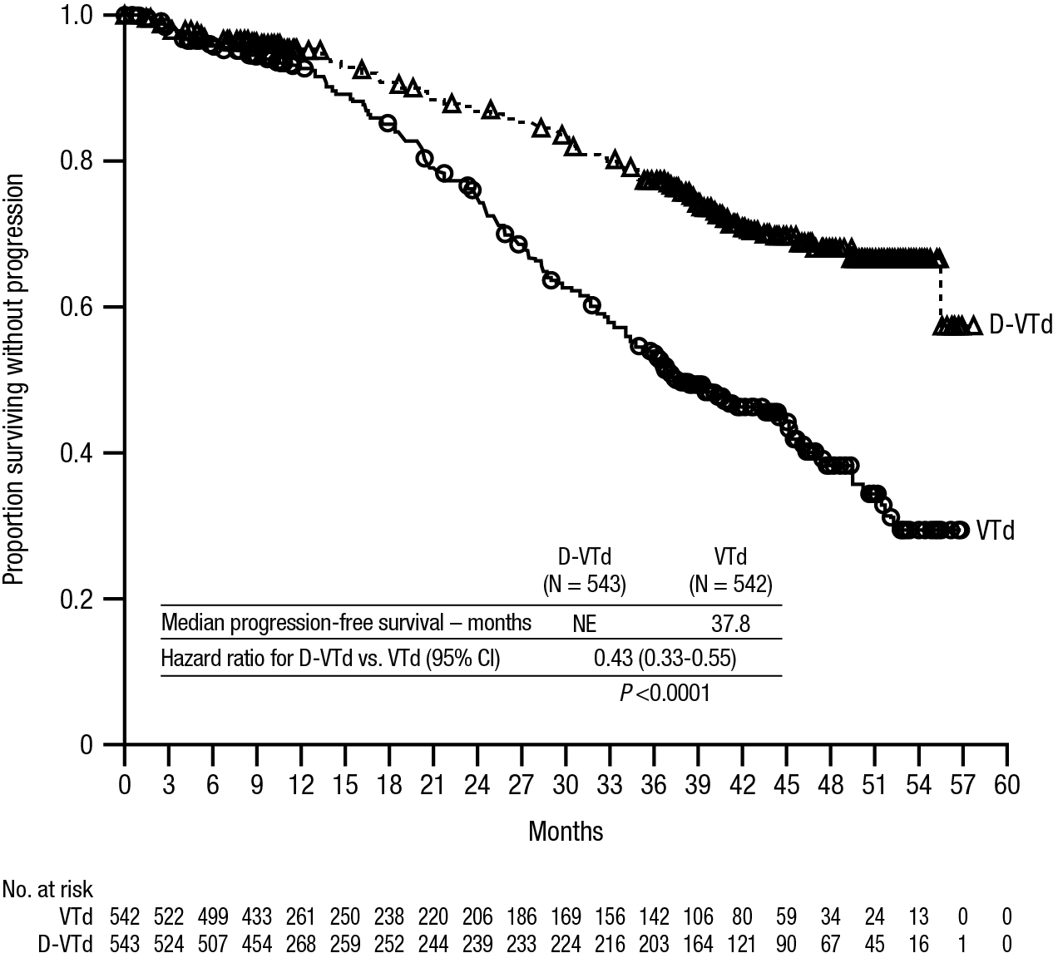

Relapsed/refractory multiple myeloma
Monotherapy:
The clinical efficacy and safety of DARZALEX monotherapy for the treatment of adult patients with relapsed and refractory multiple myeloma whose prior therapy included a proteasome inhibitor and an immunomodulatory agent and who had demonstrated disease progression on the last therapy, was demonstrated in two open-label studies.

In study MMY2002, 106 patients with relapsed and refractory multiple myeloma received 16 mg/kg DARZALEX until disease progression. The median patient age was 63.5 years (range, 31 to 84 years), 11% of patients were ≥75 years of age, 49% were male and 79% were Caucasian. Patients had received a median of 5 prior lines of therapy. Eighty percent of patients had received prior autologous stem cell transplantation (ASCT). Prior therapies included bortezomib (99%), lenalidomide (99%), pomalidomide (63%) and carfilzomib (50%). At baseline, 97% of patients were refractory to the last line of treatment, 95% were refractory to both, a proteasome inhibitor (PI) and immunomodulatory agent (IMiD), 77% were refractory to alkylating agents, 63% were refractory to pomalidomide and 48% of patients were refractory to carfilzomib.

Efficacy results of the pre-planned interim analysis based on Independent Review Committee (IRC) assessment are presented in table 10 below.

Table 10: IRC assessed efficacy results for study MMY2002
Efficacy endpoint | DARZALEX 16 mg/kg  N=106
Overall response rate¹ (ORR: sCR+CR+VGPR+PR) [n (%)] | 31 (29.2)
95% CI (%) | (20.8, 38.9)
Stringent complete response (sCR) [n (%)] | 3 (2.8)
Complete response (CR) [n] | 0
Very good partial response (VGPR) [n (%)] | 10 (9.4)
Partial response (PR) [n (%)] | 18 (17.0)
Clinical benefit rate (ORR+MR) [n (%)] | 36 (34.0)
Median duration of response [months (95% CI)] | 7.4 (5.5, NE)
Median time to response [months (range)] | 1 (0.9; 5.6)
¹ Primary efficacy endpoint (International Myeloma Working Group criteria).
CI=confidence interval; NE=not estimable; MR=minimal response.

Overall response rate (ORR) in MMY2002 was similar regardless of type of prior anti-myeloma therapy.
At a survival update with a median duration of follow-up of 14.7 months, median OS was 17.5 months (95% CI: 13.7, not estimable).

In study GEN501, 42 patients with relapsed and refractory multiple myeloma received 16 mg/kg DARZALEX until disease progression. The median patient age was 64 years (range, 44 to 76 years), 64% were male and 76% were Caucasian. Patients in the study had received a median of 4 prior lines of therapy. Seventy-four percent of patients had received prior ASCT. Prior therapies included bortezomib (100%), lenalidomide (95%), pomalidomide (36%) and carfilzomib (19%). At baseline, 76% of patients were refractory to the last line of treatment, 64% were refractory to both a PI and IMiD, 60% were refractory to alkylating agents, 36% were refractory to pomalidomide and 17% were refractory to carfilzomib.

Pre-planned interim analysis showed that treatment with daratumumab at 16 mg/kg led to a 36% ORR with 5% CR and 5% VGPR. The median time to response was 1 (range: 0.5 to 3.2) month. The median duration of response was not reached (95% CI: 5.6 months, not estimable).

At a survival update with a median duration of follow-up of 15.2 months, median OS was not reached (95% CI: 19.9 months, not estimable), with 74% of subjects still alive.

Combination treatment with lenalidomide
Study MMY3003, an open-label, randomised, active-controlled phase III study, compared treatment with DARZALEX 16 mg/kg in combination with lenalidomide and low-dose dexamethasone (DRd) to treatment with lenalidomide and low-dose dexamethasone (Rd) in patients with relapsed or refractory multiple myeloma who had received at least one prior therapy. Lenalidomide (25 mg once daily orally on days 1-21 of repeated 28-day [4-week] cycles) was given with low dose dexamethasone at 40 mg/week (or a reduced dose of 20 mg/week for patients >75 years or BMI < 18.5). On DARZALEX infusion days, 20 mg of the dexamethasone dose was given as a pre-infusion medicinal product and the remainder given the day after the infusion. Treatment was continued in both arms until disease progression or unacceptable toxicity.

A total of 569 patients were randomised; 286 to the DRd arm and 283 to the Rd arm. The baseline demographic and disease characteristics were similar between the DARZALEX and the control arm. The median patient age was 65 years (range 34 to 89 years) and 11% were ≥75 years. The majority of patients (86%) received a prior PI, 55% of patients had received a prior IMiD, including 18% of patients who had received prior lenalidomide; and 44% of patients had received both a prior PI and IMiD. At baseline, 27% of patients were refractory to the last line of treatment. Eighteen percent (18%) of patients were refractory to a PI only, and 21% were refractory to bortezomib. Patients refractory to lenalidomide were excluded from the study.

With a median follow-up of 13.5 months, the primary analysis of PFS in study MMY3003 demonstrated an improvement in the DRd arm as compared to the Rd arm; the median PFS had not been reached in the DRd arm and was 18.4 months in the Rd arm (HR=0.37; 95% CI: 0.27, 0.52; p < 0.0001). Results of an updated PFS analysis after a median follow-up of 55 months continued to show an improvement in PFS for patients in the DRd arm compared with the Rd arm. Median PFS was 45.0 months in the DRd arm and 17.5 months in the Rd arm (HR=0.44; 95% CI: 0.35, 0.54; p 0.0001), representing a 56% reduction in the risk of disease progression or death in patients treated with DRd (see figure 6).

Figure 6: Kaplan-Meier curve of PFS in study MMY3003

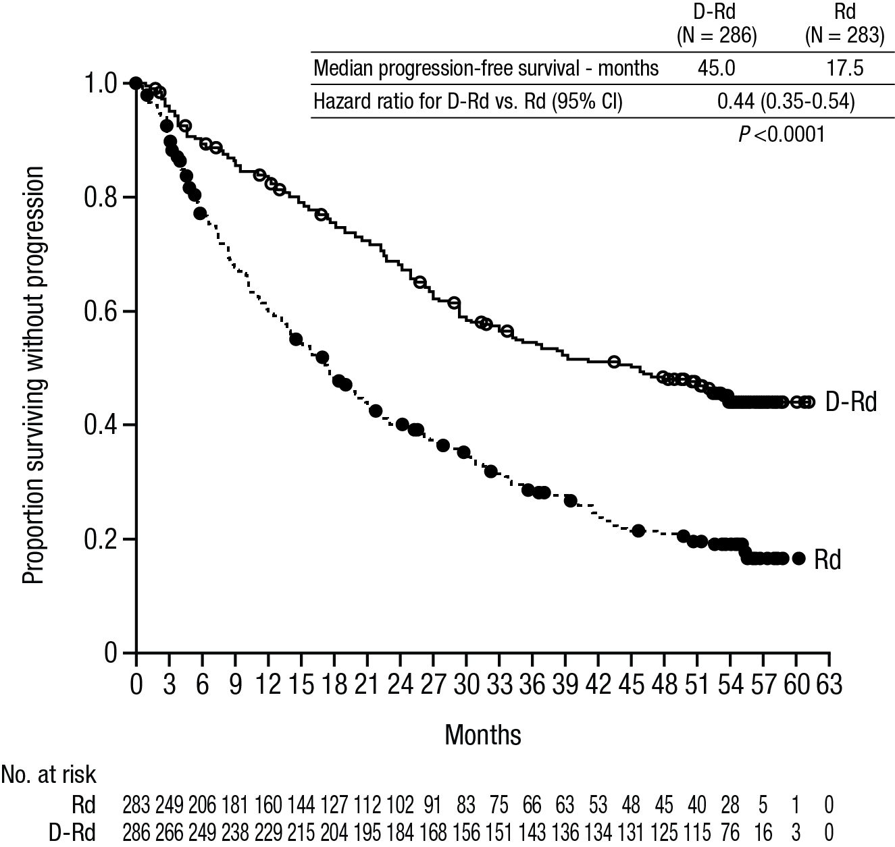

After a median follow-up of 80 months, DRd has shown an OS advantage over the Rd arm (HR=0.73; 95% CI: 0.58, 0.91; p=0.0044). The median OS was 67.6 months in the DRd arm and 51.8 months in the Rd arm.

Figure 7: Kaplan-Meier curve of OS in study MMY3003

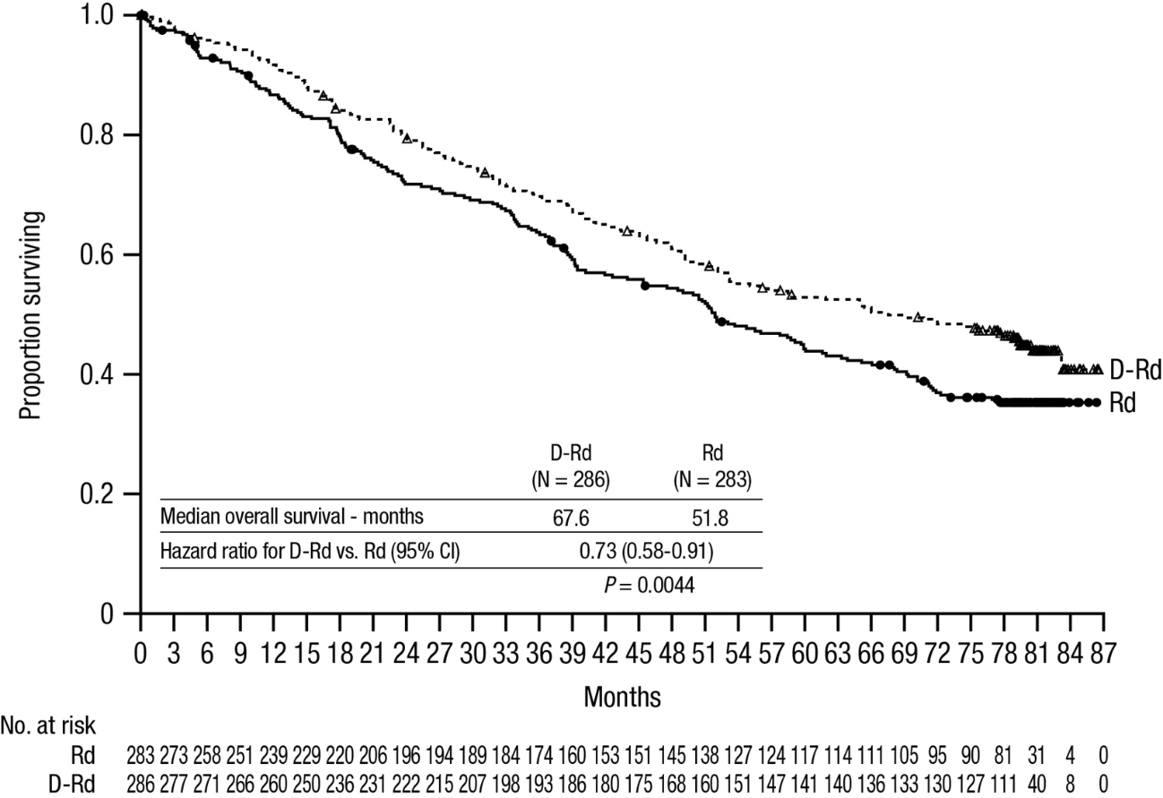

Additional efficacy results from study MMY3003 are presented in table 11 below.

Table 11: Additional efficacy results from study MMY3003
Response evaluable patient number | DRd (n=281) | Rd (n=276)
Overall response (sCR+CR+VGPR+PR) n(%) | 261 (92.9) | 211 (76.4)
p-valueª | <0.0001
Stringent complete response (sCR) | 51 (18.1) | 20 (7.2)
Complete response (CR) | 70 (24.9) | 33 (12.0)
Very good partial response (VGPR) | 92 (32.7) | 69 (25.0)
Partial response (PR) | 48 (17.1) | 89 (32.2)
Median time to response [months (95% CI)] | 1.0 (1.0, 1.1) | 1.3 (1.1, 1.9)
Median duration of response [months (95% CI)] | NE (NE, NE) | 17.4 (17.4, NE)
MRD negative rate (95% CI) ^{b} (%) | 21.0 (16.4, 26.2) | 2.8 (1.2, 5.5)
Odds ratio with 95% CI^{c} | 9.31 (4.31, 20.09)
P-value^{d} | <0.0001

DRd=daratumumab-lenalidomide-dexamethasone; Rd=lenalidomide-dexamethasone; MRD=minimal residual disease; CI=confidence interval; NE=not estimable.
ª p-value from Cochran Mantel-Haenszel Chi-Squared test.
^{b} Based on Intent-to-treat population and threshold of 10⁻⁵
^{c} Mantel-Haenszel estimate of the common odds ratio is used. An odds ratio >1 indicates an advantage for DRd.
^{d} p-value is from a Fisher’s exact test.

Combination treatment with bortezomib
Study MMY3004, an open-label, randomised, active-controlled phase III study, compared treatment with DARZALEX 16 mg/kg in combination with bortezomib and dexamethasone (DVd), to treatment with bortezomib and dexamethasone (Vd) in patients with relapsed or refractory multiple myeloma who had received at least one prior therapy. Bortezomib was administered by subcutaneous injection or intravenous injection at a dose of 1.3 mg/m² body surface area twice weekly for two weeks (days 1, 4, 8, and 11) of repeated 21 day (3-week) treatment cycles, for a total of 8 cycles. Dexamethasone was administered orally at a dose of 20 mg on days 1, 2, 4, 5, 8, 9, 11, and 12 of each of the 8 bortezomib cycles (80 mg/week for two out of three weeks of the bortezomib cycle) or a reduced dose of 20 mg/week for patients >75 years, BMI <18.5, poorly controlled diabetes mellitus or prior intolerance to steroid therapy. On the days of DARZALEX infusion, 20 mg of the dexamethasone dose was administered as a pre-infusion medicinal product. DARZALEX treatment was continued until disease progression or unacceptable toxicity.

A total of 498 patients were randomised; 251 to the DVd arm and 247 to the Vd arm. The baseline demographic and disease characteristics were similar between the DARZALEX and the control arm. The median patient age was 64 years (range 30 to 88 years) and 12% were ≥75 years. Sixty-nine percent (69%) of patients had received a prior PI (66% received bortezomib) and 76% of patients received an IMiD (42% received lenalidomide). At baseline, 32% of patients were refractory to the last line of treatment. Thirty-three percent (33%) of patients were refractory to an IMiD only, and 28% were refractory to lenalidomide. Patients refractory to bortezomib were excluded from the study.

With a median follow-up of 7.4 months, the primary analysis of PFS in study MMY3004 demonstrated an improvement in the DVd arm as compared to the Vd arm; the median PFS had not been reached in the DVd arm and was 7.2 months in the Vd arm (HR [95% CI]: 0.39 [0.28, 0.53]; p-value < 0.0001). Results of an updated PFS analysis after a median follow-up of 50 months continued to show an improvement in PFS for patients in the DVd arm compared with the Vd arm. Median PFS was 16.7 months in the DVd arm and 7.1 months in the Vd arm (HR [95% CI]: 0.31 [0.24, 0.39]; p-value < 0.0001), representing a 69% reduction in the risk of disease progression or death in patients treated with DVd versus Vd (see figure 8).

Figure 8: Kaplan-Meier curve of PFS in study MMY3004

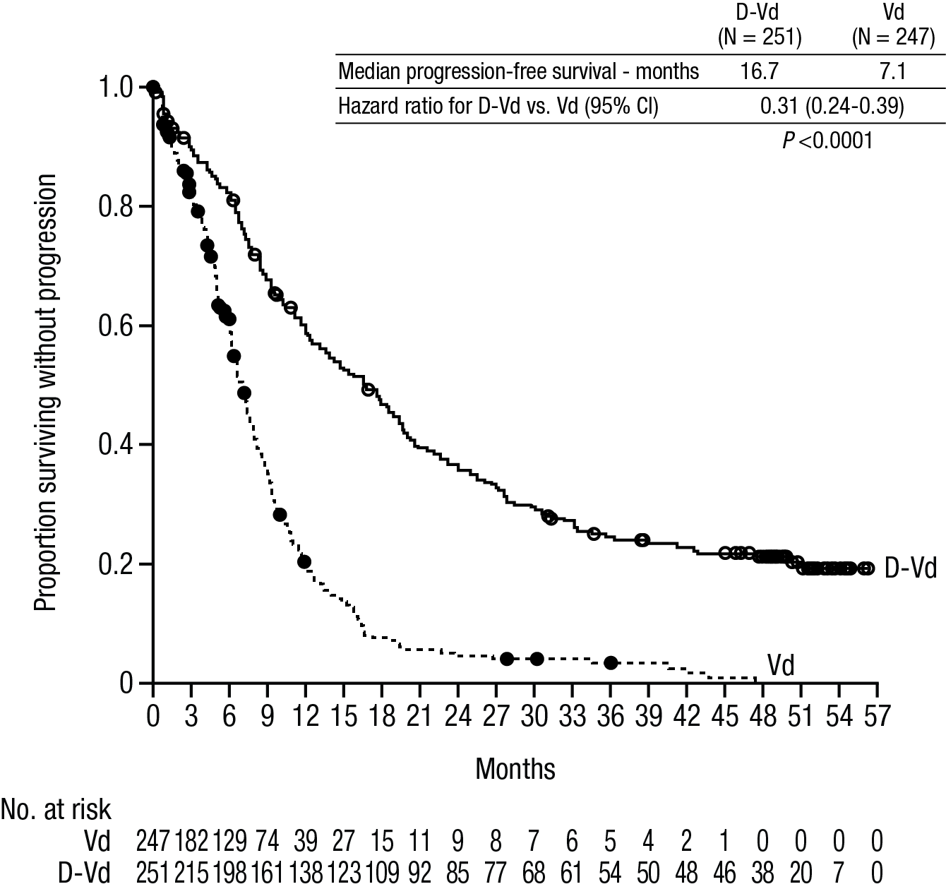

After a median follow-up of 73 months, DVd has shown an OS advantage over the Vd arm (HR=0.74; 95% CI: 0.59, 0.92; p=0.0075). The median OS was 49.6 months in the DVd arm and 38.5 months in the Vd arm.

Figure 9: Kaplan-Meier curve of OS in study MMY3004

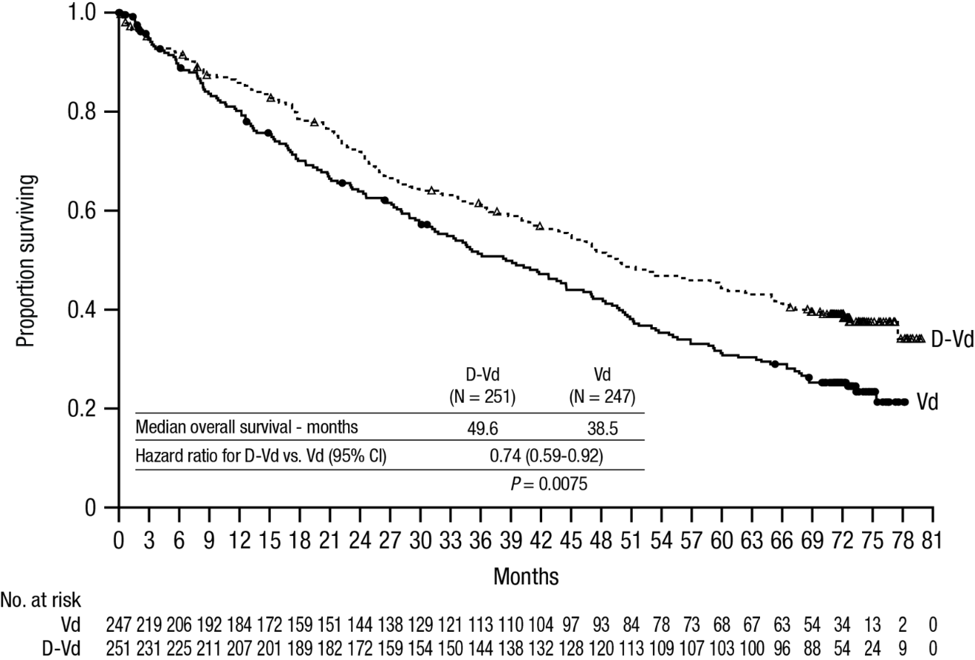

Additional efficacy results from study MMY3004 are presented in table 12 below.

Table 12: Additional efficacy results from study MMY3004
Response evaluable patient number | DVd (n=240) | Vd (n=234)
Overall response (sCR+CR+VGPR+PR) n(%) | 199 (82.9) | 148 (63.2)
P-valueª | <0.0001
Stringent complete response (sCR) | 11 (4.6) | 5 (2.1)
Complete response (CR) | 35 (14.6) | 16 (6.8)
Very good partial response (VGPR) | 96 (40.0) | 47 (20.1)
Partial response (PR) | 57 (23.8) | 80 (34.2)
Median time to response [months (range)] | 0.9 (0.8, 1.4) | 1.6 (1.5, 2.1)
Median duration of response [months (95% CI)] | NE (11.5, NE) | 7.9 (6.7, 11.3)
MRD negative rate (95% CI)^{b} | 8.8% (5.6%, 13.0%) | 1.2% (0.3%, 3.5%)
Odds ratio with 95% CI^{c} | 9.04 (2.53, 32.21)
P-value^{d} | 0.0001

DVd=daratumumab- bortezomib-dexamethasone; Vd=bortezomib-dexamethasone; MRD=minimal residual disease; CI=confidence interval; NE=not estimable.

ª p-value from Cochran Mantel-Haenszel Chi-Squared test.

^{b} Based on Intent-to-treat population and threshold of 10⁻⁵
^{c} Mantel-Haenszel estimate of the common odds ratio is used. An odds ratio >1 indicates an advantage for DVd.

^{d} p-value is from Fisher’s exact test.

Cardiac electrophysiology
Daratumumab as a large protein has a low likelihood of direct ion channel interactions. The effect of daratumumab on the QTc interval was evaluated in an open-label study for 83 patients (study GEN501) with relapsed and refractory multiple myeloma following daratumumab infusions (4 to 24 mg/kg). Linear mixed PK-PD analyses indicated no large increase in mean QTcF interval (i.e. greater than 20 ms) at daratumumab C_{max}.

Paediatric population
DARZALEX is indicated for use in adults above the age of 18 (see section 4.2 for information on paediatric use).

5.2 Pharmacokinetic properties

The pharmacokinetics (PK) of daratumumab following intravenous administration of daratumumab monotherapy were evaluated in patients with relapsed and refractory multiple myeloma at dose levels from 0.1 mg/kg to 24 mg/kg.

In the 1 to 24 mg/kg cohorts, peak serum concentrations (C_{max}) after the first dose increased in approximate proportion to dose and volume of distribution was consistent with initial distribution into the plasma compartment. Following the last weekly infusion, C_{max} increased in a greater than dose-proportional manner, consistent with target mediated drug disposition. Increases in AUC were more than dose-proportional and clearance (CL) decreased with increasing dose. These observations suggest CD38 may become saturated at higher doses, after which the impact of target binding clearance is minimised and the clearance of daratumumab approximates the linear clearance of endogenous IgG1. Clearance also decreased with multiple doses, which may be related to tumour burden decreases.

Terminal half-life increases with increasing dose and with repeated dosing. The mean (standard deviation [SD]) estimated terminal half-life of daratumumab following the first 16 mg/kg dose was 9 (4.3) days. The estimated terminal half-life of daratumumab following the last 16 mg/kg dose increased, but there are insufficient data for a reliable estimation. Based on population PK analysis, the mean (SD) half-life associated with non-specific linear elimination was approximately 18 (9) days; this is the terminal half-life that can be expected upon complete saturation of target mediated clearance and repeat dosing of daratumumab.

At the end of weekly dosing for the recommended monotherapy schedule and dose of 16 mg/kg, the mean (SD) serum C_{max} value was 915 (410.3) micrograms/mL, approximately 2.9-fold higher than following the first infusion. The mean (SD) predose (trough) serum concentration at the end of weekly dosing was 573 (331.5) micrograms/mL.

Four population PK analyses were performed to describe the PK characteristics of daratumumab and to evaluate the influence of covariates on the disposition of daratumumab in patients with multiple myeloma; analysis 1 (n=223) in patients receiving DARZALEX monotherapy while analysis 2 (n=694), analysis 3 (n=352) and analysis 4 (n=355) were conducted in patients with multiple myeloma that received daratumumab combination therapies. Analysis 2 included 694 patients (n=326 for lenalidomide-dexamethasone; n=246 for bortezomib-dexamethasone; n=99 for pomalidomide-dexamethasone; n=11 for bortezomib-melphalan-prednisone; and n=12 for bortezomib-thalidomide-dexamethasone), analysis 3 included 352 patients (bortezomib-melphalan-prednisone) and analysis 4 included 355 patients (lenalidomide-dexamethasone).

Based on the population PK analysis of daratumumab monotherapy (analysis 1), daratumumab steady state is achieved approximately 5 months into the every 4-week dosing period (by the 21st infusion), and the mean (SD) ratio of C_{max} at steady-state to C_{max} after the first dose was 1.6 (0.5). The mean (SD) central volume of distribution is 56.98 (18.07) mL/kg.

Three additional population PK analyses (analysis 2, analysis 3 and analysis 4) were conducted in patients with multiple myeloma that received daratumumab combination therapies. Daratumumab concentration-time profiles were similar following the monotherapy and combination therapies. The mean estimated terminal half-life associated with linear clearance in combination therapy was approximately 15-23 days.

Based on the four population PK analyses (analyses 1-4) body weight was identified as a statistically significant covariate for daratumumab clearance. Therefore, body weight based dosing is an appropriate dosing strategy for the multiple myeloma patients.

Simulation of daratumumab pharmacokinetics was conducted for all recommended dosing schedules in 1309 patients with multiple myeloma. The simulation results confirmed that the split and single dosing for the first dose provide similar PK, with the exception of the PK profile in the first day of the treatment.

Special populations

Age and gender
Based on four individual population PK analyses (1-4) in patients receiving daratumumab monotherapy or various combination therapies (analyses 1-4), age (range: 31-93 years) had no clinically important effect on the PK of daratumumab, and the exposure of daratumumab was similar between younger (aged <65 years, n=518) and older (aged ≥65 to <75 years n=761; aged ≥75 years, n=334) patients.

Gender did not affect exposure of daratumumab to a clinically relevant degree in the population PK analyses.

Renal impairment
No formal studies of daratumumab in patients with renal impairment have been conducted. Four individual population PK analyses were performed based on pre-existing renal function data in patients receiving daratumumab monotherapy, or various combination therapies (Analyses 1-4), and included a total of 441 patients with normal renal function (creatinine clearance [CRCL] ≥90 mL/min), 621 with mild renal impairment (CRCL < 90 and ≥60 mL/min), 523 with moderate renal impairment (CRCL < 60 and ≥30 mL/min), and 27 with severe renal impairment or end stage renal disease (CRCL <30 mL/min). No clinically important differences in exposure to daratumumab were observed between patients with renal impairment and those with normal renal function.

Hepatic impairment
No formal studies of daratumumab in patients with hepatic impairment have been conducted. Changes in hepatic function are unlikely to have any effect on the elimination of daratumumab since IgG1 molecules such as daratumumab are not metabolised through hepatic pathways.
Four individual population PK analyses were performed in patients receiving daratumumab monotherapy or various combination therapies (Analyses 1-4), and included a total of 1404 patients with normal hepatic function (total bilirubin [TB] and aspartate aminotransferase [AST] ≤ upper limit of normal [ULN]), 189 with mild hepatic impairment (TB 1.0 x to 1.5 x ULN or AST >ULN) and 8 patients with moderate (TB > 1.5 x to 3.0 x ULN; n=7), or severe (TB > 3.0 x ULN; n=1) hepatic impairment. No clinically important differences in the exposure to daratumumab were observed between patients with hepatic impairment and those with normal hepatic function.

Race
Based on four individual population PK analyses in patients receiving either daratumumab monotherapy or various combination therapies (analyses 1-4), the exposure to daratumumab was similar between white (n=1371) and non-white subjects (n=242).

5.3 Preclinical safety data

Toxicology data have been derived from studies with daratumumab in chimpanzees and with a surrogate anti-CD38 antibody in cynomolgus monkeys. No chronic toxicity testing has been conducted.

Carcinogenicity and mutagenicity
No animal studies have been performed to establish the carcinogenic potential of daratumumab.

Reproductive toxicology
No animal studies have been performed to evaluate the potential effects of daratumumab on reproduction or development.

Fertility
No animal studies have been performed to determine potential effects on fertility in males or females.

6. PHARMACEUTICAL PARTICULARS

6.1 List of excipients

Sorbitol
L-histidine hydrochloride monohydrate
L-methionine
Polysorbate 20
L-histidine
Water for injections

6.2 Incompatibilities

This medicinal product must not be mixed with other medicinal products except those mentioned in section 6.6.

6.3 Shelf life

Unopened vials
The expiry date of the product is indicated on the packaging materials.

After dilution
From a microbiological point of view, unless the method of opening/ dilution precludes the risk of microbial contamination, the product should be used immediately. If not used immediately, in-use storage times and conditions are the responsibility of the user and should be no more than 24 hours at refrigerated conditions (2°C-8°C) protected from light, followed by 15 hours (including infusion time) at room temperature (15°C-25°C) and room light. If stored in the refrigerator, allow the solution to reach ambient temperature before administration.

6.4 Special precautions for storage

Store in a refrigerator (2°C-8°C).
Do not freeze or shake .
Store in the original package in order to protect from light.

For storage conditions after dilution of the medicinal product, see section 6.3.

6.5 Nature and contents of container

5 mL concentrate in a type 1 glass vial with a rubber stopper and an aluminium seal with a flip-off cap containing 100 mg of daratumumab. Pack size of 1 vial.
20 mL concentrate in a type 1 glass vial with a rubber stopper and an aluminium seal with a flip-off cap containing 400 mg of daratumumab. Pack size of 1 vial.

6.6 Special precautions for disposal and other handling

This medicinal product is for single-use only.
Prepare the solution for infusion using aseptic technique as follows:

- Calculate the dose (mg), total volume (mL) of DARZALEX solution required and the number of DARZALEX vials needed based on patient weight.
- Check that the DARZALEX solution is colourless to yellow. Do not use if opaque particles, discolouration or other foreign particles are present.
- Using aseptic technique, remove a volume of sodium chloride 9 mg/mL (0.9%) solution for injection from the infusion bag/container that is equal to the required volume of DARZALEX solution.
- Withdraw the necessary amount of DARZALEX solution and dilute to the appropriate volume by adding to an infusion bag/container containing sodium chloride 9 mg/mL (0.9%) solution for injection (see section 4.2). Infusion bags/containers must be made of polyvinylchloride (PVC), polypropylene (PP), polyethylene (PE) or polyolefin blend (PP+PE). Dilute under appropriate aseptic conditions. Discard any unused portion left in the vial.
- Gently invert the bag/container to mix the solution. Do not shake.
- Visually inspect parenteral medicinal products for particulate matter and discolouration prior to administration. The diluted solution may develop very small, translucent to white proteinaceous particles, as daratumumab is a protein. Do not use if visibly opaque particles, discolouration or foreign particles are observed.
- Since DARZALEX does not contain a preservative, diluted solutions should be administered within 15 hours (including infusion time) at room temperature (15°C-25°C) and in room light.
- If not used immediately, the diluted solution can be stored prior to administration for up to 24 hours at refrigerated conditions (2°C-8°C) and protected from light. Do not freeze. If stored in the refrigerator, allow the solution to reach ambient temperature before administration.
- Administer the diluted solution by intravenous infusion using an infusion set fitted with a flow regulator and with an in-line, sterile, non-pyrogenic, low protein-binding polyethersulfone (PES) filter (pore size 0.22 or 0.2 micrometre). Polyurethane (PU), polybutadiene (PBD), PVC, PP or PE administration sets must be used.
- Do not infuse DARZALEX concomitantly in the same intravenous line with other agents.
- Do not store any unused portion of the infusion solution for reuse. Any unused product or waste material should be disposed of in accordance with local requirements.

Manufacturer: Janssen-Cilag International NV., Turnhoutseweg 30 B-2340 Beerse, Belgium
Registration holder: J-C Health Care Ltd., Kibbutz Shefayim 6099000, Israel

Revised in 02/2026
Registration number: 157-75-34719-00

